Syria crisis field diary (27 July 2012) (229 wds)
A school bag can make all the difference
Yasmine Abu-Seedo
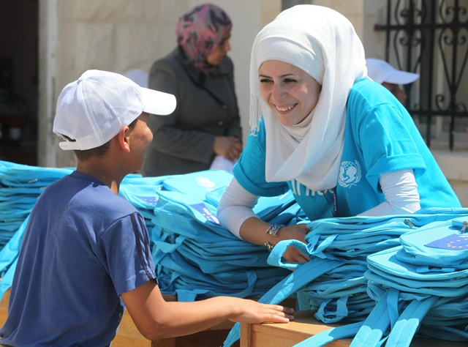
Field Monitor, UNICEF Jordan
There was a real sense of excitement in the air during my recent visit to a school in Ramtha, northern Jordan.
The school has become a UNICEF-supported summer camp for 174 Syrian refugee children and a smaller number of Jordanian children. The children receive remedial education and recreational activities. The European Union is generously supporting the summer camp programme.
For the Syrian children, it’s an opportunity to regain education missed in the chaos of conflict and displacement, and also to just enjoy being children again in a safe environment.
UNICEF Jordan field monitor Yasmine Abu-Seedo chats with a young boy attending a summer camp for Syrian refugee children in northern Jordan. © UNICEF Jordan/2012/Malkawi
The children knew that schoolbags were going to be distributed later that day and they could hardly wait. Many of the children from displaced families had arrived in Jordan with only what they could carry. They were so eager to have a school bag again and be like other children.
I talked to three Syrian girls who told me how much they enjoy being at the summer camp. Not only are they happy to be back in class and learning again, but they also like the sports and the opportunity to make new friends. They are very positive to be moving forward.
But with the increasing stream of Syrian families crossing into Jordan, escaping the on-going violence in their country, there is a desperate need for more services and activities so that all vulnerable Syrian refugee children can be reached.

