Syria crisis field diary (31 July 2012)
Children’s scars on the inside need healing too
Merrin Waterhouse
Child Protection & GBV Specialist, UNICEF Lebanon
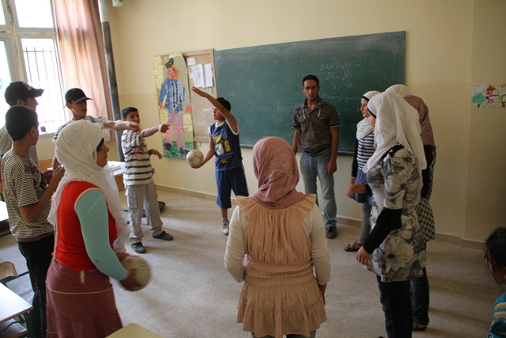
During a recent field visit to a UNICEF-supported Child Friendly Space (CFS) in Lebanon, I talked to a 12-year-old boy who bore a very physical scar of the Syrian conflict. He had been doing routine a chore --- walking to attend to the family cow -- when he was shot in the foot by a sniper. Fortunately he got treatment and is on the mend.
Children take part in a group activity at a UNICEF-supported Child Friendly Space in Lebanon. © UNICEF/2012/Youngmeyer
For many children the scars they bear are internal and come from the terrible things they have witnessed in the Syrian conflict – among them the sounds and sights of fighting, people killed or injured, and homes destroyed.
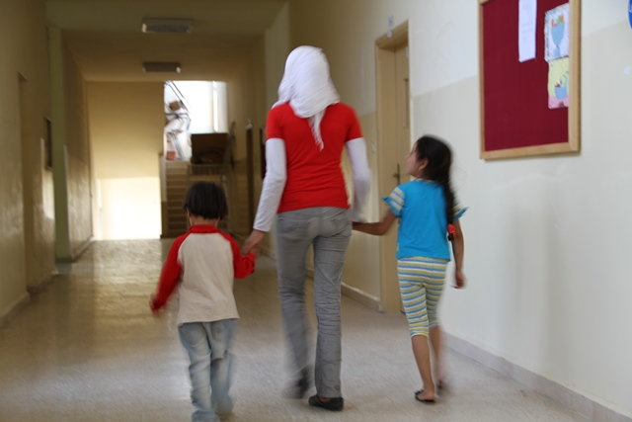
To help Syrian refugee children bounce back, UNICEF is supporting 20 CFSs in north and east Lebanon. They provide a safe space for children to play, take part in structured group activities, receive individual support, and can be referred to more specialised care. Parents are helped to support their children to heal (and heal themselves). The centres make a real difference for children: they get to feel good about life again, no longer afraid to meet others and are ready to go to school.
Children attending a Child Friendly Space held at a school in Lebanon. © UNICEF/2012/Youngmeyer
With the surge in numbers of Syrian children arriving in Lebanon, UNICEF is scaling up its child protection response. This includes not only more CFS, but the possibility of mobile child protection services to reach children in dispersed host communities. The needs are great.

