Allocation Paper  Call For Proposals November 2015  Humanitarian Pooled Fund – [Jordan] | 

Table of Contents

I. Rationale 2
A. HPF Strategic Priorities and alignment with the Jordan Response Plan 4
B. Use of the Grants Management System (GMS) 10
C. Prioritization of projects 10
D. Partners’ eligibility and capacity assessment 10
II. Timeline and Procedure 11
III. Contacts: 11
IV. Complaints Mechanism 11
V. Acronyms 11

Rationale

This allocation paper is issued by the Humanitarian Coordinator (HC), in consultation with the Advisory Board of the HPF, to set the funding priorities for this call.

This allocation paper also provides strategic direction and guidance for the allocation process for this call.

A total amount of US$ 4.5 million is available for this call. This paper outlines the allocation priorities and provides guidance on this Call for Proposal of the Humanitarian Pooled Fund in Jordan (HPF).

Donor Contributions

Based on donors’ commitments and preliminary indication of pledges, a total figure of US $4.5 million will be allocated to this call.

The ceiling for any project is maximum US $400,000.

Objective of allocation

The priorities for the HPF are to respond to the inter-sectoral priorities and fill urgent funding gaps with the sector response plans.

Humanitarian context in Jordan

From a humanitarian perspective, and in recognition of the human tragedy unfolding within Syria,the Government of Jordan has welcomed Syrians seeking refuge, protection, and safety from the conflict. Within that same humanitarian spirit, the government and the people of Jordan have extended public services, facilities, resources and hospitality in an attempt to accommodate the most pressing needs of the Syrian refugees.

A massive influx of over 628,160 registered Syrian refugees has so far sought refuge in Jordan, comprising 25% women, 23% men, 25% girls, and 27% boys. Approximately 85 percent of all refugees are hosted within Jordanian communities and the remaining 15 percent are accommodated within camp settings. Syrian refugees now live in all areas of Jordan, though the main concentrations in local communities are in the northern governorates close to the Syrian border as well as the cities of Amman and Zarqa.

As a result, the volume of refugees is placing enormous strain on the social, economic, institutional and natural resources systems in Jordan. Jordanians have been impacted to different degrees by the situation. In those areas most affected by the refugee influx, all population segments are affected in some manner. But as in all crises, it is the poorest and most vulnerable Jordanian households, and the most vulnerable people within them, that are impacted the most.

Absorbing such a vast number of Syrians within what was already the poorest part of the country is having a profound impact on the demographic and socio-economic landscape of Jordan. Tensions in some areas have become palpable and are expected to exacerbate as long as the crisis endures. Urgent action is needed to address these challenges and to prevent the prospect of an inter-generational reproduction of the crisis, which is an increasing risk the longer the crisis continues.

Total available funding

HPF Strategic Priorities and alignment with the Jordan Response Plan

Strategic Objective of JRP

The JRP’s overall objective: To provide protection and emergency humanitarian response to Syrian refugees and to strengthen the resilience of affected Jordanian people, communities and institutions, while at the same time (i) mitigating the ongoing impact of the Syrian crisis, (ii)) sustaining social and economic stability, and (iii) preserving the development gains achieved in the last decades.

Alignment with the Jordan Response Plan
Sector Priorities | Sector Specific Objective | JRP project title/ERF Project Outcome | Indicators
1. SHELTER:
Sector Overall Objective: To ensure vulnerable Jordanian households and Syrian refugees have improved access to adequate shelter
Cash-for-Rent to vulnerable refugee households in urban areas. Shelter is the most under-funded sector in  relation to the 3rd quarter Financial Tracking of the refugee response | Adequate shelter and basic facilities and services provided for vulnerable WGBM from both Jordanians and Syrian refugees, living outside of camps | REF 2.3: Provision of conditional cash for rent to vulnerable households | - # of vulnerable households  headed by women, girls, boys or  men received conditional cash  for rent assistance
2. BASIC NEEDS:
Sector Overall Objective: (Social Protection in the JRP)
- Basic Needs Support to Refugees inside the Camps
- Basic Needs Support to Vulnerable Refugees (outside camps) and affected Jordanians
Support to maintaining refugee households’ assets through unconditional cash or household item assistance, thereby reducing the risk of exposure to negative coping mechanisms. Focus on urban areas, but also prioritise household support in Azraq, where limited market access is a contributing factor to higher food  insecurity | REF 5: Basic household needs of refugee WGBM are met in camp and non-camp settings through the provision of in-kind or monetized voucher assistance | REF 5.1 Basic needs support to refugees inside the camps | - # of individuals assisted with new arrival kits in camps  - # of individuals in camps receiving replacement / replenishments kits
 |  | REF 5.2 Basic needs support to vulnerable refugees (outside camps) and affected Jordanians | - # of individuals provided with support towards their basic needs
3. HEALTH:
To improve the health status of Syrian refugees and Jordanian host communities by strengthening the national health systems and services
1. Support secondary referral care for priority cases such as deliveries and emergency obstetric care, neonatal care and war-wounded including supporting priority medical referrals from the eastern and western borders. | Equitable access, uptake and quality of secondary and tertiary healthcare for Syrian WGBM and vulnerable Jordanian populations in highly impacted areas | REF 2.1 Secondary and tertiary healthcare for refugee WGBM in camps and out of camps and vulnerable Jordanians | - # of consultations provided to WGBM  - # of sessions of rehabilitation provided to WGBM  - # of new nursing/convalescent care beds available  - # of deliveries in presence of skilled attendant  - # of WGBM referred for secondary and tertiary care
2. Strengthen and expand the community health network in underserved areas and the availability of key integrated community level interventions. | Comprehensive healthcare for Syrian women, girls, boys and men and Jordanian populations in highly impacted areas. | REF 3.1 Community health for refugee women, girls , boys and men in camps and out of camps and  vulnerable Jordanians | - # of active community health volunteers  (male/female, Syrian/ Jordanian)  - # of trainings provided to CHVs (male/ female, Syrian/Jordanian)  - # of home nursing or rehabilitation services provided (WGBM)  - # of CU5, PLW and elderly screened for malnutrition  - # of male and female community workers trained in psychological first aid
4. EDUCATION:
To ensure sustained quality educational services for all, particularly the most vulnerable
1. Support boys and girls (children and youth) to benefit from formal, non-formal, and basic life skills and PSS activities. | Quality and protectiveness of learning environments enhanced for all vulnerable boys and girls (children, adolescents and youth) | REF 1.3 Alternative Certified Education Pathways Project | - # of out-of-school boys  and girls benefitting from  certified alternative education  services  - # of out-of-school boys  and girls benefitting from  non-certified alternative  education services
2. Support boys and girls (children and youth) to access essential learning materials. | Access to education sustained for all vulnerable boys and girls (children, adolescents and youth) affected by the Syria crisis | REF 2.1 Equal Access to Education Opportunities | - # of boys and girls in remedial courses.  - # of boys and girls receiving essential education supplies (kits).  - # of boys and girls benefitting from activities that support psycho-social development and resilience.  - # of boys and girls with specific needs accessing educational and psycho-social services.
3. Support Jordanian public schools with small scale intervention to expand absorption capacity (including  WASH in schools). | Capacity of education service providers increased to deliver quality inclusive education and training for all boys and girls (children and youth) – particularly the  most vulnerable | RES 2.1 Increasing School Absorptive Capacity and Utilization | - # of schools renovated and refurbished.  - # of fully equipped schools built  - # of salaried teachers on a temporary basis on the payroll.  - # of schools
5. WASH:
To enhance the government capacity - and in particular the host communities - to meet the increase in demand for water and sanitation services.
WASH repairs and rehabilitation in schools | Culturally and gender appropriate safe and equitable access to water for drinking, cooking, personal and domestic hygiene ensured | REF 1.4 Water Supply improvement in schools and public health facilities | - # of girls and boys with access to safe drinking water based on minimum standards
WASH repairs and rehabilitation in schools | Access to sustainable, culturally and gender appropriate sanitation services ensured | REF 2.4 Improve sanitation in public schools, health facility and child friendly spaces in host community | - # of girls and boys have access to improved sanitation
WASH support to vulnerable households in communities, includes household level support; repairs and  rehabilitation of the water network in these areas to reduce water loss | Culturally and gender appropriate, safe and equitable access to water for drinking, cooking, and personal and domestic hygiene ensured | REF 1.2 Water Supply through tankering and HH improvement of Syrian and Jordanian in host community | - # of people supplied with water  - # of girls, boys, women and men with access to water based on minimum standards
 | Access to sustainable, culturally and gender appropriate sanitation services ensured | REF 2.1 Safe wastewater management in camps | 1)Person/toilet seat ratio  2) Proportion of boys, girls, women and men that have access to safe wastewater management  - # of HH with access to sewer network  - # of children boys and girls with access to safe and friendly sanitation facilities  - % of waste collection/disposal to waste generated at HH
 |  | REF 2.2 Improve sanitation in household for most vulnerable | - # of girls, boys, women and men have better access to sanitation facilities  - # of HH practicing improved wastewater management
 |  | REF 2.3 Emergency sewerage system improvement for Syrians and Jordanians | - # of household have access to improved sewage services

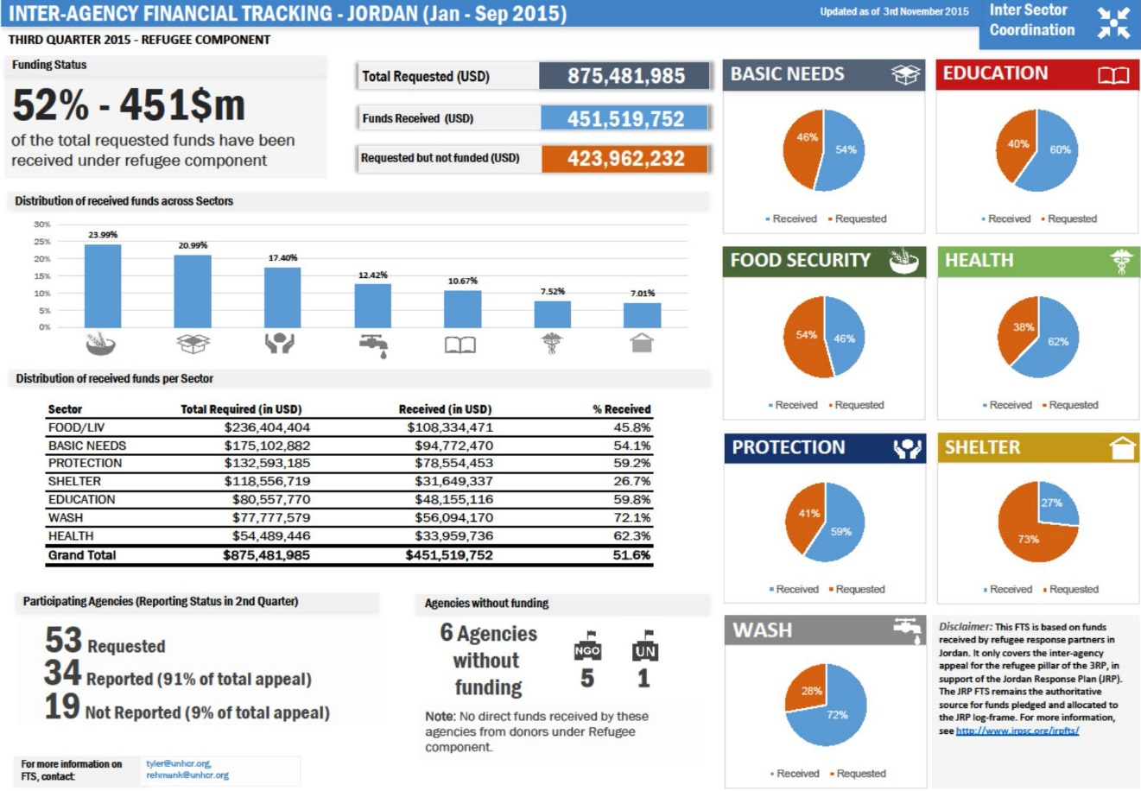

Use of the Grants Management System (GMS)

The use of the Grant Management System (GMS) is a pre-requisite to applying for HPF funding. The GMS supports the full implementation of standard procedures and due diligence processes. It provides support throughout the entire project cycle management. It is the repository of necessary supporting project documents and it ensures timely and effective implementation of control mechanisms to manage and mitigate risks associated to the fund management.

Before submitting projects, implementing partners will go through a due diligence process. During the process, partners will request the registration on the GMS and shall provide a set of information and documentation as per the annex.

Interested partners must contact the Humanitarian Financing Unit (HFU) to express their interest in applying for funding. Details and guidance on the registration and application processes will be provided by the HFU to each partner individually.

Projects submitted offline will not be considered for programmatic or technical review.

Prioritization of projects
The review and approval of project proposals is made in accordance with the programmatic framework described above and on the basis of the following criteria:

- Projects must demonstrate a clear linkage/alignment with the strategic and sectoral objectives.
- Only projects targeting prioritized locations that can be completed within six (12) months will be considered for funding.
- Projects must demonstrate a high degree of cost effectiveness (i.e.: maximum outcome and beneficiary reach for every dollar invested) relative to the project budget as well as to the type of activity.
- Direct implementation of HPF-funded projects by the recipient agency, rather than through a partner/sub-contracted organization, is encouraged. If the recipient agency proposes to work with/through an implementing partner organization, meaningful guidance, coordination, capacity building, technical advice, monitoring and evaluation capacities, or any other function of additional value need to be well articulated in the project proposal.
- Risk management: assumptions and risks are comprehensively and clearly spelled out, along with risk management and mitigation strategies.
- Monitoring: A realistic monitoring and reporting strategy is developed in the proposal.
- The maximum allowable budget for HPF projects is US$400,000. Only eligible organizations cleared and recommended by OCHA’s Humanitarian Financing Unit (HFU) following the completion of the Due Diligence process can apply for funding under this allocation;
- Organisations must use the HPF online Grants Management System (GMS) for the submission of project proposals.
- Applicants must ensure the project proposal is complete and accurate before submission.
- Before submitting an application, applicants are encouraged to seek guidance and support from OCHA HFU, allowing as much time before submission as possible.

Partners’ eligibility and capacity assessment
Jordan HPF aspires to provide equitable opportunity to all humanitarian actors, and promote partnerships with humanitarian organizations to respond quickly and effectively to emergencies.

- UN agencies, IOM, international and national non-governmental organizations, and organizations of the Red Cross/Red Crescent movement, can apply for and receive funding from the Fund.
- International and national NGOs that seek funding must undergo a capacity assessment process to determine their eligibility
- Capacity assessment for International and National NGOs will be undertaken by the HFU to determine the eligibility and the risk level of each organization. The required documents and information will be provided by the HFU to the prospective implementing partner.

II Timeline and Procedure

Task description | Responsible | Date
Endorsement of the allocation document | HPF Advisory Board | 11-Nov | 15-Nov
Launch the call and set the allocation parameters in the Grants Management System (GMS) | Humanitarian Financing Unit | 15-Nov
Partners' registration on the GMS and applications' submission | Implementing Partners  Humanitarian Financing Unit | 15-Nov | 28-Nov
Send application to the Sectors  Technical review and recommendations | Humanitarian Financing Unit  Sectors' review committees | 28-Nov | 4 Dec
Review Board review of the shortlisted applications | HPF Review Board | 7-Dec
Review Board meeting for projects' approval | HPF Review Board  Humanitarian Financing Unit | 10-Dec
Inform the AB with the results of the RB meeting  Inputs from the AB | HPF Advisory Board | 11-Dec | 12-Dec
Request the RCHC's final endorsement | Resident Coordinator / Humanitarian Coordinator | 13-Dec

III Contacts

HPF Manager: Ms. Amani Salah, salah1@un.org , +962 (0) 79 535 4227.
HPF Programme Analyst: Mr. Hanna Abubarham, abubarhamh@un.org +962 (0) 79 869 0448
Humanitarian Finance Officer: Mr. Mohammad Al Masri al-masri@un.org +962 798674615
Head of OCHA Jordan Office: Ms Sarah Muscroft, muscroft@un.org , +962 (0) 79 897 4078.

IV Complaints Mechanism

The following email address, JHPF1@un.org , is available to receive feedback from stakeholders who believe they have been treated incorrectly or unfairly during any of the Fund’s processes. OCHA will compile, review, address and (if necessary) raise the issues to the HC, who will then take a decision on appropriate follow-up action.

V Acronyms

AB Advisory Board
CBPF Country-based Pooled Fund
GMS Grant Management System
HC Humanitarian Coordinator
HFU Humanitarian Financing Unit
JRP Jordan Response Plan
OCHA Office for the Coordination of Humanitarian Affairs

