
FOOD SECURITY SECTOR WORKING GROUP
CONTINGENCY PLANNING SUB-WORKING GROUP MEETING

DATE: Friday, 19 June 2015
VENUE: WFP Offices, Azariah Building Downtown, Block E, 6th Floor, Beirut

PARTICIPANTS:
Name | Organisation | Designation | Email
Derya Mutlu | ACF | Food Security Sector WG NGO Co-Chair | dmutlu@lb.acfspain.org
Pierre Yves Malgorn | Concern | Programme Director | pierreyves.malgorn@concern.net
Rebecca Carter | DRC | Head of Program | rebecca.carter@drclebanon.dk
Karamanoukian, Pardie | FAO | FSS WG Information Management Officer | pardie.karamanoukian@fao.org
Iman Bashir | IRW-Leb | Program Officer | iman.albashir@islamicrelief-leb.org
Achim, Apweiler | LRC | Relief Delegate | AAchim@redcross.nl
Samir Raad | Mercy Corps | MC WFP Program Manager | majid.rafihi@gmail.com
Sabine farah | Ministry of Social Affairs | Food Security Sector Coordinator | farah.j.sabine@gmail.com
Abdul-Majid Rafihi | Ministry of Social Affairs | Co-Chair - Contingency Planning Adviser | majid.rafihi@gmail.com
Yannick Martin | OCHA | HAO | martiny@un.org
David, Larue | PU-AMI | FSL Coordinator | lib.fs@pu-ami.org
Carla Lacerda | Save / AI | Senior Cash Advisor | carla.lacerda@savethechildren.org
Thomas Whitworth | Save the Children Lebanon | Shelter & NFI Adviser | thomas.whitworth@savethechildren.org
Dagher, Khalil | UNHCR | Basic Assistance Coordinator | dagherk@unhcr.org
Petzoldt, Marc | UNHCR | Targeting Assistance Officer | petzoldt@unhcr.org
Line Rindebaek | WFP | Co-Chair - WFP Coordinator, FSS WG | line.rindebaek@wfp.org
Seonghee Choi | WFP | Reports and Information Management Officer | seonghee.choi@wfp.org
Brett Hanley | WFP | Programme Officer | brett.hanley@wfp.org

AGENDA
  - Introductions - Abdul Majid Rafihi (MoSA) & Line Rindebaek (WFP)
  - Contingency Planning Tools / Background
  - Current Situation / Gap Analysis
  - Round the Table Updates on Potential Contributions
  - Agree on Way Forward / “Road Map”
  - AOB
NOTE FOR THE RECORD

- INTRODUCTIONS
Co-chairs, WFP Coordinator for the Food Security Sector Working Group (FSS WG), Line Rindebaek and MoSA Contingency Planning Adviser, Abdul-Majid Rafihi welcomed participants.

- CONTINGENCY PLANNING TOOLS/BACKGROUND
A quick overview on the contingency process to date and the tools which the FSS WG are working from today was presented by MoSA:
MoSA called for a meeting in December 2014 to come up with a contingency plan for funding shortfalls and food assistance gap filling.
In early 2015, a Sub-technical WG developed a Contingency Plan that includes 1) a matrix calculating the gaps under each scenario, 2) SOPs outlining roles & responsibilities, activities and timeline and 3) a technical guidance note for agencies’ complementary activities.
The matrix was shared among the sector members to be populated with agencies’ contributions towards mitigation of possible consequences of unexpected FA funding shortfalls. The matrix was to be circulated on a monthly basis.
On the government level, there is a national level contingency plan. Within this framework, MoSA is working to add a chapter concerning Syrian “displaced” with possible scenarios and a plan for preparedness, including information on food security. In terms of the background on the national framework, it was noted that it is a disaster response unit at the Prime Minister’s office, which deals with different scenarios at the national level but currently does not include refugees. MoSA is working to incorporate the refugee crisis into this framework.
MoSA FSS WG Focal Point, Sabine Farah advised that higher level coordination is ongoing closely with WFP for continuous funding shortfalls and cutbacks in WFP assistance. MOSA will be supporting WFP as much as possible, knowing that the coming months are not promising. Meanwhile, the MOSA team and the CP taskforce will continue the contingency plan exercise and to mobilize partners.

- CURRENT SITUATION / GAP ANALYSIS
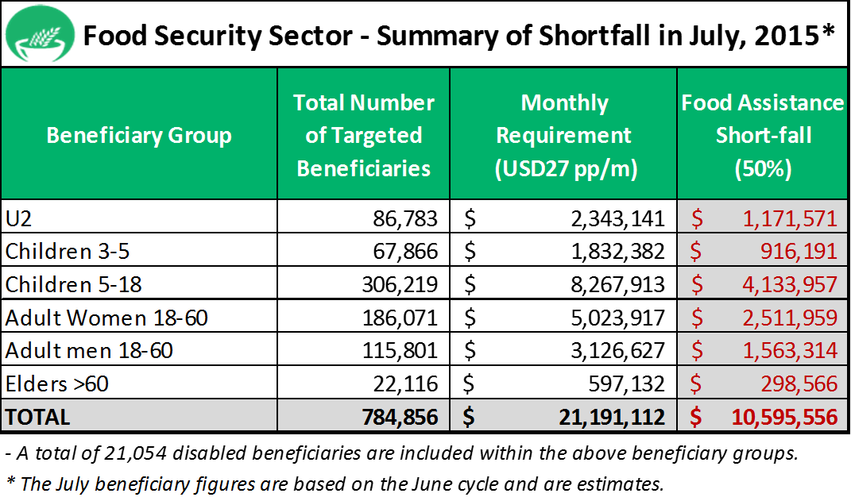
A gap analysis with 50% shortfall in July by population groups was presented. Based on estimated beneficiary figures, and considering the original $27 dollars per day per person to cover minimum food requirements, there is a shortfall of some US$ 10.6 million for food assistance in July.
Working with MoSA, WFP has undertaken a gap analysis factoring in agencies’ contributions towards mitigation of the funding shortfall. However, to date only UNICEF, Lebanese Red Cross (1000 complementary HH food parcels) and IOCC (1000 HH food parcels) have indicated stocks available for top ups of food assistance. It was noted the UNICEF contributions would be appropriate for nutrition interventions (malnutrition or acute malnutrition cases) rather than to top up regular food assistance.

Although the focus is to review the contingency planning matrix, given the timing, WFP will consider the Ramadan food distributions as far as possible. WFP is working with MoSA to coordinate ongoing Ramadan assistance to avoid duplications.

- ROUND TABLE UPDATES ON POTENTIAL CONTRIBUTIONS
Participants shared potential/available resources for topping up food assistance in July:

Save the Children (Lebanese Cash Consortium): The Lebanese Cash Consortium has no resources available for top up of food assistance.
Mercy Corps: No resources available for top up of food assistance.
Concern: No resources available for top up of food assistance.
UNHCR: No resources available for top up of food assistance.
DRC: DRC have limited funding but may be able to assist a small caseload of extremely vulnerable cases.
PU-AMI: Very limited funds available for top up of food assistance.
ACF: No resources available for top up of food assistance, however in case of an emergency situation they can approach their donors. It was suggested that the sector looks into longer term solutions to food security post December
Lebanese Red Cross: 1,000 parcels will be available in July only with no possibility to increase the quantity.
Islamic Relief: No resources available for contingency planning. Islamic Relief is currently focusing on Ramadan with 3,000 food parcels provided to vulnerable families (including Palestinian, Lebanese and Syrians) and 6,000 more parcels to arrive.
MoSA: MoSA is working with the Saudi Embassy on the possibility of supporting Syrian refugees with food parcels for Ramadan. No update available at present.
OCHA/CERF: CERF gave US$4 million to WFP early this year. No more funding will be available. Country Based Pooled Fund (CBPF) proposals are currently being reviewed for innovation and protection windows. OCHA noted that for the CBPF proposal, the food assistance fits in the innovation window and a final decision will be made in the next weeks.
It was suggested to look at increasing voucher values for more vulnerable groups rather than providing 50% of ration to all post August.
WFP noted that they focus on highly and severely households vulnerable to food insecurity. Scenarios are being explored for funding levels under 50% and as such will look more closely at the data already available through the household targeting exercise. Internally WFP is looking at how to address new referrals for food assistance considering the limited funding and as such are preparing SOPs.
WFP: It was suggested to look further at mapping vulnerability to ascertain how we most effectively can use the available assistance identified through this exercise to top up assistance.
Based on the targeting exercise, HH visits and available data, WFP can assist in identifying those that are most vulnerable that should be considered for top up in food assistance. WFP will also work with Sub Offices to help identify severely food insecure families within the group of HHs that have not already been assessed through HH visits.
It will also be considered to reach those not already receiving other complementary forms of assistance, who are likely to feel the 50% reduction even more.
WFP will continue to reach out, at central level and through WFP sub offices, to organizations working within food security to see if further possibilities exist for topping up food assistance.

Overall comments: It was suggested to consider the possibility of approaching the private sector or institutions. MoSA confirmed that although this is not done at present, it is something which should be looked into. WFP added that WFP headquarters and regional bureau are mobilizing funds from all possible entities including private sector partners.
ACTION POINT: FSS WG to look into the possibility of linking up with private sectors for possible funding.

- WAY FORWARD / ROAD MAP

General Comments:
In terms of advocacy, it was suggested that a reduction in direct assistance should be compensated by livelihood activities for example, in a labor intensive sector such as agriculture. MoSA noted that in terms of concrete actions, this is something to do with Livelihood Working Group. An inter-ministerial committee is currently finalizing a document outlining procedures and conditions for livelihoods interventions in Lebanon.

Given the lack of assistance available for gap filling compared to December, 2014, the possibility of a large scale media campaign was mentioned. It was confirmed that communication on the US$13.5 (mobile message) will go out next week and an information campaign will be done including posters and Q&A. There is a need to communicate with a wider range of the public.

Beneficiary Figures:
It was confirmed, that even as the beneficiary numbers are reduced through the household targeting exercise, the food security sector will still be facing a funding shortfall due to overall reduced funding.

NEXT STEPS:
Targeting Top Up Assistance
Based on the targeting exercise, HH visits and available data, WFP will assist in identifying those that are most vulnerable that should be considered for top up in food assistance. WFP will also work with Sub Offices to help identify severely food insecure families within the group of HHs that have not already been assessed through HH visits.
ACTION POINT: WFP to follow up.

Sub-Regional Level:
MoSA highlighted the importance of mapping out all NGOs on the ground, reaching out through sub-regional interagency meetings etc. Although these small charities may have limited capacity to fill food assistance gaps, extremely vulnerable individuals identified in their specific areas could potentially be refered to them.
ACTION POINT: MoSA and FSS WG will work together to engage local level NGOs and to reach out through sub-regional Inter Agency meetings etc.

Private Sector
Regarding fundraising from private sector, WFP can follow up with its regional bureau but the working group members are also encouraged to link up with private sector actors.
ACTION POINT: FSS WG to look into options of members working with private sector in coming months.

Summary Paper
Based on the inputs on agencies’ possible contributions towards mitigation of the funding shortfall and the discussions in the contingency planning task force meeting, FSS WG and MoSA will work to prepare a brief document highlighting the key gaps and the impacts of the reduction of food assistance.
ACTION POINT: FSS WG/MoSA to prepare brief document.

There were no AOBs.

FOOD SECURITY SECTOR WORKING GROUP – CONTINGENCY PLANNING CONTACTS:

Line Teilmann Rindebaek
WFP Coordinator - Food Security Sector Working Group
line.rindebaek@wfp.org

Abdul-Majid Rafihi
MoSA Contingency Planning Adviser
majid.rafihi@gmail.com

These figures are estimates only based on available information on June caseload figures and used to indicate rough estimate of projected shortfall in July. Please note that safety net cases are excluded from this table.

