
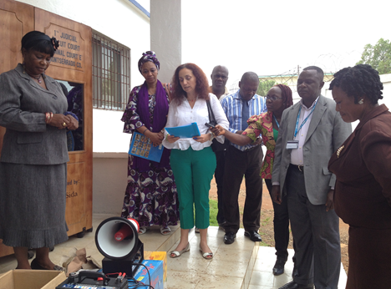

Deputy Representative and Senior Protection Officer of UNHCR handed over megaphones and batteries to be used in the trial of the sexual offences to SGBV Crimes Unit. The Judge of the Criminal Court E also attended the ceremony.

UNHCR LIBERIA
PROTECTION SITUATION REPORT
Covering the period: May 01-31 2014

EXECUTIVE SUMMARY:
Following an attack on Fété, Côte d’Ivoire on 15 May 2014 and subsequent fighting between the Ivorian Government Forces and unknown men, the Ivorian authorities have requested the UNHCR Liberia to immediately suspend all voluntary repatriation activities. UNHCR has canceled three planned convoys from both Nimba and Maryland Counties, affecting nearly 1,000 refugees ready to repatriate. Prior to the incident, the Ivorian authorities lifted the suspension on the voluntary repatriation as of 9 May 2014, but UNHCR and its partners had been working to comply with the new health formalities proposed by the Ivorian government – yellow fever vaccine before resuming the voluntary repatriation. UNHCR and LRRRC confirmed with the local authorities a small influx of about 50 people who have arrived in Worthy, a bordering community in River Gee Country but have self-relocated to Kronoken due to security reasons. The recent intention survey on voluntary repatriation in Grand Gedeh indicates that 903 individuals/350 households from both PTP refugee camp and communities are willing to repatriate. A meeting of the Tripartite Technical Committee was held in Zwedru from 7 to 8 May 2014 to review measures to accelerate voluntary repatriation of the Ivorian refugees in Liberia. The members of the committee were the UNHCR Côte d’Ivoire and Liberia and its Government counterparts; SAARA (Service d'Aide et Assistance aux Refugies et Apatrides) and LRRRC (Liberia Refugee Repatriation and Resettlement Commission). The Asylum Committee convened its first sitting for the year and adjudicated 3 asylum cases and granted refugee status for 3 Syrian nationals.
- Persons of Concern/ Registration
Liberia is currently hosting 44,175 refugees, asylum seekers, and other persons of concern. The Ivorian refugee population slightly increased by 85 individuals from 42,026 at the end of April 2014 to 42,111 at the end of May 2014. The breakdown of the Ivorian population by locations is as below:
County | Population | Location | Population
Nimba | 7,659 | Bahn Refugee Camp | 7,207
Nimba | 7,659 | Communities | 452
Grand Gedeh | 20,351 | PTP Refugee Camp | 15,424
Grand Gedeh | 20,351 | Communities | 4,927
River Gee | 1,719 | Communities | 1,719
Maryland | 11,795 | Little Wlebo Refugee Camp | 10,152
Maryland | 11,795 | Communities | 1,643
Montserrado | 587 | Communities | 587
Grand Total |  |  | 42,111

- Refugee Status Determination (RSD)
The Asylum Committee held its first sitting of the year to adjudicate five (5) asylum cases on 23 May 2014. Two (2) Syrian asylum-seekers were granted refugee status while the decision on the three Pakistani cases was put on hold pending further country of origin information. The committee comprises LRRRC, Ministry of Foreign Affairs, Ministry of Internal Affairs, and Ministry of Justice. UNHCR is granted an observer status.

- Access to Asylum/Border Monitoring
UNHCR FO Saclepea and LRRRC conducted a joint border monitoring mission to the Buutuo from 19th to 21st May 2014, in Gborplay and Lougatuo axis of Nimba County. The purpose of the mission was to assess security situation in these locations bordering western Côte d’Ivoire and to gather information on possible new arrivals in the wake of the recent skirmishes in Fété, Côte d’Ivoire. The team visited Buutuo, Behweley, Dubuzon, Kelay, Kparblee, Blemieplay and Lougatuo and held discussions with the statutory Superintendent of Zoe Geh District, BIN Officers, Town Chiefs, LRRRC monitors, ordinary citizens and the GHANBATT-19 Commander. The general security situation in all locations visited was reported calm and stable. And there were no reports of new arrivals. Liberians and Ivorian citizens continue to commute across the Liberian – Ivorian border to conduct normal business without hindrance. The only exception was in Blemieplay where the Town Chief informed the mission that Ivorian security forces had sealed up the border out of fear of the spillover of the Ebola virus from Liberia. He said the border had been closed for almost two months, hence denying residences of Blemieplay access to basic commodities from the neighboring Ivorian markets.
Sub-Office Zwedru conducted border monitoring mission to five borders at the Liberia - Ivorian borders in Tempo, B’hai, Barti-jan and Bentley respectively. Immigration officials posted at the border crossing points reported no new influx as the result of the recent reported attack in Côte d’Ivoire. Instead, they reported refugees that have crossed the borders to Côte d’Ivoire. The Immigration officials provided a list of eleven (11) Ivorian refugees and UNHCR verified same with seven out of the eleven refugees being active refugees residing at the PTP camp. The refugees who are currently residing at the PTP camp will be meeting UNHCR and LRRRC to request clarity on their departure.

50 Ivoirians who fled from Fete to Worty, a border community in River Gee County have self-relocated to Kronoken. UNHCR will conduct protection screening for the newly arrived asylum seekers.

- Protection Highlights (Achievements and Challenges)
Tripartite Technical Committee held in Zwedru: A meeting of the Tripartite Technical Committee was held in Zwedru from 7 to 8 May 2014. The members of the committee are UNHCR Liberia and Côte d’Ivoire and its Government counterparts SAARA and LRRRC. The focus of the meeting was to develop special measures for the accelerated voluntary repatriation of Ivorian refugees hosted in Liberia. The Ivorian team also took the opportunity during the mission to visit PTP refugee camp, where a meeting with a cross-section of refugees was held.

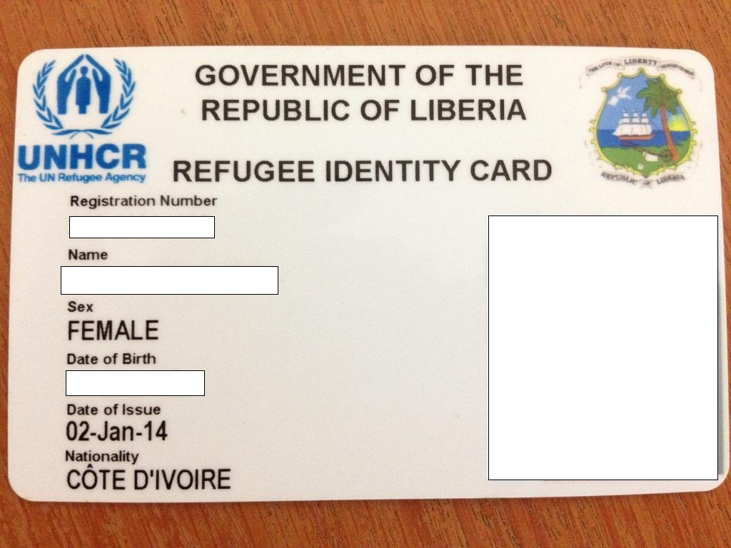
Issuance of Refugee ID cards started in Bahn Refugee Camp in Nimba County: In the 4th week of May 2014, issuance of refugee identity cards began in Bahn Refugee camp. The distribution is going on simultaneously with the updating of refugee names in the UNHCR data base and the registration of newborn babies.
Level III verification conducted for refugees registered in Little Wlebo Refugee Camp Maryland County: UNHCR Field Office Harper (FOH) jointly with LRRRC commenced the Level III verification exercise for the Ivorian refugees registered in Little Wlebo refugee camp on 19 April 2014 to update refugee bio-data information and to capture new births. The verified refugees were provided with new ration cards. The refugee ID cards are also being processed for distribution upon completion of the verification exercise.
A sample of the refugee ID card
SGBV GoL/UN Joint Program: On 30 May 2014, UNHCR Liberia, represented by the Deputy Representative, Ioli Kimyaci has donated 30 sets of megaphones, 30 pieces of 20 amps batteries and 30 packs of alkaline batteries worth $10,473 to the Judiciary. The items are to enhance audibility of the victims and witnesses testifying behind the screen during the trial of sexual offences. As most of the courts run without electricity, the different types of batteries will ensure the smooth court hearings.
A special partition, so called a mobile-in-camera screen, which is made of woods with wheels for mobility was launched in December 2012 in the Criminal Court E, the Temple of Justice with the support from UNDP through the Government and UN SGBV Joint Program. The introduction of the screens was to facilitate the holding of the trials of sexual offences in camera as is stipulated by the New Rape law. The screen is designed to fit within the courtroom for the purpose of providing shield to victims and witnesses testifying during trial of sexual offences. The mobile in-camera screens for 15 counties were further procured by UNDP and handed over to the Judiciary. All the circuit courts are now equipped with the mobile in-camera screens, enabling protection of the identity of the victims and the witnesses during testimonies. Training Modules and Posters on steps to use the mobile in-camera screens were also developed with the support from UNDP.
The SGBV Crimes Unit also signed a Memorandum of Understanding with ten (10) attorneys who are going to carry out the training on the use of mobile in-camera screens in sixteen (16) Circuit Courts in 15 Counties to ensure the consistent use of the screens during the trials. UNHCR is a participating agency to the Government and UN SGBV Joint Program funded by SIDA to support the implementation of the national SGBV Action Plan and the donation of the items and the training were all made possible under this program.

- Protection Monitoring
- Monitoring of Detention Centers
UNHCR BO Monrovia visited the Monrovia Central Prison on 8 May 2013 to monitor the conditions of nine (9) Ivorian refugees awaiting outcome of their extradition case which is pending at the Supreme Court of Liberia. All nine (9) were seen and spoken to. UNHCR provided each refugee with assorted food items (farina, garie, garlics, salt, pepper, oil, Maggi cubes, and sugar) to supplement the food provided by the prison authorities and non-food items (slippers, tooth paste, medicated soap and laundry soap). The refugees expressed profound gratitude to UNHCR for the continuous concern and support provided to them and as usual wanted to know where their case stands. Seven (7) of them were arrested in 2012 on charges including mercenary, arson, murder, rape, etc. and two (2) were in 2013 without any charges. The Government of Liberia has been pressing for their extradition to Côte d’Ivoire, but UNHCR hired lawyers and other human rights lawyers have challenged in court the government's petition for extradition.
- Protection of Refugee Children
Save the Children International (SCI) conducted a two-day capacity building workshop for Child Friendly Spaces (CFSs) facilitators, CWC and children club members in Bahn Refugee Camp. The workshop was attended by eight (8) CFSs facilitators (male 6, female 2), three (3) CWC members (male 2, female 1) and four (4) members of the children club (boys 2, girls 2). The objective of the training was to increase participant’s awareness of the psychosocial support aspects of child friendly spaces.
CFSs in Bahn refugee camp have a total of 2,155 (boys 1,243, girls 912) children who are registered at the CFSs, while a total of 1,724 (boys 947 and girls 777) children took part in the structured recreational activities. There have been increases in the number of children attending activities at the CFSs due to the involvement of the Children club of Bahn Refugee Camp who are visiting the communities and encouraging parents to allow their children to participate in activities at the CFSs. These are some of the activities held at the CFSs during the past two weeks; Brain Gym, Action song, Touch, Ludo, checker, Monopoly, Jumping rope, Lego bricks, group discussion on the UNCRC and Heat contract. The life skills session for children in and out of school continued for eight weeks with the total of 85 children participating in the sessions.
UNHCR Field-Office Saclepea convened a Best Interests Determination (BID) panel to determine the best interests of two (2) unaccompanied minors.
- Prevention of and Response to SGBV (Sexual and Gender-Based Violence)
82 SGBV cases were reported during the month of May 2014. All of the survivors were female and cases occurred in the country of asylum. Of 82 cases, 3 cases were rape and all the survivors were minors. The most pervasive form of violence was denial of resources (32.9%), followed by physical assault (30.5%) and psychological/emotional abuse (26.0%). All cases are reported to have occurred in the country of asylum.
Monthly Statistics of numbers of reported SGBV cases
01January –31 May 2014

 | Jan | Feb | Mar | April | May | Total
Rape | 4 (2)* | 3(1) | 2(1) | 3(3) | 3(3) | 15 (10)
Sexual Assault | 2 | 4(2) | 2(1) | 3(1) | 1(1) | 12(5)
FGM | 0 | 0 | 0 | 0 | 0 | 0
Physical Assault | 21 | 25(1) | 26 | 40(1) | 26(0) | 138(2)
Forced Marriage | 1 | 4 | 2 | 1 | 0 | 8
Denial of Resources | 30 | 21 | 24 | 30 | 27 | 132
Psychological/Emotional Abuse | 31 | 20 | 27 | 27 | 25 | 130
Survival Sex/Sexual Exploitation | 0 | 0 | 0 | 0 | 0 | 0
Human Trafficking | 0 | 0 | 0 | 0 | 0 | 0
Total | 89 | 77 | 83 | 104 | 82 | 435(17)

All cases were reportedly occurred in the country of asylum. Sex of the survivors was 100% female.
* Numbers in ( ) indicates cases under 18 years old within the total reported cases.

- Durable Solutions
Voluntary Repatriation of Ivorian refugees: While there was no return facilitated in this month, a “Go and See” mission comprising twelve (12) refugees with two UNHCR staff and 2 LRRRC Officials went to Côte d’Ivoire from 12-19 May 2014. The team visited Toulepleu, Doukoue, Blolequin and Guiglo and observed that the disarmament, demobilization and reintegration process has progressed and demobilized ex-combatants had access to several rehabilitation programmes; and some are now employed in the government structures. Under the Rule of Law, there are structures in place to handle and retrieve all illegal sales of land and properties. With these developments, the refugees were encouraged to return and contribute to the peacebuilding and development of their country. The delegation has submitted a comprehensive report on the “Go and See” mission to LRRRC and UNHCR and also held briefing sessions with the entire population on the outcome of the mission.

- Access to Education
Preparation for the end of the academic year exam at primary and secondary level: In absence of a favorable response from the Ivorian education authorities to administer national exams for refugee students studying in Ivorian curriculum in Liberia, UNHCR and its partners are preparing for equivalent exams to record the educational attainment of the refugee students. Exam dates are agreed as follows:

- CEPE (end of primary school exams): 25 June 2014
- BEPC (end of lower high school exams): 9-11 July 2014
- Baccalauréate (end of high school exams): 15-17 July 2014

Currently, the numbers of eligible students for exams stand as follows:

Type of exams | Refugee Camp | Male | Female | Total
CEPC | PTP | 79 | 40 | 119
CEPC | Bahn | 16 | 11 | 27
CEPC | Little Wleblo | 26 | 12 | 38
CEPC | Sub-total | 121 | 63 | 184
BEPC | Bahn | 32 | 13 | 45
BEPC | PTP | 32 | 11 | 43
BEPC | Little Wleblo | 26 | 12 | 38
BEPC | Sub-total | 90 | 36 | 126
Baccalauréate | Bahn | 9 | 8 | 17
Baccalauréate | PTP | 4 | 12 | 16
Baccalauréate | Sub-total | 13 | 20 | 33

On Monday, 26 May 2014, the final pre-test was conducted for the 6th and 9th grade students of the primary and the secondary schools respectively in Little Wlebo Camp. The pre-test will help to assess the level of preparedness of the students ahead of the final examinations to be conducted by the Ministry of Education, UNHCR and Partners on 25 June 2014.
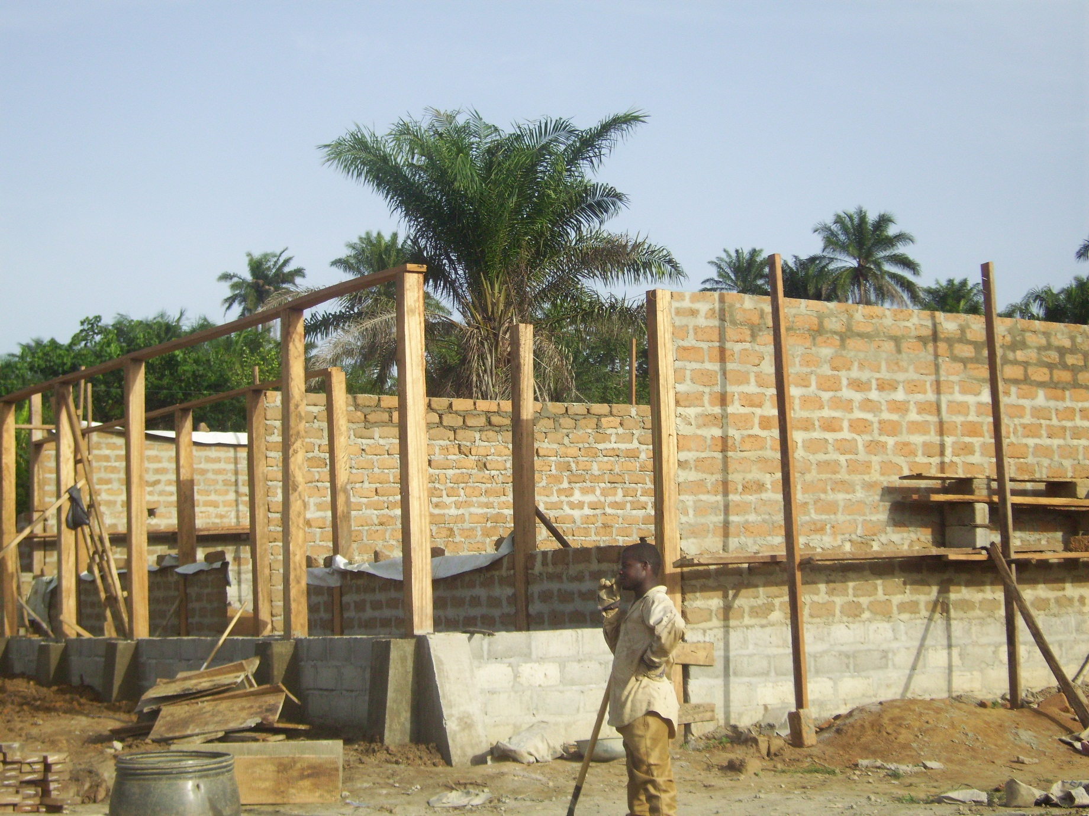
School construction in refugee hosting communities: The UNHCR Programme Unit continued the monitoring of the on-going school construction projects in Bahn hosting community and Karnplay. In Karnplay, the local mobilization of materials is going too slow due to the low capacity of the community members. As for Bahn, the project is progressing as planned with the available materials while awaiting the senior management to approve for the additional materials.
School building under construction in Bahn City COunty

Tertiary education - DAFI scholarship program: UNHCR, in collaboration with SEARCH Education Officer engaged with the major public tertiary institutions (University of Liberia, Tubman University, Grand Gedeh and Nimba Community College) to negotiate the program favorable to refugee students. UNHCR intends to sign letters of understanding with each institution.
Two (2) out of seven (7) students who sat the entrance exams in Maryland on 5 April passed. The language barrier is definitely a high hurdle and the students appealed to UNHCR to organize English classes in the refugee camps so as to get prepared for the entrance exams next year. In Harper, three (3) students have been qualified for the college program at the TU.
Against the all positive progress made, UNHCR Liberia is unlikely to be able to enroll deserving new students under the DAFI Scholarship Program for the academic year 2014-2015; the Program would only be able to support the continuing students due to a funding shortfall at a global level.

- Livelihood/Self-reliance
ADRA completed 15 backyard gardens for beneficiaries marking the total of 25 backyard gardens. This activity continues as all beneficiaries must have at least one backyard garden in the Bahn refugee camp.

ADRA received some training materials from the International Rescue Committee (IRC) for the livelihood program. The tools were turned over in the presence of LRRRC. ADRA has also completed the cleaning of the training center formerly used by IRC in Bahn refugee camp, which is considered as an alternative center for livelihood training for refugees.

On 22nd ADRA visited the proposed land (about 10 hectars) in Bahn refugee camp to be used for agriculture which is partially being used by the refugees but still there is enough land to be used. The land site visit was part of the recommendation from the BO (Supply & Project control) verification mission.

Interview and selection of vocational skills beneficiaries was conducted in Bahn refugee camp. A total of 483 names were shortlisted for interview out of which 207 persons have been interviewed.

ADRA received 15 applications for the post of trainers and interview was conducted for with 6 of the applicants that were present in the area of computer, catering and carpentry.

One hundred women, mostly survivors of violence are benefitting from livelihood activities in pastry and soap making in PTP refugee Camp as means of empowering them to meet their basic needs.
ADRA had identified 70 refugees to benefit from the agriculture project in PTP refugee camp.

- Invocation of Cessation Clauses for Liberian Refugees
UNHCR Liberia continued to work with the Liberian authorities to accelerate the issuance of remaining Liberian ECOWAS passports for the former refugees who opted for local integration in their countries of asylum. It is good to mention that we attained 83% of the implementation of the project with the distribution totally completed for the beneficiaries in 6 of the asylum countries. During this reporting period, The Ministry of Foreign Affairs (MFA) has issued more passports 1,552 to UNHCR out of which 869 have been verified by LRRRC and UNHCR had delivered to Ghana for further distribution. 1,313 passports are pending issuance.
 | TOTAL
TOTAL applications received by UNHCR Liberia from Asylum Countries | 8,995
Applications submitted directly to GoL during vetting missions | 1,557
TOTAL applications submitted to GoL | 10,552
No-Show during the vetting missions | (1,946)
Rejected (Red-Coded) applicants | (910)
Total number of approved passport applicants | 7,696
Applicants who had existing passports (No new passports issued) | (131)
Total number of passports to be issued | 7,565
Number of passports issued by GoL to UNHCR Liberia | (6,252)
Number of passports returned to GOL from UNHCR (Re-Issuance) | 52
Number of passports delivered to UNHCR Offices in the region | 5,512
Number of passports to be issued by GoL | 1,313
% of Passports issued | 83
% of Passports to be issued by GoL | 17

Compilation/ Protection Reports from:
SO Zwedru/FO Salepea & Harper/ /BO Monrovia
UNHCR Liberia

Garie is a cereal-type cassava product that is consumed widely throughout Liberia. It is very easy to prepare and can be prepared in many different ways.

