Shelter + NFI Sector WG: Athens Hub
Date: | 22 June 2016
Participants: | Danish Refugee Council (DRC), Hellenic Red Cross, International Federation of the Red Cross (IFRC), International Organisation for Migration (IOM), International Rescue Committee (IRC), Samaritan’s Purse (SP), UNHCR
Chair: | Phoebe Goodwin (goodwin@unhcr.org), UNHCR
Agenda | 1. Validation of 10 June Meeting Minutes  2. 4Ws – Who Does What Where and Why.  3. Transitional Shelter and ‘quick fix’ summerisation ideas  4. Short presentation of proposed ActivityINFO indicators.  5. News and gaps from the field.  6. AOB.
Key | CWC = Communication with Communities. CWG = Cash Working Group. PoC = people of concern (refugees + asylum seekers + migrants).  SMS = Site Management Support. ToR = Terms of Reference.
Agenda item | Discussions | Action points
4Ws – Who Does What Where and Why | IRC:  Blanket distributions of hygiene kits (plus other WASH NFI items such as cleaning/laundry supplies) in the following sites where they are operational: Schisto, Alexandria, Cherso, Diavata + Giannitsa.  IRC are currently doing cash distributions in Eleonas (plus will stock the kiosk with hygiene kits) and are using the hygiene kiosk in Lesvos.  Samaritan’s Purse:  Piloted a shade structure design at Skaramagas (see Annex below for photos) which will be implemented across whole site and completed by 8 July. SP is planning to provide shelter shading solutions at Schisto too.  Hellenic Red Cross + IFRC:  Planning to cover food needs of up to 3500 families (approx. 17000 people) in up to 6 sites in mainland with stoves for communal cooking facilities, distributions of monthly dried food parcels for 6 months + complementary cash distributions to enable PoC to buy their own fresh foods. These sites are Skaramagas, Ritsona, Nea Kavala, Cherso, Diavata & Kordelio-Softex. All of these sites (except Nea Kavala) will receive NFI support.  IOM:  Completed the following activities to date:  - Flooring for rub-hall in Ritsona  - Flooring for two small rub-halls in Oinofyta  - 14 fire protection points for Ritsona and Oinofyta (containing various types of fire extinguishers x 28)  - 100m of industrial shelves in Oinofyta’s warehouse  Planned to complete the following by 1 July:  - Setup of playground (with shading) for Ritsona & Malakasa sites  - Preparation for installation of fencing, entry & exit points and emergency gates for Ritsona  - Roofing for dining area in Oinofyta.  - Sanitary containers for Ritsona + Oinofyta (9 Toilet/WC containers, 3 Toilet/WC for vulnerable people, 2 shower containers).  22 000 hygiene kits are still expected to be distributed in first half of July to all PoC within Ritsona, Oinofyta, Malakasa, Katsika Ioanninon, Derveni + Kalohori Supermarket. IOM may consider a replenishment of needed items in August.  Each kit will include the following items: (ratio of 1 kit per person)  - 1 set face/body towel - 3 bars of soap  - 1 x Shampoo - 1 x Toothbrush  - 1 x Antibacterial Gel - 1 x Toothpaste Tube  - 4 x Wet Wipes Pocket Size - 2 x Dry Wipes Pocket Tissues  - 2 x Mosquito Repellent Spray - 2 x Sunscreen Cream/Spray Protector 40+ | Share IRC’s kit contents with WG members.  ACTIONED: See excel attached with minutes.  WG Chair to ask IOM if possible to share more details on fire protection points in Ritsona + Oinofyta.
Transitional Shelter and ‘quick fix’ summerisation ideas | PPT Presentation given by WG Chair including the following:  - preliminary/conceptual design research by UNHCR Technical Unit for transitional shelter solutions  - DRC’s shade pilot in Elliniko + schematic revised design which will be implemented for Elliniko III + Lagadikia.  - SP’s shade pilot in Skaramagas (same photos as annexed in this document).  Humanihut © Shelter System animation:  https://www.youtube.com/watch?v=VBz-zPCNZ18&feature=youtu.be  http://premiershippingcontainers.com.au/shipping-container-muvbox-to-restaurant-in-under-2-minutes.html  Second-hand caravans in Greece as potential transitional shelter solutions?  Small models can cost around 500 Euros each, while caravans at approx. 9m in length would be 1200 Euros.  Samaritan’s Purse approached KMS Buildings A.E for container quotations of shelter options, including an isobox as a communal kitchen.  Discussion consensus: promote the sharing of details for local vendors/suppliers in NFI and shelter materials/items amongst WG members to save time with procurement processes. | A Temporary Technical Task Force (of the SAG) will meet on 29 June to produce a draft catalogue of shading solutions for all shelters/communal structures in Greek PoC accommodation sites as a WG reference document for all implementing agencies to abide by with respect to minimum, harmonised standards. This draft reference will then be disseminated to all WG members for their welcomed inputs.  WG Chair to disseminate KMS documents to all members.  ACTIONED: See pdfs attached in email with minutes.  WG members to send details of local vendors/suppliers to goodwin@unhcr.org to achieve webpage uploading.
Short presentation of ActivityINFO indicators. | Meeting participants requested recirculation of draft indicators for final opportunity for additional inputs/comments.  The wording of Indicator 5.1.1 was readjusted to allow for more flexibility in scope of assistance/response; “transferred to” was replaced by “who receive”.
News and gaps from the field | IRC:  As part of IRC’s emergency response preparedness, they have ordered a stock of 1000 hygiene kits and cleaning supplies to store in their Athens warehouse. IRC will inform WG when supplies arrive.  Because Schisto banned shaving cream and disposable razors, IRC has a large supply of these items available for interested agencies to take and distribute where needed, as well as surplus jerry cans.  Hellenic Red Cross + IFRC:  Emergency response preparedness stock of NFIs in Chios.  Thermopiles Site – request for baby milk/formula.  IFRC policy prevents such distributions – prior experience has shown difficulty to ensure formula is mixed correctly before given to infants. Breastfeeding is always more desirable solution – better nutrition for baby and more practical.  However, in some regions of Syria, breastfeeding is perceived as a sign of poverty. | If other organisations need any of IRC’s stock items please contact natasha.sim@rescue.org. If gaps remain in terms of needs, agencies are encouraged to contact IRC who has capacity to order and store additional different hygiene/cleaning items.  WG Chair to enquire which organisations (if any – depending on stance for such a product) could address the gap of baby milk/formula?
AOB | LIST OF MEETING’S ACTION POINTS ALREADY ACTIONED WITHIN EMAIL from 28 JUNE:  (all files will be uploaded on Shelter + NFI Sector webpage - http://data.unhcr.org/mediterranean/working_group.php?Page=Country&LocationId=83&Id=7 )  1. Recirculation of WG documents in progress for much-needed comments/inputs;  - zipped communal kitchens strategy file  - ActivityINFO indicators with slight amendments post-22 June meeting  - Current draft ToR of WG.  2. Disseminate IRC’s work to date on fire safety in Lesvos and the mainland.  3. Share the results of the initial urban strategy meeting (held on 23 June at Caritas’ office and chaired by CRS). | NB: For the communal kitchens excel matrix – if your organisation has the capacity and is willing to implement such a project in one of the sites, please fill out and send back to goodwin@unhcr.org asap.
The next Athens Hub operational coordination meeting will be held on Thursday 07th July at 14:00.
Venue = UNHCR Branch Office; Michalokopoulou 91, Athens.
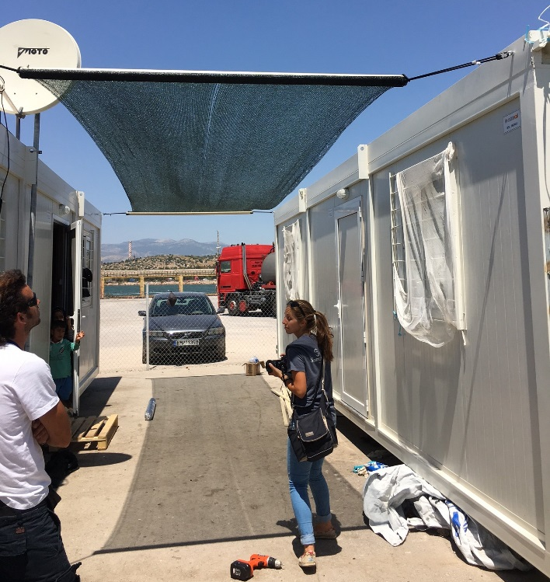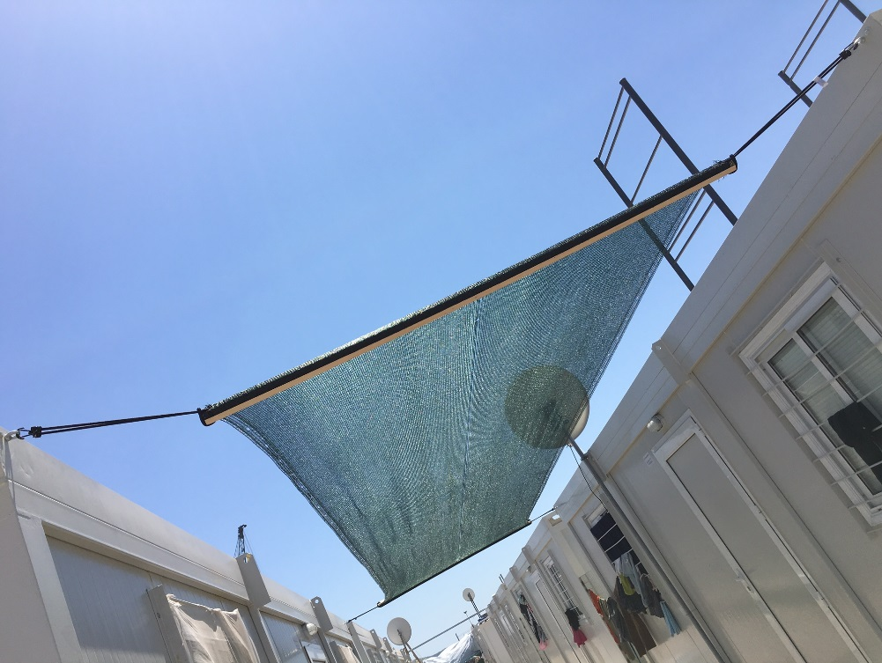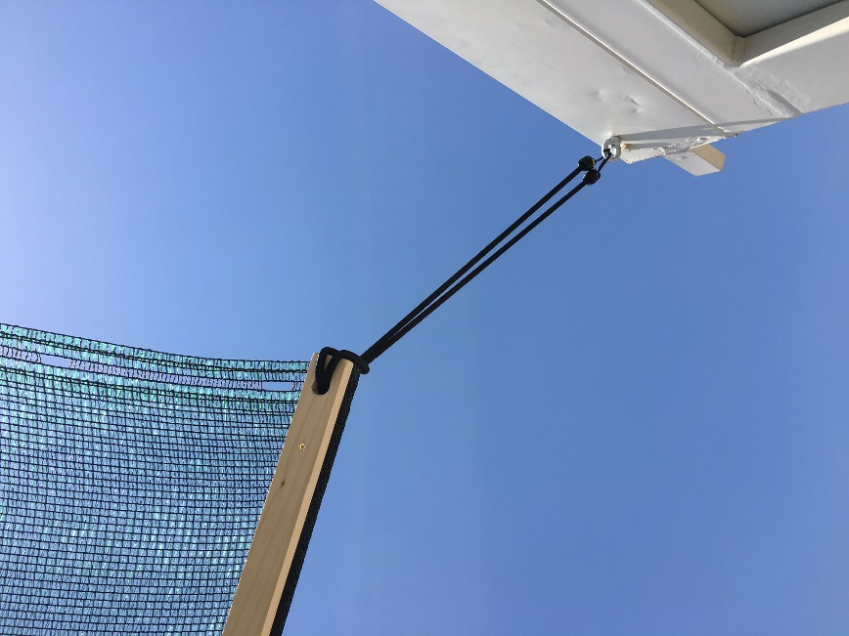
ANNEX:
Samaritan’s Purse pilot shade design in Skaramagas Port site.

