RESPONSE MONITORING TASK FORCE – MEETING 3
Minutes | November 22, 2018 | 15:00-16:00 | CONFERENCE ROOM

Meeting called by | BO HURKMANS – IM TEAM LEADER
Type of meeting | COORDINATION
Facilitator | BO HURKMANS
Note taker | HILLARY MUMBERE
Attendees | BO HURKMANS (UNHCR), HILLARY MUMBERE (UNHCR), DAMJAN NIKOLOVSKI (UNHCR), JOHN BERNARD (ARC), REBECKA RYDBERG (REACH)

Agenda topics, Introduction, Review of action points from last meeting / task force work plan, Review of progress on indicators and standardising activities, Review of standard procedure for reporting, AOB

discussion
- Review of action points from last meeting / task force work plan
  - Platform identification to be validated at regional meeting in Nairobi on 10-11 December, as a result ActivityInfo might be used in other RRRP countries too.
  - Dashboard templates can be produced with REACH support up to end of December (due to length of PPA).
  - Reporting process and monitoring framework should be validated by mid-January for those sectors that will report activities on a monthly basis (i.e. start using the platform in February).

- Review of indicators and standardising activities
  - Meetings have been held so far with Shelter, Settlement and NFI, Environment and Energy, Livelihoods, Education, Protection and Food Assistance.
  - Meetings are still outstanding for Health and WASH.
  - A monitoring framework that pulls together RRP objectives, indicators, targets and links them to sector activities was presented for feedback and will be shared along with the minutes.

- Review of standard procedure for reporting
  - There was a need to compress the timeline for reporting and to differentiate between RRP reporting and activity reporting, a revised procedure has therefore been developed.

Timeline:
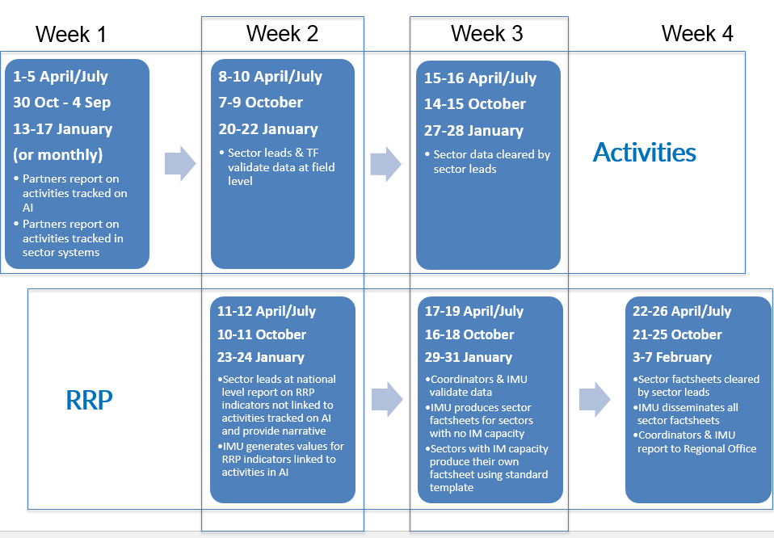

Roles and responsibilities for activity reporting:
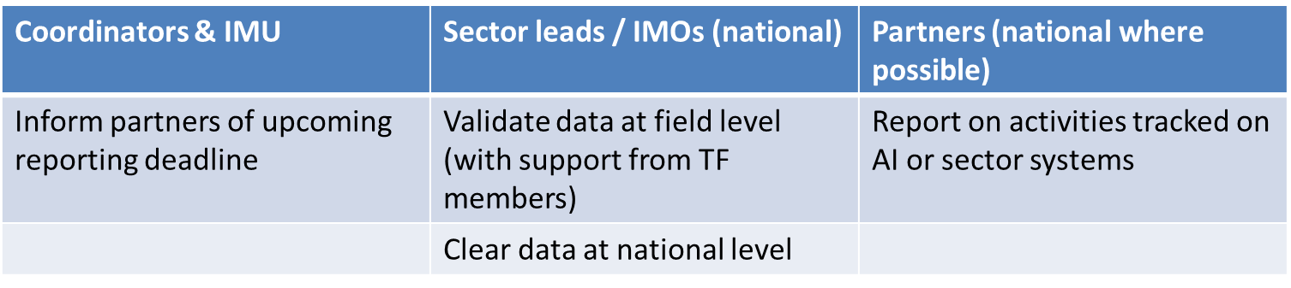

Roles and responsibilities for RRP reporting:
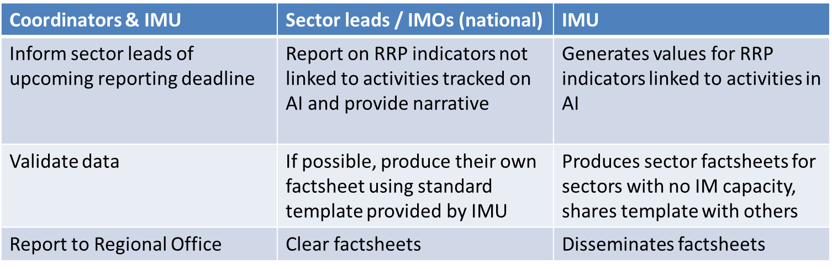
- AOB
  - Next meeting will be on 6th Dec (3 – 4pm)
Action items |  | responsible | Deadline
Reach out to colleagues in UBOS, NPA and UNDP |  | BO | EoY

