Syria crisis field diary (24 July 2012) (192 wds)
I love being able to make a difference for children
Ruba Mukbel
Field Monitor, UNICEF Jordan
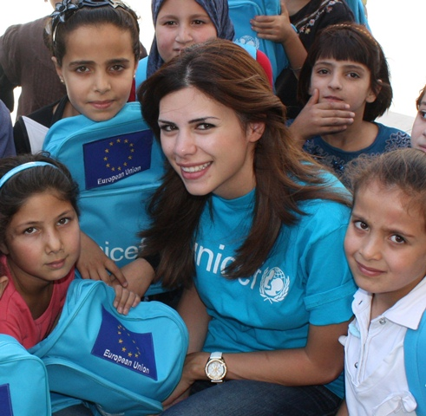
I visited Damascus two years ago and feel really sad about what is happening. Thousands of children and families are crossing into Jordan to escape the violence.
UNICEF is working with the Government of Jordan and partners to provide support in areas like child protection and education, as well as safe water, sanitation and hygiene. My role is to ensure that UNICEF assistance is being implemented effectively and efficiently.
During a monitoring visit to a UNICEF-supported summer camp in Jordan recently, I spoke to the mother of 13-year-old Enas*. The family fled from Syria after two of Enas’ brothers were killed. Her father was shot and is now paralysed.
UNICEF Jordan field monitor Ruba Mukbel shares a moment with Syrian refugee children in Ramtha, northern Jordan, who have just been issued with UNICEF schoolbags. Photo courtesy of Save the Children/Elkhairy
Enas has really been affected by these events, but her mum says that the summer camp is helping Enas to be less isolated and to make new friends. At the camp – which is one of 39 in schools around Jordan – children receive remedial education and take part in recreational activities.
What I love most about my job is being able to make a positive difference for children like Enas. It’s really inspiring to be able to see real change taking place.
*Name changed to protect identity

