This Briefing Kit is intended to provide basic information on coordination structures and processes for newly arriving partners and their staff. In most cases, more detailed information is available by following the links provided. This Kit is limited in scope to inter-agency coordination within the refugee response. It does not cover the Government’s procedures and structures, beyond its leadership in the response.
To keep the Kit useful and relevant for its target audience, your comments and suggestions are appreciated and should be sent to Yukiko Koyama, koyama@unhcr.org.
The Kit is updated every six months. More detailed and updated information is available online, including through http://data.unhcr.org/syrianrefugees/country.php?id=107

- Introduction
What is the Refugee Response in Jordan?
Under the leadership of the Government of Jordan and coordinated by UNHCR, the refugee response is a collaborative effort between the donor community, UN agencies, international and national NGOs, community-based organizations, refugees and Jordanian communities to address identified needs of refugees in Jordan.
All levels of the Government of Jordan are engaged in the response, from the Office of the Prime Minister, the Ministry of Foreign Affairs, the Ministry of Interior (MoI) and the Ministry of Planning and International Cooperation (MoPIC), to the line ministries working with the sectors, and the governorates and municipalities in the refugee-affected areas. In 2014, the MoI created the Syrian Refugee Affairs Directorate (SRAD), which is the main government entity for coordination of refugee issues in the country.
What is the Jordan Response Plan (JRP)?
At the national level, the main framework and the primary strategic document for the refugee response is the Jordan Response Plan to the Syria Crisis (JRP), led by the MoPIC. In 2014, the Government of Jordan established the Jordan Response Platform for the Syrian Crisis and 11 Task Forces to articulate the JRP for 2015. In 2015, the Platform and the Task Forces led to undertake a comprehensive vulnerability assessment and to prepare the rolling of JRP for 2016 – 2018. The JRP 2016 – 2018 has two pillars: Refugees and Resilience, and it is a call for collective action to better support

Syrian refugees and Jordanian people, communities and institutions, ensuring that critical humanitarian measures and medium-term interventions are properly integrated, sequenced and complemented. The implementation of the Plan is guided by the Jordan Response Platform for the Syria Crisis (JRPSC), under the leadership of the Government of Jordan. For more information please see http://www.jrpsc.org/
What is the Regional Refugee and Resilience Plan (3RP)?
The Regional Refugee and Resilience Plan (3RP) was firstly launched in December 2014. The 3RP brings together plans developed under the leadership of national authorities, namely, the Arab Republic of Egypt, the Republic of Iraq, the Hashemite Kingdom of Jordan, the Lebanese Republic and the Republic of Turkey to ensure protection, humanitarian assistance and strengthen resilience. The 3RP is aligned with existing national plans, including the Jordan Response Plan to the Syria Crisis 2016 – 2018. Therefore, JRP 2016 - 2018 in its entirety is the 3RP country chapter for Jordan, which represents a three-year programme of high priority interventions to enable the Kingdom of Jordan to respond to the effects of the Syria crisis without jeopardizing its development trajectory.
For the collection of partners’ budgets for the inter-agency appeal, you can search at: http://data.unhcr.org/jordan/3rp2016
For Dashboards on inter-agency appeal for 3RP achievements by sector, please visit http://data.unhcr.org/jordan/sectors/

- Main Coordination Mechanisms
The Inter-Agency Task Force (IATF)
The inter-agency refugee response is overseen by the Inter-Agency Task Force (IATF), chaired by the UNHCR Representative. The IATF is composed of heads of humanitarian UN agencies and NGOs who are contributing to the response and acts as a “Steering Committee”. Through the Inter-Sector Working Group (ISWG), the IATF oversees the system of Sector Working Groups and the related strategic, advocacy and funding processes. NGOs’ representatives are elected on to the IATF through the International NGO Forum.
The IATF ensures effective consultation and communication with the Humanitarian Country Team (HCT) and the UN Country Team (UNCT) as well as being in support to JRP.
The UNHCR Representative has the delegated authority and responsibility of the UN High Commissioner for Refugees for the protection of refugees, including the provision of assistance, and the pursuit of durable solutions. In consultation with the Government of Jordan and partners, the UNHCR Representative reports to the Regional Refugee Coordinator and up to the High Commissioner.

The Inter-Sector Working Group (ISWG)
In August 2013, the Inter-Sector Working Group (ISWG) was formed as a forum of the sectors’ chairs aimed at encouraging synergies between sectors, avoiding duplication, and working on common processes. The ISWG is the main bridge between the Sector Working Groups. It meets monthly, with membership of the sectors’ chairs and representatives of the INGO Forum. The ISWG also links the Sectors to the IATF. The main purposes of the ISWG are to:
• Coordinate, identify, process and elevate relevant topics to the IATF, referring to IATF for policy decisions and guidance at the heads of agency level;
• Facilitate the flow of information between Sectors and other fora;
• Optimize complementarity between sectors’ activities, by building on a series of common processes;
• Promote consistency in coordination on standards and capacity between sectors.
• Ensure that the cross-cutting issues, including gender equality programming, are properly reflected in the sector activities.
The ISWG ToRs are available at: http://data.unhcr.org/syrianrefugees/download.php?id=10554
ISWG web-page: http://data.unhcr.org/syrianrefugees/working_group.php?Page=Country&LocationId=107&Id=60

The Jordan INGO Forum
The Jordan INGO Forum (JIF) is a network of 43 international organizations working throughout Jordan. JIF primarily exists to serve the needs of its members and to act in their interest to better serve beneficiaries. JIF’s main objectives are information sharing; coordination; policy development and advocacy; and representation of the INGO community. While JIF focuses much of its efforts on the humanitarian response to the Syrian refugee crisis, JIF members also support other refugees in Jordan, and implement early recovery and developmental programs as well. A number of JIF members also provide support in South Syria.
The coordinator of the Jordan INGO Forum is Sarah Ferris sarah.ferris@jordaningoforum.org

JIF members meet monthly to exchange information and discuss Forum priorities at the Country Director meeting. In addition JIF hosts working
groups (such as Government Liaisons, Human Resources, Cross Border, Livelihoods) that are chaired by JIF members and meet regularly.
JIF is led by a Steering Committee comprised of five Country Directors, as well as a Forum Coordinator. The current Chairperson is Wendy Taeuber from the International Rescue Committee (IRC). JIF is hosted by the Norwegian Refugee Council (NRC), with funding support from World Vision.
In 2015 JIF members implemented over $369 million USD in programs and employed over 3,700 Jordanian staff, 600 Jordanian contractors and 300 Jordanian volunteers, in addition to 345 expatriate staff.
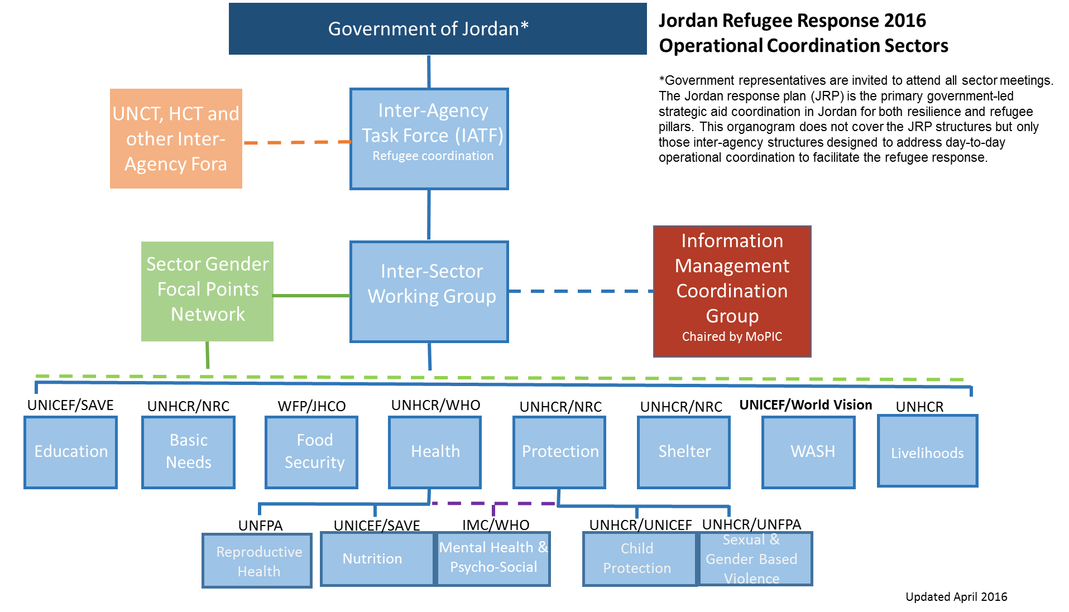

The Sectors
Currently, the eight sectors providing support within the Jordan refugee response are Basic Needs, Livelihoods, Education, Food Security, Health, Protection, Shelter, and Water, Sanitation and Hygiene (WASH). The Protection sector is sub- divided into sub-sectors of SGBV, Child Protection (CP) and Mental Health and Psycho-Social Support (MHPSS), which is also part of the Health Sector. The Health Sector is divided into sub-sectors of MHPSS, Reproductive Health (RH) and Nutrition. The sectors operate through the specific meetings.
A number of multi-sector fora exist at camp level and in urban and rural areas.

The Basic Needs Sector
Chaired by Volker Schimmel, UNHCR Schimmel@unhcr.org, co-chaired by Elias Jourdi, NRC elias.jourdi@nrc.no
Sector page http://data.unhcr.org/syrianrefugees/working_group.php?Page=Country&LocationId=107&Id=71
The Basic Needs Sector brings together partners from camp and non-camp settings working on the delivery of basic needs items, including the monetized assistance. The sector effectively merges the Non-Food Items (NFI) and the Cash Assistance Sectors. The monetized assistance also includes broader unconditional cash interventions addressing the needs of Syrian women, girls, boys and men in the context of Jordan. The main approach of the sector is to support and strengthen the link between emergency assistance and durable solutions in responding to the humanitarian crisis. The sector is maintaining a platform for all partners and stakeholders to coordinate their response through information sharing, developing of the needs based standards and avoiding overlapping of support, providing monitoring of equal access of women, girls, boys and men to assistance.

The Livelihoods Sector
Chaired by Anna Gaunt, UNHCR GAUNTA@unhcr.org
Sector page http://data.unhcr.org/syrianrefugees/working_group.php?Page=Country&LocationId=107&Id=73

The Livelihoods Working Group (LWG) was established in March 2016 under the Inter-Agency Task Force. It was created as a result of the major policy shifts that followed the London Donor Conference; in particular, the Government of Jordan's commitment to provide Syrian refugees with new livelihood opportunities.

The LWG's principal aim is to strengthen coordination of refugee-related livelihoods activities in both urban and camp settings. It brings together different UN agencies, national and international NGOs, donors, and government actors to ensure comprehensive and continuous information sharing between all parties. The LWG will also be used as a forum for discussing upcoming livelihood projects and devising a coherent approach to livelihood programming in Jordan.

The Education Sector
Chaired by Farrukh Mirza, UNICEF fmirza@unicef.org,
Sector page http://data.unhcr.org/syrianrefugees/working_group.php?Page=Country&LocationId=107&Id=14
The Syrian children are enrolling in public schools across Jordan. A key sector priority for 2016, is to ensure uninterrupted access to public education for the displaced Syrians children in the country, including those in the refugee camps along with non-formal and Informal education. Support to boost the capacity of the public education system is much needed, including launch of extra learning spaces and provision of remedial/catch-up classes for those children who had dropped out of schooling. The main objectives of the Education working group are:
- To provide the organisations and institutions with a coordination forum to support the Jordanian education system in the current and future emergencies;
- To plan and implement a response education strategy, applying norms and standards, developing capacity, responding to the needs, monitoring and evaluating impact, and conducting advocacy;
- To ensure continued access to quality education in a safe and protective environment for all vulnerable children.

The Food Security Sector
Chaired by Nicole Carn, WFP nicole.carn@wfp.org, co-chaired by Mohammad Kilani, JHCO kilani@jhco.org.jo
Sector page:http://data.unhcr.org/syrianrefugees/working_group.php?Page=Country&LocationId=107&Id=13
The Food Security Sector coordinates the food security related activities. It enhances the response by information sharing, mapping, identifying gaps and avoiding duplication. Regular meetings are held and attended by NGOs, UN agencies and other partners.

The Health Sector
Chaired by Ibraheem Abu Siam, UNHCR abusiam@unhcr.org, co-chaired by Lamia Rantissi, WHO rantissil@who.int
Sector Page http://data.unhcr.org/syrianrefugees/working_group.php?Page=Country&LocationId=107&Id=15
The Health Sector Working Group (HSWG) aims to bring together the different UN agencies, national and international NGOs, donors and government actors to support the continued provision of essential health services to Syrian refugee women, girls, boys and men.

Health Sector Working Group working with its members toward strengthening national capacity in responding to the humanitarian crisis; improving collection, analysis and dissemination of information to inform decision making and strategies development; advocate and initiate a policy dialogue with the Jordanian national authorities to adopt and/ or strengthen current policies that affect the health status of persons of concern as well as the affected host population; and coordinate implementation of activities and health strategies.

The Nutrition Sub-Sector
Chaired by Midori Sato, UNICEF msato@unicef.org, co-chaired by Sura Al Samman, Save the Children salsamman@savethechildren.org.jo
Sub-Sector page http://data.unhcr.org/syrianrefugees/working_group.php?Page=Country&LocationId=107&Id=16
The goals of the Nutrition Sub-Working Group are to monitor and improve the nutritional status of those affected by the Syrian crisis in Jordan, by ensuring an appropriate response through coordination among different UN agencies, national and international NGOs and government actors. This includes implementing programmes for the prevention and treatment of acute and chronic malnutrition (including screening, therapeutic and supplementary feeding), prevention and treatment of micronutrient deficiencies especially anaemia and strengthening nutritional surveillance including conducting regular nutrition surveys.

The Reproductive Health (RH) Sub-Sector
Chaired by Josiane Bizimana, UNFPA (jbizimana@unfpa.org)
Sub-Sector page http://data.unhcr.org/syrianrefugees/working_group.php?Page=Country&LocationId=107&Id=61
The main mission of the Reproductive Health Sub Working Group is to ensure that reproductive health needs of women and men are well addressed during the Syrian refugee crisis and that accessible and quality services are established to cover population needs. The group is working towards serving Syrian refugees, host community and others in order to increase the capacity for the long term solutions and resilience of the community.

The Protection Sector
Chaired by Douglas Disalvo, UNHCR DISALVO@unhcr.org, co-chaired byCatherine Osborn, NRC catherine.osborn@nrc.no
Sector page http://data.unhcr.org/syrianrefugees/working_group.php?Page=Country&LocationId=107&Id=11
The Protection Sector focuses on ensuring access to basic rights, including the right to seek asylum; expanding community out-reach/community-based protection mechanisms; mitigating and reducing the risks and consequences of SGBV, while improving the quality of multi sectoral response services, as well as expanding access and reach of services; ensuring that emergency child protection interventions are strengthened and harmonized; and exploring third country resettlement/durable solution options as a protection response to cases with special needs.

The Sexual and Gender Based Violence Sub-Sector
Chaired by UNHCR , co-chaired by Fatma Khan, UNFPA fkhan@unfpa.org
Sub-Sector page http://data.unhcr.org/syrianrefugees/working_group.php?Page=Country&LocationId=107&Id=35

The Sexual and Gender-Based Violence (SGBV) Sub-Working Group undertakes integrated and enhanced prevention, response and coordination efforts against SGBV by applying a survivor-centred approach. Based on assessments and analysis the SGBV Sub-Sector has identified six thematic priorities for its work: early and forced marriages; sexual violence, domestic violence, provision of legal services in accordance with survivor-centred approach, masculinities and vulnerabilities faced by people with specific needs such as people with disabilities and LGBTI individuals. SGBV Sub Sector partners work to increase opportunities for safe and confidential disclosure through expansion of safe spaces providing multi-sectoral services and increased outreach including mobile teams. There are ongoing efforts to continue building capacity of the SGBV service providers in particular with regard to dealing with survivors of early marriage and disability. SGBV Sub-Sector will continue interventions to engage men and boys as allies in the SGBV intervention. The data generated from Gender-Based Violence Information Management System (GBVIMS) and subsequent analysis will be used to inform policy and programmatic decisions with regard to SGBV prevention and response in camps and host communities.

The Child Protection Sub-Sector
Chaired by Zeina Jadaan, UNHCR jadaan@unhcr.org, co-chaired by Muhammad Rafiq Khan, UNICEF mrkhan@unicef.org
Sub-Sector page http://data.unhcr.org/syrianrefugees/working_group.php?Page=Country&LocationId=107&Id=27
The Child Protection Sub Working Group (Sub-Sector) has identified six thematic priority areas for 2016: unaccompanied and separated children (UAC/SC), child labour, children associated with armed forces and armed groups, violence against children, children with disabilities and Justice for children in conflict with the law. These six priority areas will be addressed through strengthened coordination, capacity building and mainstreaming of CP concerns into the wider humanitarian response, increased prevention and outreach activities, improving opportunities for safe and confidential disclosure and through effective referrals to expanded and improved multi-sectoral response services, including working within and strengthening existing national child protection systems and Government services to address child protection issues. All interventions to be in line with in line with the principle of Best Interest and with a survivor centred approach. This will also include continued work on alternative care procedures and strengthening the capacity of the Ministry of Social Development and the Courts to identify and formalize alternative care arrangements and promoting community based approach through community support volunteers.

The Mental Health and Psycho-Social Services (MHPSS) Sub-Sector
Chaired by Ahmad Bawaneh, IMC abawaneh@internationalmedicalcorps.org
Sub-Sector page http://data.unhcr.org/syrianrefugees/working_group.php?Page=Country&LocationId=107&Id=40
The MHPSS Working Group is a sub-sector of both the Protection (vis-a-vis psycho-social support) and Health (vis-a-vis clinical mental health) sectors. Activities of the sector are guided by and organized applying the IASC Intervention guidelines for MHPSS. The MHPSS actors reserve specialized supportive services which provide clinical mental health treatment under level four, ensuring strong coordination and referral pathways in place and secured at level one, two, and three.

The Shelter Sector
Chaired by Vincent Dupin, UNHCR dupin@unhcr.org, co-chaired by Annika Hampson, NRC annika.hampson@nrc.no
Sector page http://data.unhcr.org/syrianrefugees/working_group.php?Page=Country&LocationId=107&Id=10
The Shelter sector aims to provide Syrian refugee women, girls, boys and men with adequate shelter and access to basic facilities and services. In camp settings the sector ensures provision of adequate shelter through distribution of emergency tents or semi-permanent pre-fab units. In non-camp settings, the Shelter sector adopts five key response strategies to ensure provision of adequate shelter support to refugees: 1) upgrading of sub-standard housing units; 2) increasing quantity of adequate housing; 3) providing conditional financial assistance to meet rental costs and to ensure security of tenure; 4) adapting sub-standard dwelling units to overcome harsh weather conditions; and 5)enhancing awareness on tenure rights and obligations amongst refugee tenants and target all refugees who reside in non-camp settings.

The Water, Sanitation and Hygiene (WASH) Sector
Chaired by Esmaeil Ibrahim, UNICEF eibrahim@unicef.org, co-chaired by Roelof Wentzel, World Vision International roelof_wentzel@wvi.org
Sector page http://data.unhcr.org/syrianrefugees/working_group.php?Page=Country&LocationId=107&Id=18
The WASH sector aims to provide water, sanitation and hygiene services to the population affected by the Syrian crisis residing in camp and non-

camp settings. Key objectives of the sector are to:
- Ensure safe, equitable and sustainable access to sufficient water for drinking, cooking, personal and domestic hygiene practices;
- Provide safe and appropriate sanitation facilities;
- Minimize risk of WASH related diseases through access to the improved hygienic practices, hygiene promotion and delivery of hygienic products and services on a sustainable and equitable basis;
- Establish and maintain effective mechanisms for WASH coordination at national and sub-national levels.

The Refugee Sector Gender Focal Point Network
Co-chaired by Yukiko Koyama, UNCHR koyama@unhcr.org, Katia Urteaga Villanueva, UNICEF kurteaga@unicef.org, Nicole Carn, WFP nicole.carn@wfp.org
Network page http://data.unhcr.org/syrianrefugees/working_group.php?Page=Country&LocationId=107&Id=70
The Gender Capacity Advisor assists all sectors to ensure that women, girls, boys and men have equitable access to humanitarian assistance. There are a series of resources at the disposal of chairs and members, including sex- and age-disaggregated data to assist identifying distinct needs of women, girls, boys and men; tailored strategies; gendered performance indicators; application of the gender marker to the 3RP,etc.Each sector is encouraged to have at least one gender focal point to support sectors to consider gender equality measures. Training, ongoing network support and coaching are available. The focal points meet together as the SGFPN, reporting to the IATF.

The Winterization Task Force
Chaired by Volker Schimmel, UNHCR Schimmel@unhcr.org, co-chaired by Elias Jourdi, NRC elias.jourdi@nrc.no
Task Force page http://data.unhcr.org/syrianrefugees/working_group.php?Page=Country&LocationId=107&Id=67
The Winterization Task Force was formed in order to better coordinate the winterization assistance provided to Syrian refugees and vulnerable Jordanians. It meets in a bi-monthly basis, with membership of representatives of about 15 NGOs and UN agencies, mainly from the Basic Needs

and Shelter Sectors. The main purposes of the Task Force are to: Identify winter needs of the most vulnerable Syrians and Jordanians; standardize provision of winterization assistance; coordinate the winterization interventions in urban and camps by minimising the risk of duplication; facilitate flow of information between agencies, and other fora through the regular update of the Winterization dashboard; facilitate the referrals process among agencies by promoting the use of common database and other offline tools; ensure that gender equality programming is properly reflected in the winterization activities.

The Community Health Task Force
Co-chaired by Caroline Boustany, IRC, caroline.boustany@rescue.org and Elsa Groenveld, Medair, healthpm-jor@medair.org
Task Force page http://data.unhcr.org/syrianrefugees/working_group.php?Page=Country&LocationId=107&Id=65
The Community Health Task Force (CHTF) is part of, and reports to, the Health Sector Working Group (HSWG). The group was formed to respond to the need of focusing on community health for both refugees and the host community. In particular, there is a need to raise awareness amongst refugees on primary and reproductive health topics and their rights and methods to access services. Community health programs also serve as bridges between communities and the available health services provided by the Ministry of Health and other health actors. The activities are generally facilitated through community health volunteers (CHVs), who are highly trained to utilize a variety of tools and methods to achieve the abovementioned goals.

The Youth Task Force
The Youth Task Force is chaired by Leana Islam, UNFPA, lislam@unfpa.org and co-chaired by Raed Sawalha, NRC, raed.sawalha@nrc.no.
The YTF is a Zaatari based interagency action-oriented field-level forum created in late 2012 to promote advocacy on youth issues, coordinate relevant youth programs, as well as encourage mainstreaming of youth across other sectors. The YTF co-chairs report to the Protection and Education Sector Chairs.

As a Task Force, the YTF is not responsible for approval of policy; projects; approval of assessments; setting of objectives, outputs, indicators and associated budgeting/setting of targets, which is the responsibility of sectors alone.

The YTF objectives are:
To coordinate and promote information and resource sharing among key youth actors.
To advocate with donors, implementing agencies, camp and national authorities, and advocacy groups for the needs of youth in the camp.
To coordinate the implementation of activities that respond to specific youth needs, and promote youth participation in program planning, setup, and implementation.

The Disability Task Force
The Task Force is co-chairs by UNHCR and Handicap International.
The Disability Task Force (DFT) aims to improve identification and consolidation of information on refugees and vulnerable host populations with disabilities in Jordan; to improve access to specialised services for refugees and vulnerable host populations with disabilities in Jordan. It serves as a platform for information sharing on disability data.
For more information, please contact Sarah Pallesen, UNHCR pallesen@unhcr.org.

- Camp Coordination
Zaatari Camp Coordination
Zaatari refugee camp is co-managed by the Syrian Refugee Affairs Directorate (SRAD) and UNHCR.
Zaatari camp was established in July 2012 and has grown exponentially ever since. The camp is now at full capacity with around 80,000 refugees. The camp is divided into 12 districts over 5 Km2. The camp has nine schools, nine primary healthcare clinics, two hospitals, bread and NFI distribution centres, two supermarkets, around 3,000 shops operated by refugees, playgrounds, sports areas and community centres.

The camp management forum chaired by UNHCR (Hovig Etyemezian, etyemezi@unhcr.org) supports coordination of activities of over 40 agencies working inside the camp. Representatives of each agency working in Zaatari are strongly encouraged to attend the camp management and sectorial coordination meetings, which provides the forum for sector updates, achievements, challenges and upcoming events. Calendar of coordination meetings is enclosed.

Sector | Day | Time | Chair | Contact
Camp Management and Coordination (CMC) | Tuesday | 13:00 (every second week) | UNHCR | Hovig Etyemezian etyemezi@unhcr.org
WASH | Sunday | 11:00 (every second week) | UNICEF | Habib Ur Rahman hrehman@unicef.org
Community Mobilization | Tuesday | 12.30 ( every second week) | UNHCR | Irene Omondi omondii@unhcr.org
Basic Needs and Livelihoods | Tuesday | 10.30 ( every second week) | UNHCR | Adem Shaqiri shaqiri@unhcr.org  Livia Das Neves dasneves@unhcr.org
Health | Monday | 10.30 ( every second week) | IMC/UNHCR | Iyad Shyayit SHTAYIAT@unhcr.org
Reproductive Health | Monday | 10.30 ( every second week) | UNFPA / UNHCR | Iyad Shyayit SHTAYIAT@unhcr.org
MHPSS | Tuesday | 13:00 (every second week) | UNHCR | Iyad Shyayit SHTAYIAT@unhcr.org
Education | Tuesday | 11.30 (every second week) | UNICEF/NRC | Farrukh Mirza Fmirza@unicef.org  Walaa Alhhusban walaa.alhhusban@nrc.no
Age and Disability | Sunday | 13:00 (every second week) | HI & UNHCR | Ihab Shaban shabanih@unhcr.org
Youth Task Force | Tuesday | 10.30 (every second week) | UNFPA/ NRC | Lena Islam lislam@unfpa.org  Raed Sawalha raed.sawalha@nrc.no
CP and GBV | Thursday | 11.30 (every second week) | NHF | Esraa Shaqbouaa e.social@ifh-jo.org  Hanin Zoubi H.zoubi@ifh-jo.org
Protection | Thursday | 13:00 (every second week) | UNHCR | Sophie Etzold ETZOLD@unhcr.org  Sergii Lavrukhin lavrukhi@unhcr.org
Security | Tuesday | 11:00 (every second week) | UNHCR | Ala Almadani ALMADANI@unhcr.org

Activities in Zaatari
Agencies working in Zaatari conduct a variety of activities highlighted in the Zaatari key events map, which is published monthly on the inter-agency portal. The map visualizes who is doing what where along with sector highlights, arrival information and a meetings calendar.

How to start activities in Zaatari?
All new activities in the camp must be recommended by the relevant sector to Camp management (SRAD/UNHCR) for the final approval.
Zaatari inter-agency portal page http://data.unhcr.org/syrianrefugees/settlement.php?id=176&country=107&region=77
Zaatari online situation map http://data.unhcr.org/jordan/zaatari/
For more information please contact Hovig Etyemezian etyemezi@unhcr.org.
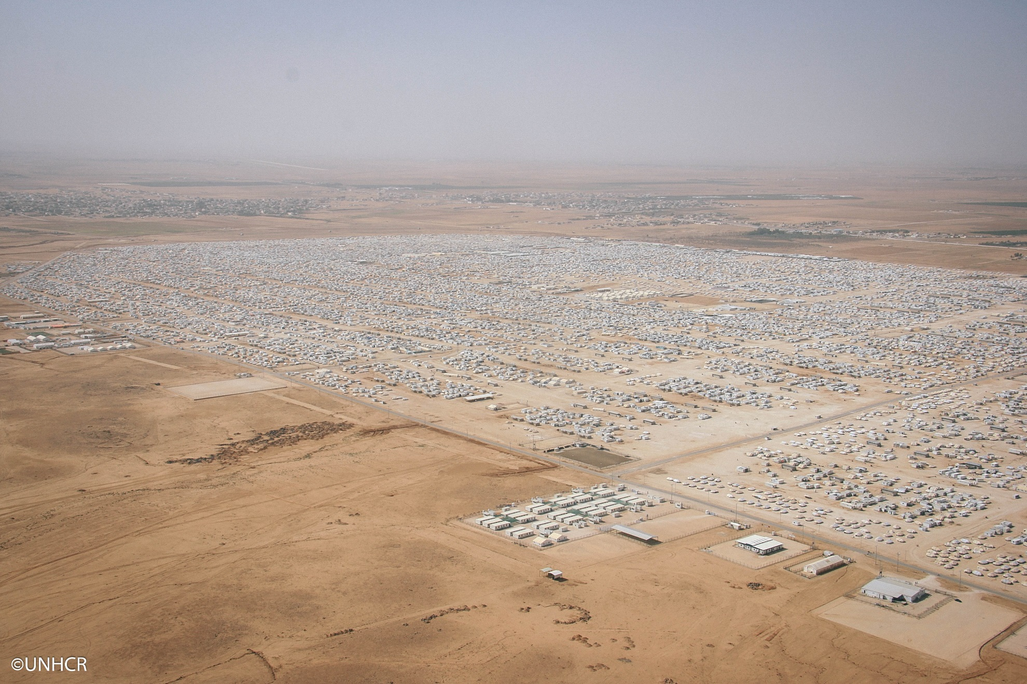
Azraq Camp Coordination
Azraq refugee camp is coordinated by Syrian Refugee Affairs Directorate (SRAD) and UNHCR. After a year of planning, Azraq camp opened in April 2014. The camp is currently divided into six villages, and has the potential to be expanded to accommodate 120,000-130,000refugees at maximum capacity. It has been designed and built on lessons learnt from Zaatari, with a village-based approach which aims to foster a greater sense of ownership and community among residents. Transitional shelters (T-shelters) continue to be constructed across the camp, and there is already a functioning supermarket, school, community centre and hospital. The camp has a developed coordination mechanism composed of different agencies, which include sector meetings and task forces. Camp Coordination is chaired by SRAD and UNHCR, Acacio Jafar Juliao juliao@unhcr.org.
Azraq inter-agency portal page http://data.unhcr.org/syrianrefugees/settlement.php?id=251&country=107&region=73
A calendar of coordination meetings is enclosed. A representative from each agency working in Azraq is strongly encouraged to attend the camp management and coordination meetings. The meeting provides a forum for the sectors’ updates, achievements and challenges.

Sector | Day | Time | Chair | Contact
Community Services and Mass Information | Wednesday | 10.30 (every second week) | UNHCR | Susan Mirbagheri MIRBAGHE@unhcr.org
Security Information Network | Monday | 11:00 (every second week) | UNHCR | Mohannad Bazbaz BAZBAZ@unhcr.org
WASH | Wednesday | 10:00 (every other week) | UNCIEF | Habib Ur Rahman hrehman@unicef.org
Health and Nutrition | Wednesday | 10:00 (every other week) | UNHCR | Reema Abu Ghazaleh ABUGHEZA@unhcr.org
Protection | Wednesday | 10.30 (every other week) | UNHCR | Mounir Maalouli MAALOULI@unhcr.org
Camp Management and Coordination | Wednesday | 11.30 (every second week | UNHCR | AcacioJafarJuliao juliao@unhcr.org

Activities in Azraq
A situation map highlights activities and services under each sector in Village. Azraq information is now updated and accessible through http://data.unhcr.org/jordan/azraq/

How to start activities in Azraq?
All new activities in the camp must be approved and coordinated with: SRAD and camp management. Camp management will approve requests supported by the relevant sector and if they are cost effective, focused, constructive and have the greatest possible impact. All activities in the camp have an effect on overall security, so it is imperative to go through the correct procedures before commencing any activity in the camp. Any organisation that does not respect this condition will have their permission to operate in the camp revoked by the camp management.
For more information please contact Acacio Jafar Juliao juliao@unhcr.org.

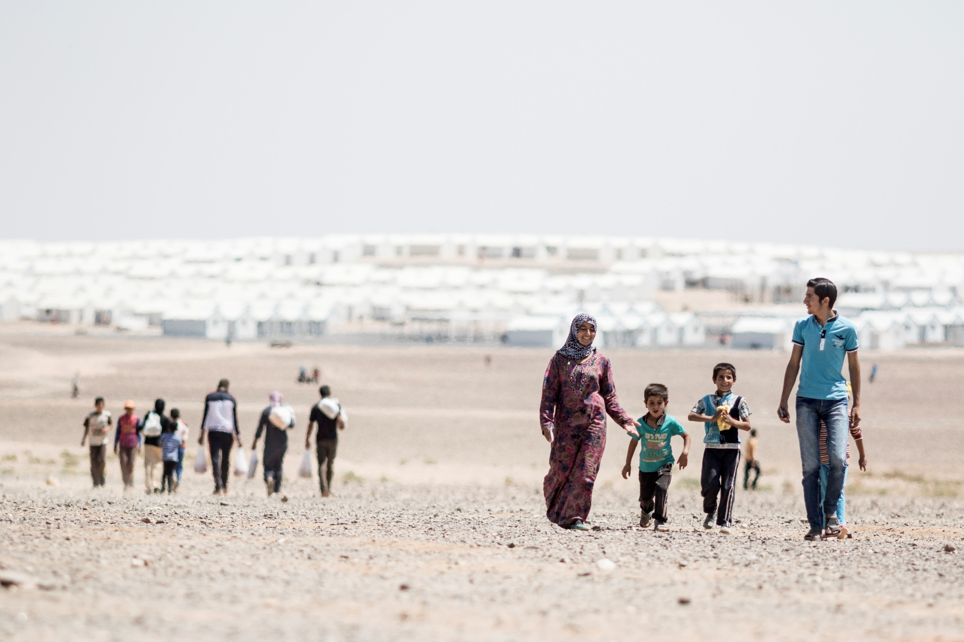

- Urban Coordination
Since late 2013, area-based Governorate-level coordination has been set up. Reviewed and approved by the IATF and the INGO Forum, governorate-level coordination is intended to be a light model, focused on local issues and challenges. The purpose of the meetings is to increase the effectiveness of operational coordination, and thus is opened for the programme managers, case managers and other actors at the implementation level. The urban coordination forum discusses topics related to the local 5Ws (including mapping of the national NGOs and CBOs activities), local problem solving or access constraints, application of referral pathways at the governorate level, identifying challenges that need to be raised at a national level. If appropriate and based on the need, the sector task forces can be established to focus on identifying and addressing specific issues. Meetings are generally held on the monthly basis. Steps are being taken to ensure the meetings are accessible for the Arabic speakers.
A key principle of the forum is engagement with the Governor’s office and with line ministry representatives based in that governorate. The exact format varies from governorate to governorate.
The governorate meetings do not duplicate efforts at the national sector level. The information flow is ensured between the governorate meetings and the sectors, with staff from the Inter-Sector Coordination Unit tasked to ensure follow-up on issues at the national level, and vice- versa.
As of March 2016, Governorate coordination groups are established in Irbid, Mafraq and Amman. Other Governors have taken the initiative to call periodic coordination meetings.

How to get information on activities in a particular governorate?
There are governorate level pages on the portal. Visit the Jordan page at http://data.unhcr.org/syrianrefugees/country.php?id=107 , then click on the governorate tabs at the top of the page.

When and where are the governorate coordination meetings?

Meetings take place in either Irbid, or Amman, or South or Mafraq. For the venue and date/time please see the meeting calendar on the bottom http://data.unhcr.org/syrianrefugees/country.php?id=107
Irbid Coordination is chaired by Katherine Dunn, UNHCR dunnk@unhcr.org, co-chaired by Fairouz Hassan, CARE Fairouz.Hassan@jo.care.org
Mafraq Coordination is chaired by Catherine Philippe, UNHCR philipp@unhcr.org, co-chaired by Michael McDonald, ACTED michael.mcdonald@acted.org.
South Coordination: Chaired by: Mohammed Al-Ani, UNHCR alani@unhcr.org, co-chaired by Anthony Dutemple, DRC anthony.dutemple@drc-jordan.org.
Amman Coordination is chaired by Rawan AL Omari, UNHCR ALOMARIR@unhcr.org, co-chaired by Carmen Issa, DRC
(Carmen.Issa@drc-jordan.org.
See the urban coordination page http://data.unhcr.org/syrianrefugees/working_group.php?Page=Country&LocationId=107&Id=72

- Useful Tools and Data Resources
Services Advisor
Services Advisor is a web-based system enabling mapping of the services available for refugees. http://advisor.unhcr.jo.
The Services Advisor allows users to view the services on the map and in the service directory, where they can filter by sector, area, names of the service provider and referral requirements. The tool is extremely useful particularly to identify gaps in services. The service providers are encouraged to update the tool regularly.
The Coordinated Needs Assessment Registry
Any assessment related to the JRP/3RP objectives, should be subjected to the approval process. Partners are recommended to register their planned assessment online in the Needs Assessment Registry. The registered assessment will be reviewed by the relevant sector chairs, and either approved, modified or rejected. Standard Operating Procedures (SOPs) are now in place for the approval process, and donors have been requested to ensure that funding for new assessments is contingent on following these SOPs.
These SOPs apply to all data collection exercises (whether primary or secondary), involving any part of the refugee or host communities in Jordan, including:
- Knowledge, attitudes and practice (KAP) surveys;
- Needs assessments;
- Contextual analysis or research by individuals, organisations or institutions;
- Large project or programme evaluations.
- These SOPs do not apply to data collection activities, which are considered part of normal programming, including:
- Gathering of output-level data;
- Post-Distribution Monitoring (PDM) activities;
- Beneficiary selection activities for approved projects.
Through the portal, the Registry also acts as a repository of past assessments. Partners can filter by agency, location, population type, methodology, etc.
The Registry is available at http://data.unhcr.org/syrianrefugees/country.php?id=107
The SOPs can be downloaded at http://data.unhcr.org/syrianrefugees/download.php?id=10389
The SOPs do not replace government approval for assessments. Requesting authorisation from MoPIC is a separate and parallel process which agencies should go through. Additionally, agencies should seek approval of the appropriate line ministries. Lastly, approval by the Syrian Refugee Affairs Directorate (SRAD) is required in some geographical locations, such as in Zaatari camp.

ActivityInfo
ActivityInfo, through https://www.syrianrefugeeresponse.org/ is the main online tool for recording activities and achievements for the refugee response. This site allows partners to record their own activities, check other agencies’ activities and generate maps and analysis. There are several databases on line:
- 3RP Appeal database: built on the JRP logframe of Sectors, Objectives and Outputs, partners recorded their appeal on line.
- 3RP Monitoring database: using the same JRP logframe hierarchy, partners record their achievements against agreed indicators, which, after validation by sector chairs, form the basis for the monthly sector dashboards and 3Ws. Partners can conduct their own analysis of achievements or gaps, and can request support from the inter-sector coordination for additional analysis.
The Guidelines are available at http://data.unhcr.org/syrianrefugees/download.php?id=10412
For more information, please contact Information Management Support, Gorgui Niokhor Diouf (dioufg@unhcr.org).

Financial Tracking System
Every quarter, financial tracking by partner and sector is conducted. Inter-Agency appealing partners will be contacted by UNHCR and requested to report on the funds received against their appeal by sector. The Financial Tracking focal point is Gorgui Niokhor Diouf (dioufg@unhcr.org).
Please search visualization of the Financial Tracking System at
http://data.unhcr.org/jordan/fts/#sector=&quarter=0-+Overall&partner=&partnergap=
Examples of the FTS dashboard for 2015 are available at http://data.unhcr.org/syrianrefugees/download.php?id=10217

Sector Performance
Sector performance surveys are conducted online. The last were conducted in 2013, 2014 and 2015. This is a key way for partners to provide feedback on sector performance, and comments are used to guide re-design of the sectors and capacity building of sector chairs. Your feedback really matters! The survey results are available at http://data.unhcr.org/syrianrefugees/download.php?id=9624
http://data.unhcr.org/syrianrefugees/download.php?id=6158
http://data.unhcr.org/syrianrefugees/download.php?id=3914

Registration and Refugee Assistance Information System (RAIS)
UNHCR and the government register refugees entering Jordan, providing them with documentation. Basic information is collected on each individual, including their profile and basic vulnerability. This information is stored in databases, including the Refugee Assistance Information System (RAIS). Through this system, partners can access basic information about refugees, check distribution lists, and to register assistance they have provided.
The updated refugee registration numbers and trends are available on the main page of the portal, with a breakdown by age, gender and geographical location. Please visit http://data.unhcr.org/syrianrefugees/country.php?id=107
A Situation Map, overlaying refugee and Jordanian populations, together with government services, is available at http://data.unhcr.org/jordan/situa on-map/ For more information, please contact Information Management Support, Gorgui Niokhor Diouf (dioufg@unhcr.org).

Vulnerability Assessment Framework (VAF)
An inter-agency process is ongoing to facilitate both monitoring of vulnerability and targeting of assistance on the basis of vulnerability. The Vulnerability Assessment Framework (VAF) is managed by the Advisory Board with UN agencies, NGOs and donors. Common indicators of vulnerability have been agreed and validated through participatory focus groups with refugees and through econometric testing by the World Bank. Data on each refugee household is now being collected against these indicators and resulting in a hierarchy of vulnerability profiles, as extremely vulnerable, highly vulnerable, vulnerable, etc.
Accessible through the database, these profiles are available to partners to ensure that the most vulnerable refugees are being targeted. Regular assessments and updating will mean that trends in vulnerability will be available to facilitate broader strategic decision-making.
The VAF documents are available on line at http://data.unhcr.org/syrianrefugees/working_group.php?Page=Country&LocationId=107&Id=69

- Partners
There are around 60 organizations appealing in the JPR / 3RP, and many more implementing activities across the country.
Partners’ own websites and complemented by a series of information management tools that allow donors to find out more about the activities, achievements and appeals of the different UN agencies, international and national NGOs who participate in coordination.
Key sources of information include:
• Partners’ websites: For instance, see http://www.unicef.org; http://www.caritasjordan.org.jo/
• Partner pages on the refugee response portal: h p://data.unhcr.org/syrianrefugees/partnerlist.php?Country=107

• Inter-active infographics for each partners’ 3RP appeal: http://data.unhcr.org/jordan/3rp2016/
• Sector dashboards: http://data.unhcr.org/jordan/sectors/
• ActivityInfo: the partners’ appeals and achievements are recorded on syrianrefugeeresponse.org. For access please contact sector chairs or Coordination Associates.
• Services Advisor: the partners’ services available for refugees are recorded at http://advisor.unhcr.jo. Users can see the partners’ activities on the map and in the service directory.

- Important Contacts
Need More Information? Contact the Inter-Sector Coordination Team:
- Yukiko Koyama, Inter-Sector Coordinator koyama@unhcr.org for inter-sector coordination
- Elena Guseva, Associate Inter-Sector Coordination Officer guseva@unhcr.org for inter-sector coordination
- Noha Gibreel GIBREEL@unhcr.org for Food Security sector, Youth Task Force and Disability Task Force
- Ghassan Shehadehshehadeg@unhcr.org for Protection sector and PSEA
- Rawan Baybars BAYBARS@unhcr.org for Shelter sector and Azraq camp coordination
- Ruba Saleh salehru@unhcr.org for Basic Needs sector and Amman and South area urban coordination
- Maysa Saeidi SAEIDI@unhcr.org for WASH sector and Zaatari camp coordination
- Rema’a Alawi alawi@unhcr.org for Livelihoods sector and Irbid area urban coordination
- Nidal Almasadh ALMASADH@unhcr.org for Health sector and Sector Gender Focal Points Network
- Rasha Al-Awamleh alawamle@unhcr.org for Education sector and Mafraq area urban coordination
Need Information Management Support? Contact the Information Management Team:
- Gorgui Niokhor Diouf dioufg@unhcr.org for ActivityInfo, Services Advisor, sector dashboard, etc.
- Firas Alsagban alsagban@unhcr.org
- Murad Alsamhouri ALSAMHOU@unhcr.org

- List of Acronyms
3RP | Regional Refugee and Resilience Plan
CBO | Country Based Organization
CMC | Camp Management and Coordination
CP | Child Protection
FTS | Financial Tracking System
GoJ | Government of Jordan
HCT | Humanitarian Country Team
IATF | Inter-Agency Task Force
INGO | International Non-Governmental Organization
ISWG | Inter-Sector Working Group
JRP | Jordan Response Plan
JRPSC | Jordan Response Platform for the Syrian Crisis
JRR | Jordan Refugee Response
MHPSS | Mental Health and Psycho-Social Support
MoI | Ministry of Interior
MoPIC | Ministry of Planning and International Cooperation
NFI | Non-Food Item
NGO | Non-Governmental Organization
RAIS | Refugee Assistance Information System
RH | Reproductive Health
SGBV | Sexual and Gender Based Violence
SGFPN | Sector Gender Focal Point Network
SRAD | Syrian Refugee Affairs Directorate
UNCT | United Nations Country Team
VAF | Vulnerability Assessment Framework

