Winterization TF Meeting – 30 June 2015
- Decisions from last Meeting
In the previous meeting of the Winterization TF 5 June 2015), the following elements were agreed:
- Standard package
- Drafting and application of guidelines for distribution to vulnerable parts of the population (PwD / Elderly)
- Preference for per capita calculation of assistance (even if pro-rated)
- Targeting criteria to be discussed in August
- Use of winterization module (but with updates)

- Rapid Assessment
In the same meeting, there were discussions on whether NFIs that can last more than one year should be redistributed or not. A tiered system was in place during the last cycle, which allowed for partial winterization packages. However, concerns were raised, as refugees are known to liquidate NFIs received as part of winterization assistance in the warmer summer months. Since that meeting, four partners (DRC, IRC, PU-AMI, UNHCR, UNICEF) conducted a rapid assessment to better understand to what degree these assets are liquidated. Partners used one of two options:
- When there has been prior confirmation that a heater was provided/purchased for previous winter seasons, beneficiaries should be asked if they still have the item.
- When there is no prior knowledge on whether Winterization assistance was provided, beneficiaries should be asked if they received winterization assistance and whether it included a heater or cash for a heater. If a heater was acquired, they should then be asked if they still have it.
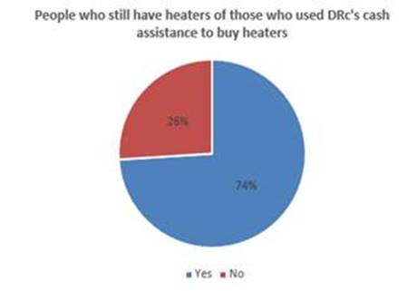
DRC
Methodology: A follow-up phone survey was done with HH randomly sampled form the originally contacted for feedback in March 2015. The sample includes 70 households (interviews with HoH or spouse).
Results: 27% of the beneficiaries reported using the cash assistance provided by DRC in December-January to buy heaters. These had an average cost of 66 JOD. Of those who used at least a portion of the cash to buy a heater, 74% of still have heaters at their homes. Only three interviewed households indicated that they had sold their heaters. Overall (not only those who used cash assistance for heaters), 64% of the participated beneficiaries (average family size = 5) reported that they still have heaters for the coming winter season.

IRC
Methodology: A small sample (around 20%) of beneficiaries had reported buying winter household items, from which a random sample of 87 cases was selected. They were asked questions related to scenario 1: did you buy a heater last winter? Do you still have it?
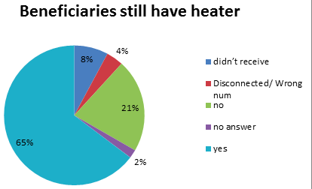
Results: 80.46% reported buying a heater from IRC Winterization cash assistance, of which 91.43% reported that they had kept it until now.

PU-AMI
Methodology: 51 households were selected, all of which had received either full NFI assistance or a heater in the 2013-2014 Winterization cycle. They were asked one question related to scenario 1: do you still have the heater?
Results: 33 out of 51 households (64.71%) reported that they still have the heater received in the 2013-2014 Winterization cycle. 11 out of 51 households (21.57%) reported that they no longer have the heater; 1 did not give an answer and 2 were either disconnected or a wrong number. Note: 4 households answered that they did not receive a heater, despite their case numbers being present on the list. This could be due either to a small percentage of error on the list, or the beneficiaries not giving the correct answer.

UNICEF
Methodology: Telephone interviews were conducted with a sample of 100 random families from a total of 500 families receiving UNICEF child cash grants.
Results: 63 families out of the 100 asked acknowledged receiving Winterization assistance. Out of this 63, 39 families stated that the type of assistance received was cash, whilst 24 said they had received heaters. Out of these 24 families who received heaters, 12 families stated that they still have the heaters.

UNHCR
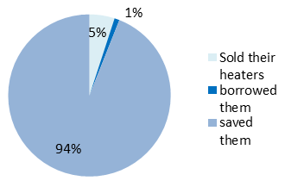
Methodology: A sample size of 270 families who had declared they had bought either heaters or gas refills for their heaters in the PDM for the 4th quarter of the year 2014 was selected. These families were called and asked questions based on scenario 1.
Results: 94% of cases answered that they did not sell their heaters. 5% of cases said they had sold their heaters, which they did after the winter season and for varying reasons. The most prevailing reason was to pay the accommodation rent, whereas others sold their heaters to buy NFIs or to pay for health services. 4 cases answered that the heaters they used during winter had been borrowed from their neighbours and returned after the winter season had finished (Note: these are all families who had reported buying refills in the PDM).

- Winterization Standard

- The findings from the rapid assessment of heaters received in previous Winterization cycles generally show that most often, beneficiaries actually kept their heaters. This would be evidence in favour of keeping a two-tiered system as in the previous cycle.
- It was agreed that, while monetised assistance should remain based on an in-kind package equivalent, it is acceptable for beneficiaries to spend the money on what they perceive as their most urgent needs in winter.
- It was agreed that the standard family size for use of a gas heater should remain at 5. Therefore, the figures below have been calculated by taking the total price of the heater + gas + bottle package (285 JOD) and dividing it by the family size of 5.
- The meeting emphasised that there is not a sectoral preference for either cash or in-kind winter support, but that agencies should make evidence-based decisions for any particular group to be served.
- Four organisations (ICMC, NRC, PU-AMI, UNHCR) carried out market research to determine the cost in JOD of the items, which make up the winterization standard package. The results were as follows:

Item Cost (in JOD)
 | MTB | HTB | Heater (local) | Heater (imported) | Gas bottle | Gas refill
NRC | N/A | N/A | 80 | 43 | 43 | 8
ICMC | N/A | 14 | 80 | N/A | 45 | 8-10
PU-AMI | 12-15 | 20-25 | 75-110 | N/A | 35 | 8
UNHCR | 8 | 12-15 | 70-80 | N/A | 46 | 10

Based on findings outlined in the above table and using the MEB approach, the table below gives an estimate of the cost of a standard Winterization package, depending on the case size.

Cost of Winterization (in JOD)
 | Unit Cost | Entitlement | Family Size
 |  |  | 1 | 2 | 3 | 4 | 5 | 6 | 7
MTB | 8 | 16 | 8 | 16 | 24 | 32 | 40 | 48 | 56
HTB | 16 | 16 | 8 | 16 | 24 | 32 | 40 | 48 | 56
Heater | 80 | 80
Bottle | 45 | 45
Refill | 10 | 160
Pro-rated heater + gas + refill |  | 57 | 57 | 114 | 171 | 228 | 285 | 342 | 399
Pro-rated refill |  | 32 | 32 | 64 | 96 | 128 | 160 | 192 | 224

Draft Final Standard:
Per capita cost (Tier 1 – “Full”): 16 + 57 JOD = 73 JOD
Per capita cost (Tier 2 – “Partial”): 16 + 32 JOD = 48 JOD

