
UNHCR LIBERIA
PROTECTION SITUATION REPORT
Covering the period: April 01-30 2014

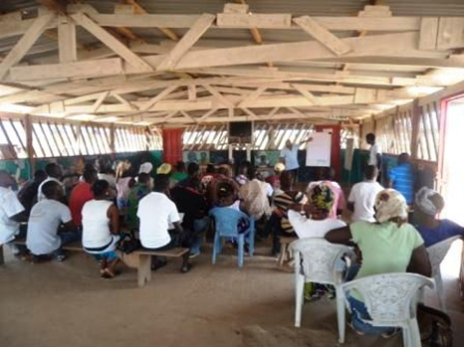
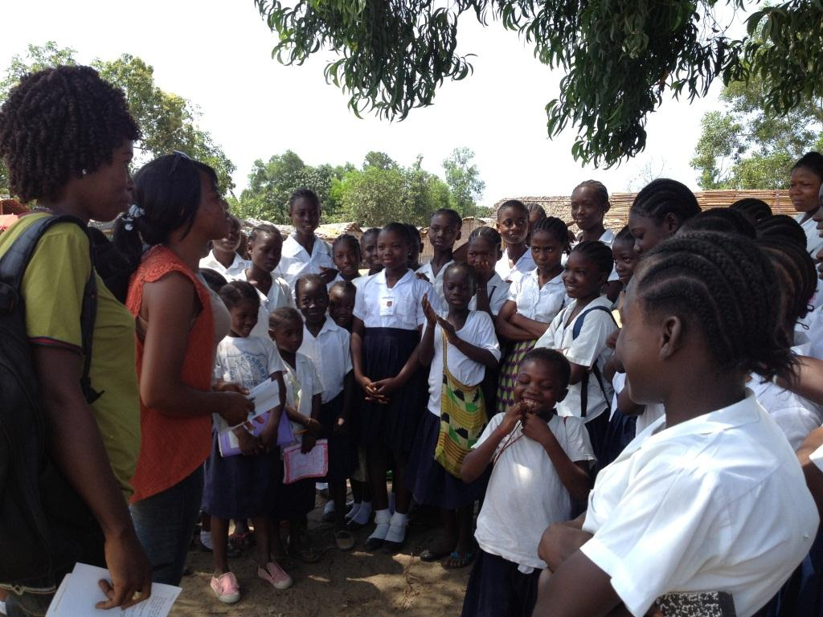
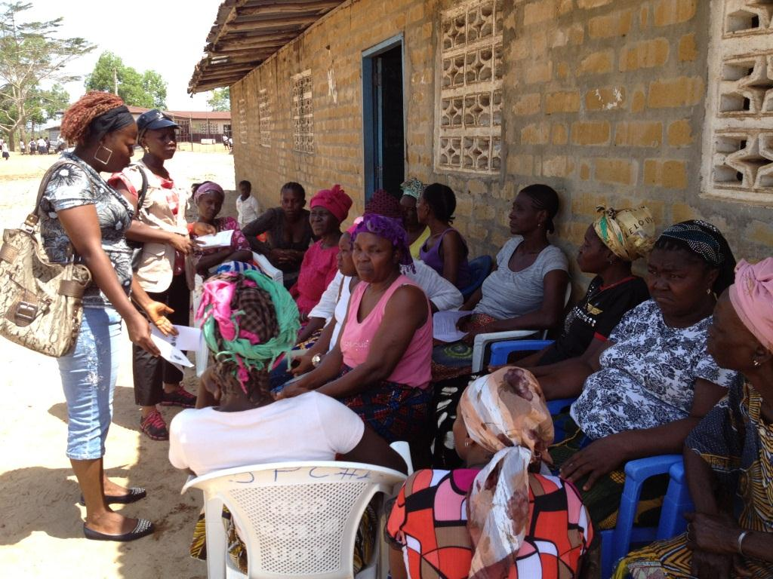
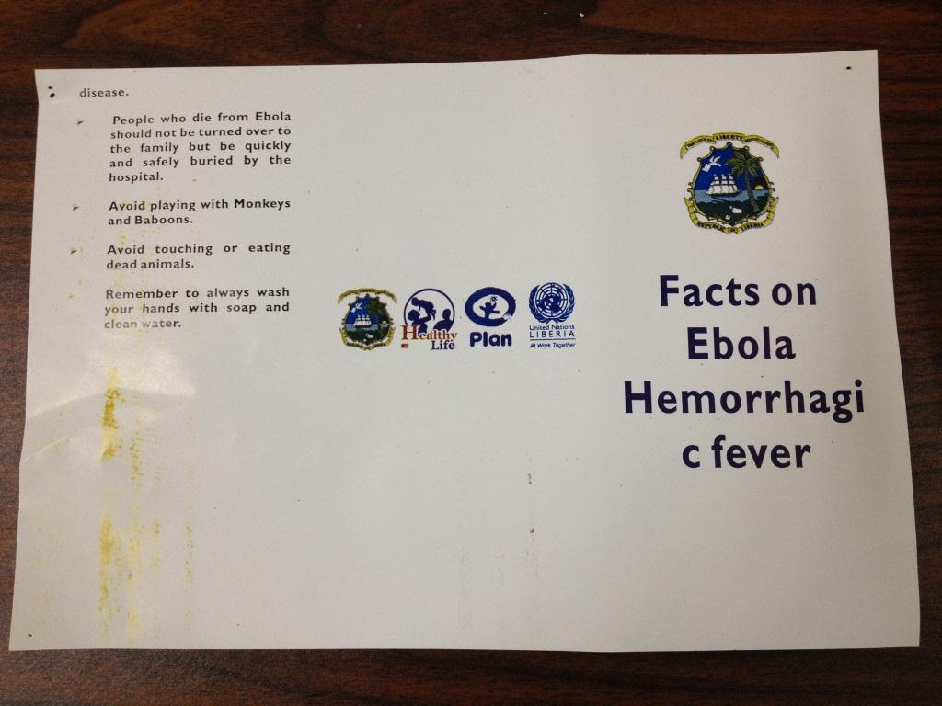
UNHCR and its partners carried out various activities to contain Ebola outbreak among refugees and the other persons of concern, in coordination with the Ministry of Health and Social Welfare.

EXECUTIVE SUMMARY
The voluntary repatriation of Ivorian refugees was temporarily suspended by the Ivorian Government who took precautions against the Ebola outbreak. As a result, there was no repatriation of Ivorian refugees facilitated by the UNHCR in the month of April 2014. The porous border and the weak health-care system have posed serious challenges in containing the Ebola outbreak in the sub-region. In Liberia, the number of suspected, probable and confirmed cases of Ebola stood at 13 as of 30 April 2014. Of the 13 cases, 6 have tested positive, 2 were probable and 5 were suspected cases. UNHCR worked closely with the Ministry of Health to make sure the refugees and the other persons of concern were part of the national response and no Ebola patients were reported among our persons of concern, UNHCR and its partner staff. The UNHCR is closely following up with the UNHCR Côte d’Ivoire and the Ivorian authorities to resume the voluntary repatriation. 177 families/420 individuals already signed up for the voluntary repatriation in PTP Refugee Camp, eagerly waiting for the day of return.

- Persons of Concern/ Registration
Liberia is currently hosting 44,087 refugees, asylum seekers, and the other persons of concern. The Ivorian refugee population decreased by 1,587 individuals from 43,613 at the end of March 2014 to 42,026 at the end of April 2014, mainly owing to the no show of registered refugees during the verification exercise in communities. The breakdown of Ivorian population by locations is as below:
County | Population | Location | Population
Nimba | 7,616 | Bahn Refugee Camp | 7,164
Nimba | 7,616 | Saclepea former Refugee Camp | 69
Nimba | 7,616 | Communities | 383
Grand Gedeh | 20,309 | PTP Refugee Camp | 15,379
Grand Gedeh | 20,309 | Communities | 4,930
River Gee | 1,719 | Communities | 1,719
Maryland | 11,795 | Little Wlebo Refugee Camp | 10,152
Maryland | 11,795 | Communities | 1,643
Montserrado | 587 | Communities | 587
Grand Total |  |  | 42,026

The Asylum-seeker registration: An Eritrean national applied to LRRRC for asylum and his application was shared with UNHCR Sub Office Zwedru.

- Refugee Status Determination (RSD)
Training for Eligibility Committees Members: The UNHCR BOM Protection section conducted a half day training for the Eligibility Committee’s members in Monrovia on 18 April 2014. The Training was geared toward the capacity building of members of the two committees. In Liberia, first instance Refugee Status Determination (RSD) is conducted by the Asylum Committee and appeals are conducted by the Appeal Committee, both of which are chaired by seconded representatives from following three ministries; Ministry of Foreign Affairs, Ministry of Internal Affairs, Ministry of Justice and Ministry of Planning and Economic Affairs. The constant turnover of the officials seconded to the committees necessitates constant training for the members to ensure that they are well informed about the procedures for the granting of asylum in Liberia. The Eligibility Committee members and alternates were introduced to the basic procedure for refugee status determination; dealing with female asylum applicants; and gender-related asylum claims. In relation to the gender-related asylum claims, the basic concepts and protection concern of LGBTI (Lesbian, Gay, Bisexual, Transgender and Intersex) - a diverse group who do not conform to the conventional notions of male and female gender roles - were introduced. UNHCR protection staff also facilitated a workshop for LRRRC officials this month.
- Access to Asylum/Border Monitoring
On 28 April 2014, a joint team of UNHCR and LRRRC Protection staff conducted a joint community/border monitoring mission to various communities including Yediaken, Gbon, Yorbloken and the Yorbloken border entry point within Maryland County. The Bureau of Immigration and Naturalization (BIN) officers informed the team that the cross border movement of the refugees remained restricted after the introduction of sanctions on spontaneous movement to Côte d’Ivoire. The BIN also reported that there were no new arrivals recorded since the last group of new arrivals fleeing from Grabo, Fete and surrounding villages in March 2014.

Border monitoring was conducted at the Garley and B’hai borders. UNHCR staff spoke to the Immigration officials and local authorities at these borders, and it was revealed that the situation was calm and there were no new arrivals. In these locations, the border crossers seemed going about their normal activities while the immigration officers were also processing papers on behalf of the border crossers.

- Protection Highlights (Achievements and Challenges)
Effort to contain the Ebola outbreak among the refugees and the other persons of concern to UNHCR have continued: UNHCR attended the coordination meetings at the Ministry of Health to make sure UNHCR was part of the national response and that the refugees and the other persons of concern were included in the preparedness plan for the Country. UNHCR Sub and Field Offices continued to work closely with partners to support the various County Health Teams to develop and support contingency plans in the refugee host Counties. In the refugee camps, UNHCR, in close collaboration with partners and camp management, continued working to minimize unnecessary movements of refugees in and out of the refugee camps and carefully monitored spontaneous arrivals, handling of burials and management of waste disposal system. As part of the preparedness for a potential Ebola outbreak, Isolation Centers in Bahn and PTP Refugee Camp clinics have been equipped with Personal Protective Equipment (PPE) received from WHO. In addition, UNHCR procured 18 megaphones and printed 5,700 brochures and posters to be used by Community Health Workers (CHW) for Ebola awareness campaigns in the camp. The Ebola Virus awareness messages were also disseminated in French through FM radios and CDs in refugee camps. As a result, no Ebola causalities have been reported among the refugees and the other persons of concern as well as UNHCR and its partner staff.
565 birth certificates distributed for refugee children born in Liberia: UNHCR Field Office Harper has finalized the distribution of birth certificates to the refugee parents. 565 birth certificates (288 Female and 277 Male) have been distributed. UNHCR dispatched 49 certificates to UNHCR Tabou for those who repatriated before the printing of the certificates. In PTP refugee camp in Grand Gedeh County, a three-day exercise in support of the continuous registration of newborn babies commenced on 9 April 2014. The process continued with the photo capturing of 150 babies born during the period January - March 2014.
Protection from sexual exploitation and abuse (SEA)/Code of Conduct: In order to build an environment free of violence and exploitation, Zwedru Sub-Office, Saclepea and Harper Field Offices have conducted training on SEA and Code of Conduct for their partner staff. In total 407 partner staff including government officials (Liberian National Police and LRRRC) were reminded of the responsibilities to prevent incidents of SEA committed by UN, NGO and inter-governmental (IGO) personnel against colleagues and beneficiaries of protection and assistance and to take action as quickly as possible when incidents do occur.
Level III verification conducted for refugees registered in communities in Maryland County: UNHCR Field Office Harper (FOH) jointly with LRRRC concluded the Level III verification exercise for the Ivorian refugees registered in various communities in Maryland County from 3 to 14 April 2014. Absenteeism was as high as 60% despite various outreach activities through radio, notices posted in the communities and meetings with the refugees and host community leaders prior to the verification. Though it is difficult to ascertain the main reasons for the absenteeism, one can reasonably conclude that the majority of those absentees have spontaneously returned to Côte d’Ivoire. FOH plans to conduct a final verification exercise for this group in May according to UNHCR registration standards procedures.
Relocation of 95 refugees to Little Wlebo Refugee Camp: On 1 April 2014, UNHCR in collaboration with LRRRC, DRC and CARITAS facilitated the relocation of 95 (50 Female, 45 Male) individuals within 24 families to Little Wlebo Camp from Nyaaken and Kronoken communities in River Gee County. The refugees are part of the new arrivals that recently fled to Liberia after the rebel attack in Grabo and Frete in Côte d’Ivoire on the 23 February 2014.

- Protection Monitoring
- Monitoring of Detention Centers
9 refugees still remain detained at Monrovia Central Prison. 6 refugees are currently in the Corrections Palace in Zwedru, Grand Gedeh County. One male refugee is in detention at Harper Central Prison for alleged rape and the Harper Magisterial Court transferred him to the 4th Judicial Circuit Court in Maryland County.
- Unaccompanied and Separated Refugee Children
UNHCR Sub-Office Zwedru convened a Best Interests Determination (BID) panel to determine the best interests of a child under consideration for resettlement.
- Prevention of and Response to SGBV (Sexual and Gender-Based Violence)
104 SGBV cases were reported during the month of April 2014. All of the survivors were female and cases occurred in the country of asylum. Of 104 cases, 3 cases were rape and all the survivors were minors. The most pervasive form of violence was physical assault (38.5%), followed by denial of resources (28.8%) and psychological/emotional abuse (26.0%). All cases are reported to have occurred in the country of asylum.
Various training for the prevention of SGBV has been conducted to curtail the occurrence of SGBV among the refugee population. In Bahn Refugee Camp, IRC conducted training from 16-17 April 2014 targeting the refugee block leaders and the central leadership with the aim of establishing GBV Task Force in all of the 12 blocks in the refugee camp. The Save the Children conducted one day GBV training for vulnerable families including refugees living with disabilities. IRC and Save the Children jointly conducted one day GBV training for 11 (8 Male and 3 Female) Child Friendly Space facilitators. In PTP Refugee Camp, IRC recruited 100 refugee women for skill training on baking and soap making and empowerment activities.
Monthly Statistics of numbers of reported SGBV cases
01January –30 April 2014

 | Jan | Feb | Mar | April | Total
Rape | 4 (2)* | 3(1) | 2(1) | 3(3) | 12 (7)
Sexual Assault | 2 | 4(2) | 2(1) | 3(1) | 11(4)
FGM | 0 | 0 | 0 | 0 | 0
Physical Assault | 21 | 25(1) | 26 | 40(1) | 112(2)
Forced Marriage | 1 | 4 | 2 | 1 | 8
Denial of Resources | 30 | 21 | 24 | 30 | 105
Psychological/Emotional Abuse | 31 | 20 | 27 | 27 | 105
Survival Sex/Sexual Exploitation | 0 | 0 | 0 | 0 | 0
Human Trafficking | 0 | 0 | 0 | 0 | 0
Total | 89 | 77 | 83 | 104 | 353(13)
* Numbers in ( ) indicates cases under 18 years old within the total reported cases.
All cases were reportedly occurred in the country of asylum. Sex of the survivors was 100% female.
- Durable Solutions
Voluntary Repatriation of Ivorian refugees: There was no return facilitated in this month. “Go and See” and “Come and Tell” mission planned this month was also postponed owing to the suspension of the Voluntary Repatriation by the Government of Côte d’Ivoire.
- Access to Education
Preparation for the end of the academic year exam at primary and secondary level: UNHCR held Education Coordination Meeting on 16 April 2014 to prepare for the end of school year exams at primary and secondary levels. The meeting was attended by key education partners; Danish Refugee Council-DRC, Finn Church Aid-FCA, Save the Children International –SCI and LRRRC. As likelihood of Ivorian education authorities administrating the national exams for Ivorian students in refugee camps in Liberia is low, the partners tentatively agreed to administrate internal exams in August 2014. The final decision is pending the outcome of the meeting among Ivorian education authorities, UNICEF Côte d’Ivoire and UNHCR Côte d’Ivoire. In preparation of exams equivalent to CEPE (end of primary school exams) students graduating 6th Grade (CM2) in the end of the 2013-2014 academic year, a mock exam known as exame blanc was administrated for 108 (55 Male/53Female) refugee students.
Distribution of scholastic materials: In Little Wlebo Refugee Camp, DRC completed distribution of one set of school uniform to 188 students in the secondary school. Distribution of uniforms to students in the ECD and Primary schools will continue in the month of May 2014.
Tertiary education: 7 refugees in Maryland sat entrance examinations for possible enrollment at the Tubman University.

- Livelihood/Self-reliance
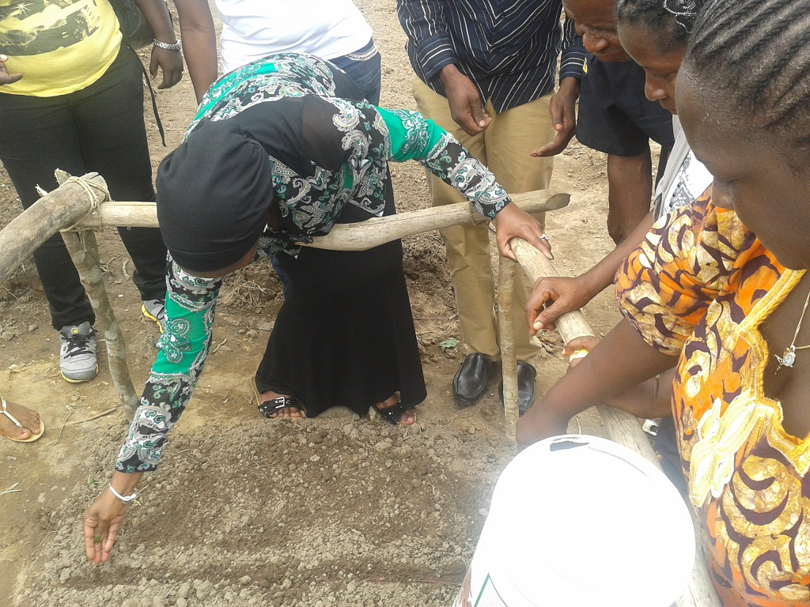
ADRA, Adventist Development and Relief Agency in cooperation with UNHCR and other partners and the refugee leaders, managed to select 50 gardeners (24 female/ 26 male) in Bahn Refugee Camp. The selected farmers have constructed 58 nursery beds. From the land prepared, one part will be used for plots demonstration or model back yard garden for the 50 farmers and the other refugees. The purpose of the nursery is to teach the selected farmers the most improved method of preparing nursery beds, sowing seeds in the nursery beds, constructing palm booth to shade the newly sowed seed; using compost to fertilize the soil; and getting seedlings which will be used by the farmer in back yard garden.
UNHCR Head of Sub-Office Zwedru who visited Bahn Refugee Camp in Nimba County planting the first cabbage seed on nursery.
Cestos River in Nimba County

- Documentation for Liberian Refugees in the Countries of Asylum
As to fairly implement the project related to passport issuance to refugees who opted for local integration in their countries of asylum, after the invocation of Cessation Clause, it is good to mention that UNHCR efficiently supported the Government of Liberia. Mobile teams were formed to undertake passport vetting missions in nine (9) of the ECOWAS countries in the region.
Three main government agencies were involved in this activity: the Ministry of Foreign Affairs (MFA), the Bureau of Immigration and Naturalization (BIN) and the Liberian Refugee Repatriation and Resettlement Commission (LRRRC).
 | TOTAL
TOTAL applications received by UNHCR Liberia from Asylum Countries | 8,995
Applications submitted directly to GoL during vetting missions | 1,557
TOTAL applications submitted to GoL | 10,552
No-Show during the vetting missions | (1,946)
Rejected (Red-Coded) applicants | (910)
Total number of approved passport applicants | 7,696
Applicants who had existing passports (No new passports issued) | (131)
Total number of passports to be issued | 7,565
Number of passports issued by GoL to UNHCR Liberia | (4,700)
Number of passports returned to GOL from UNHCR (Re-Issuance) | 52
Number of passports delivered to UNHCR Offices in the region | 4,643
Number of passports to be issued by GoL | 2,865
% of Passports issued | 62
% of Passports to be issued by GoL | 38
A total of 11 passport vetting missions were undertaken and completed or Liberian refugees in the Gambia, Senegal, Guinea-Bissau,Nigeria, Ghana, Côte-d’Ivoire,Guinea-Conakry, Mali and Sierra Leone), during which a total of 7,696 applicants (89%) were approved while 910 applicants (11%) were denied Liberian nationality.
As of 30 April 2014, 4,700 passports were issued to UNHCR Liberia, out of which 4,643 passports have been delivered to the countries of asylum. 2,865 passports were pending for issuance by the passport department at the Ministry of Foreign Affairs in Monrovia.

Compilation/ Protection Reports from:
SO Zwedru/FO Salepea & Harper/ /BO Monrovia
UNHCR Liberia

