INTER – SECTOR WORKING GROUP STRATEGY:
COMMUNAL KITCHENS IN REFUGEE + MIGRANT SITES OF GREECE
PURPOSE OF COMMUNAL KITCHENS:
- Return control of meal consumption to rightful refugees and migrants – increasing dignity, independence and culturally-appropriate, healthy eating habits.
- Reduce high fire risk at sites by preventing people of concern (PoC) from cooking on open fires or self-made brick-insulated stoves at their tents. Urgent to eradicate this practice due to total fire ban across Greece from May – September.
- Gradually phase out Government’s heavy, finite program of delivering 3 pre-prepared meals per day to sites (average cost of per day per person (3 meals) = 5 – 7 euros).
- Reduce food wastage at sites, thus decreasing presence of rats/rodents and snakes.
- Facilitate meal consumption flexibility needed for the period of Ramadan; 6 June – 5 July 2016.
- Strengthen local markets and economies via PoC purchase (cash-based assistance) of ingredients from local supermarkets/vendors, in turn improving PoC relations with the local communities.

PURPOSE OF STRATEGY:
- Provide the conceptual framework and checklist of all necessary considerations for communal kitchen implementing agencies to use as a guiding reference.
- Set broad minimum standards for all sectors implicated within a communal kitchen project so that all accommodation sites receive harmonized cooking facilities regardless of context-specific approach pursued by different implementing agencies.

DEFINITION:
Communal kitchens in any PoC accommodation site may be defined as one or a mix of the following;
- PoC cook independently for their respective families only in designated shared space/s.
- A selected/voluntary group of PoC cook for site’s population in designated kitchen space/s.
- Volunteers/local Greek residents/NGO staff cook for PoC population in designated kitchen space/s.
Communal kitchen/s do not equal the direct distribution of cooking equipment (e.g. camping stove) for PoC to use within/next to their shelter.

PHASED IMPLEMENTATION:
SITE TYPOLOGY | SITE TIMELINE | KITCHEN/COOKING APPROACHES (using any of the 1 -3 definition types)
Tented open camp in semi-urban or rural area | LONG TERM | 1. New base build of communal kitchen unit/s (respecting minimum technical standards + material composition options outlined in this strategy on page 6).  2. Retrofit existing building/s within camp where selection is justifiable based on site layout, structural safety and cost effectiveness (respecting strategy’s minimum technical standards).  3. Rehabilitate former commercial/industrial kitchen within camp (respecting strategy’s minimum technical standards).
Tented open camp in semi-urban or rural area | SHORT TERM | 4. Demountable or mobile kitchen facility (respecting strategy’s minimum technical standards + material composition options outlined in this strategy on page 6).
Commercial / industrial warehouse site | LONG TERM | 5. Adapt communal kitchen unit design to site-specific infrastructure, providing fixed stoves for families to cook independently in designated shared space/s.
Commercial / industrial warehouse site | SHORT TERM | 4. Demountable or mobile kitchen facility (respecting strategy’s minimum technical standards + material composition options outlined in this strategy on page 6).

Ideally the programme should incorporate a phased implementation of the Multi-Purpose Grant Minimum Expenditure Basket (MPG-MEB) alongside the construction/establishment of communal kitchens so persons of concern have means to transition to providing for themselves.

IMPLEMENTATION PHASE | Local Market Access (Green or Orange Score*) | Incentivize / Create Market Access (Red Score*) | No possibility of Market Access
INITIAL | Provide limited cooking facilities (exclude approach 3 from table above) for supplementary meals or snacks only. Retain standard military/catered pre-packaged meal distributions.  Limited = Number of stoves provided to be based on figure of site population, focus group discussions with key PoC informants to determine ‘supplementary’ needs, + kitchen space available.  Maximum ratio of 1 stove per 10 families**
INTERMEDIARY/ TRANSITION | Remove 1 – 2 military/catered pre-packaged meals and introduce the Transition MEB. Transportation tranche of MEB could cover public transport cost to markets beyond 2km from site/s (orange score). | Remove 1 – 2 military/catered pre-packaged meals and incentivize nearest market sources to travel within walking distance of site/s to establish mobile/regular (or permanent) raw food shops and meal vendors. Introduce a food voucher system for these vendors. | Remove 1 – 2 pre-prepared and packaged meals. Governmental site management to replace these with the delivery of raw foods/dry rations for the PoC to be able to cook themselves.
INTERMEDIARY/ TRANSITION | Access to restaurants and cafes would enable PoC to choose what type of freshly-prepared meal/s they wish to consume for when they do not have access to the communal kitchen or they simply do not want to cook themselves. | Access to newly created food vendors/markets would enable PoC to choose desired meal ingredients for cooking and the freshly-prepared meal/s they wish to consume for when they do not have access to the communal kitchen or they simply do not want to cook themselves. | These deliveries should be based on household orders to ensure appropriate choice and quantities of ingredients. As per current food distribution setup, Government will be held accountable for quality control of raw food and dry ration deliveries.
INTERMEDIARY/ TRANSITION | Increase the number of communal kitchen structures or stoves within a single kitchen space (where a site is restricted to one location for a communal kitchen). Ensure a minimum ratio of 1 stove to 8 families**
FULL | Completely remove the remaining army/air force/catered meal distributions and introduce the complete MEB package. | IF POSSIBLE, completely remove the remaining army/air force/catered meal distributions and increase the capacity of mobile/regular (or permanent) raw food shops and meal vendors. Retain food voucher system for these vendors.  If impractical, do not completely remove catered meals and remain at “intermediary” phase. | All pre-prepared and packaged meals replaced by the delivery of raw foods/dry rations of the PoC.
FULL | The final increase of communal kitchen structures or stoves within a single kitchen space (where a site is restricted to one location for a communal kitchen) to reach “full phase” scale. Ensure a minimum ratio of 1 stove to 4 families**

KEY:
* Reference to Market based Programming Question and Indicator in Accommodation Sites:
** = Final stove to family ratio chosen by implementing agency/ies will be informed by an in-depth contextual analysis of population groups, cooking needs, cultural considerations, site-specific kitchen infrastructure parameters etc.
Question: Are the site residents able to reach supermarkets, pharmacies or other types of stores?
Indicator: Site residents able to access local markets.
Green:  Distance to stores is 2km or less /up to 10km with public transportation. | Orange:  Distance to stores is more than 2km and less than 5km / up to 20km with public transportation. | Red:  No stores available in nearby distance 5km and above with no availability public transportation.

NB FOR IMPLEMENTATION TABLE:
1. These implementation phases and market-based approaches are not strictly exclusive.
2. It will be crucial to monitor that all families are able to satisfy their individual dietary needs by preparing or purchasing all their daily meals and snacks. For agencies pursuing MEB (market analysis, design and monitoring of system) and/or the food stuff supply (delivery and distribution of raw food materials) within a communal kitchen rollout, their accountability to cover X population for X amount of time must be firmly guaranteed.

TYPE OF COOKER | Positives | Negatives
ELECTRIC HOT PLATE | - Lowest fire risk of all cooking fuel with no open flame or gas leaks.  - Cleaner energy than gas.  - Heat is equally distributed.  - Little maintenance required.  - Smooth-top electric range is easier to clean.  - More stable for pots + pans than grated gas stoves.  - As standalone items, electric stove units are less expensive than gas.  - No need for ignition to start. | - Requires significant power supply – 1.5 kW per unit at peak supply.  - Cooking time is longer than gas stoves – slower to heat up + cool down.  - Parts are more easily removed + stolen than gas burners.  - More expensive long term to procure electricity than gas.  - Uncommon in Afghanistan.  - Placed on the ground will result in the stove pits remaining dangerously hot for a long period after the cooking has finished.
PROPANE GAS BURNER | - Quick turnover for meal preparation & less time needed in kitchen space.  - All gas suppliers in Greece deliver refills directly to sites. | - Risk of explosion.  - Ongoing demand for gas supply.  - Space needed for gas cylinders or single large gas tank.  - Adequate flame protection must be provided.
BARBEQUE | - Requires no power supply.  - Easier for PoC to make bread. | - May not be accepted by site authorities despite being legal during fire ban.
OVEN | - Ideal for PoC to make bread + associated dough-related foods.  - More efficient use of heat as it is trapped in an enclosed volume.  - Can bake/roast more than one item at a time (depending on oven size). | - Requires much more space than electric hot plates or gas burners.  - Uses more power.
SOLAR COOKER | - Uses only direct sunlight energy to cook food or drink – no fuel + costs nothing to operate.  - Environmentally friendly – no air pollution or contribution to deforestation/desertification.  - Low fire risk. | - Can only be used in daylight hours with significant sun exposure – unusable on cloudy, rainy days.  - Takes significantly longer time compared to electric hot plates, gas burners or BBQs.  - Not as efficient at retaining heat as conventional cooking devices.  - Eyesight may be damaged if the concentrated beams of sunlight are reflected back into a user’s eyes.

CULTURAL + CONTEXTUAL CONSIDERATIONS:
1. Differing cooking practices may exist between urban and rural populations. For example, rural Afghanis predominantly prefer to cook on the ground. Thus, chosen stove typology is contingent upon the cultural practices of the community/ies living in the site.
2. Strong culture among many PoC of baking bread using a “sadj” stove. This is already in practice at Petras Olympus site (see image 001 for reference). Some PoC groups are accustomed to using clay ovens for bread making.
3. Traditional cooking practices among significant percentage of PoC = brick insulated fire ovens. Households in Ritsona camp have improvised with locally sourced material to build such ovens themselves (see image 003 for reference).
4. Common social practice of tea/coffee consumption by/for men. A separate space for this activity should be incorporated into a communal kitchens project. For example, by providing small electrical boilers with designated power outlets. This would prevent discouragement/reduction of women’s access to communal kitchen facilities.
5. Primary anecdotal evidence of particular ethnic groups expressing desire to not cook alongside other ethnic communities. Without encouraging cultural segregation, there may be less risk of tensions among the PoC and greater ease of operational management if the population using each unit is culturally homogeneous. Therefore, it should be obligatory to study the ethnic composition/s of the different blocks/areas of the site prior to kitchen/s installation to assess the possibility of grouping kitchen units by nationality.
6. Many PoC at sites have taken matters into their own hands and have already well-established their own cooking mechanisms. Some women at Eko Gas Station have begun cooking and selling food to other PoC while Cherso has a falafel stand run by PoC.

COMMUNAL KITCHEN MANAGEMENT COMMITTEE:
- 1 x kitchen management committee per independent kitchen unit/facility (depending on site population, layout of units within available space etc.).
- Committee membership;
- Each committee should be facility-based, meaning that members should be selected from the block/zone/area in the site where the respective kitchen unit is located.
- Women are more likely to use the kitchens and therefore they will probably take greater ownership.
- Once committee is established, organizational modalities should be discussed and agreed with the members with culturally-sensitive solutions encouraged.
- Should the committee need guidance or should their system turn out to be ineffective, the following options may be considered:
OPTION A | OPTION B
Creation of a card system where each family’s time slot + allocated cooking stove is indicated on the card. This should regulate the use + create peer pressure to stick to the agreed schedule + further increase ownership of individual stoves by the 4 x families who are supposed to share the same stove. | The use of a kitchen unit is organized by a group of 24 families. One person would be responsible for the kitchen. He/she would be in charge of opening the kitchen in the morning and closing it during at night. A kitchen with 4 stoves could be allocated to 24 families. Considering that there are 4 stoves and that the kitchen can be open from 5:30am until 21:30, one stove could be used for 16 hours per day, so 2 hours 40 minutes per family. Allotment of a specific stove per family should be maintained in order to maximize ownership.
- Roles + responsibilities;
- Committee members should be spread across the different shifts, tasked to ensure PoC do not misuse the kitchens and to facilitate the resolution of inter-personal conflicts.
- While on shift, committee members should enforce a staggered timing to turn on each hot plate so as not to draw a ton of amps at once.
- Kitchens should be locked after all shifts are over. Depending on nature of stakeholder relationships and presence at specific sites, these key/s could be returned every evening to the Site Manager (Greek government body). Such practice would require the appointment of a focal point from the management committee (key collection in morning and return in evening).
- Monitor the regular cleaning and rubbish disposal of kitchen units by all utilizers – every family benefiting from the kitchen must contribute to its cleanliness and maintenance equitably. If there are difficulties sustaining such voluntary contributions, as a last resort, a humanitarian agency operating at the site could coordinate or take charge of the cleaning duties.
Other management considerations:
- Kitchen maintenance and repair works, requiring financial support and/or technical expertise, should be the responsibility of the governmental site manager or the SMS sector agencies working at the site. Kitchen users will need to monitor the state of their facility’s hardware (stoves and taps etc.), reporting back regularly to the official site manager/SMS agency in charge.
- All kitchen units must be closed for at least 5 hours per day/night (e.g. 12 midnight – 5am), the exact timing of which should be decided democratically – led by management committee and with inclusion of all families that will use that kitchen facility.
- Intensive information campaign to sensitize the site’s population on kitchen rules, with structured monitoring by the official site manager/SMS agency in charge.

DISABLED ACCESS TO COMMUNAL KITCHENS
Vulnerability mapping and the identification of people with specific needs whose disabilities may prevent them from accessing the kitchen facilities:
- If accompanied by family or a caretaker who is able to cook and procure food for them; no action required.
- If unaccompanied, protection agency/ies active within the site are to identify potential willing caretakers and pair them with disabled individuals in need of cooking assistance (including the supply of cooking ingredients). If no willing caretaker is available, alternative systems should be explored, such as providing targeted catering services.

FOOD STORAGE
- Assumptions:
- Refugees are able to purchase food 1 or more times per week, but not every day.
- Refugees prefer to store food in their family shelter.
- Refugees fear that their food may be stolen by other site residents without means to secure it.
- Focus group discussions with families should be carried out to understand their preferred food storage modalities.
- Possible solution = Blanket distribution of large metal boxes with padlocks for the safe storage of food inside family shelters. These boxes would need to be accompanied by distributions of Tupperware boxes (with high quality seals) in order to hygienically preserve food for short periods of time within the metal boxes. The Tupperware could be a core component of a blanket kitchen set distribution (including forks, plates, bowls, pots etc.) that have been blocked from all sites (except Ritsona) to date.
- Communal kitchen storage is not advocated due to the large number of families using the same facility and difficulty in ensuring enough sealed and lockable cupboard space under clear management.
- If pre-fabricated shipping containers are pursued as the kitchen unit typology, a sealed off cold store could be built at the end of each container.
- Sealable cabinets for general use and commonly shared ingredients (e.g. herbs, salt etc.).

CHILDREN:
Pending results of needs assessment household surveys/focus group discussions within the chosen site, the project should consider the following options to ensure mothers can prepare their families meals without compromising their ability to look after their small children:
1. Where space permits, establish a child friendly space adjacent and within eye reach to the kitchen unit where children can play (e.g. under a roof awning/shade structure projected from kitchen) and parents can simultaneously prepare meals and watch over the play area.
2. If families using one particular communal kitchen unit agree, the management committee could establish a rotational system of ‘babysitting’ between mothers and PoC volunteers for when mothers need to dedicate their family’s allocated kitchen time slot to cooking only.

MINIMUM COMMUNAL KITCHEN UNIT TECHNICAL STANDARDS:
- 4 x walled + rainproof space with lockable door access.
- Clerestory and skirting openings covered in mosquito/insect-proof mesh for adequate natural ventilation (while ensuring sufficient roof overhang).
- Maximum number of stoves per kitchen facility = 24 (3 x modules of 8).
- Minimum ratio of 1 stove per 4 families with full phase implementation (no catered meal distributions and no access to food vendors/the purchase of pre-prepared meals at all).
- Internal lighting for nighttime use, preferably energy-efficient LEDs via roofed solar powered supply.
- Minimum 20m from nearest toilet facilities.
- Fire safety options: (select one)
- 1 x fire blanket per stove
- 2 x fire extinguishers per 8 stoves.
- Buckets of water and sand in close proximity to kitchen.
- Minimum 20L bin capacity per stove – waste to be removed at least once per day.
- Minimise removal parts of stove elements by screw - fixing to counter top.
- Minimum 1:2 ratio of sink: stove. Sinks within kitchen units to be used for food preparation, hand and dishwashing only with flow-restricted taps (push pedal system or equivalent).
- Stoves should incorporate timers to prevent risk of being left on once meal preparation has finished.
- The size of the cooking pots used by PoC has implications on the type of stove selected, as well as the bench depth and preparation area.

Material composition of kitchen unit to be selected from the following options:
Pre-fabricated containers that have been customized into a demountable kitchen facility.
Benefits include avoidance of any formal construction development applications and ease of container relocation should sites close or if new ones are created.

OR:

Structure: 1. Recycled timber frame on concrete pillar footings (unless floor is concrete slab).
2. Metal frame on concrete pillar footings (unless floor is concrete slab).
\
Flooring: 1. Sheets of linoleum on timber stud frame.
2. Oriented Strand Board.
3. Concrete slab with edge strip footings.

Wall cladding options:  1. Oriented Strand Board  2. Corrugated iron sheeting. | Roofing options:  1. Corrugated iron sheeting.  2. Corrugated aluminum sheeting

Bench tops:
1. 50mm concrete slab with epoxy finish (easy to clean and use as food preparation surface) on frame or one monolithic structure.
2. Pre-fabricated wooden or metal framed units with cut outs for sinks and screw fixed metal sheets for food preparation areas.

Additional ventilation options:
- Foldable shutters above height of bench top – easy to seal shut during winter season.
- Simple wall cut outs with mosquito net/mesh protection
- Ceiling fans.

NB: Choice to be pursued by implementing agency/ies in collaboration with relevant government authorities, site managers and focal points. Choice to be justified to Sector WG based on specific contextual needs and capacities; local market analysis, appropriate cash-based food assistance programming (vouchers with vendors or pre-paid cards with ease of food market access).
WATER, SANITATION + HYGIENE ESSENTIAL STANDARDS:
Water supply infrastructure:
- Distance between stoves and sinks should be minimized for ease of use, hand washing hygiene and to minimize circulation movement between appliances where several people are cooking simultaneously.
- Sufficient water quality and pressure at sinks is very important with the provision of large diameter pipes to sinks where feasible.
- The sinks must have a chained plug or equivalent to allow for easy rinsing of food products.
- Where feasible on sites, laundry washing facilities should be linked externally to kitchen unit structures (see ‘Principal Modular Option’ in “Communal_Kitchens_Modular-Diagrams-for-plan-layouts.pdf”) to economise on water supply, piping and drainage requirements for these communal functions.

Waste Management:
- Minimise water wastage wherever possible - consider reclaiming water used in kitchens for agricultural purposes. If space and soil conditions permit, grey water could be reused on small, communal or household edible gardens.
- Waste collection bins lined internally with correctly sized plastic bags and with foot operated lids should be placed in the kitchen within easy reach for the person(s) cooking. Separate bins for degradable waste should be considered if composting is an option on the site. Large, external collection bins (covered) should be located close to the communal kitchen to allow for ease of waste transfer from the smaller bins inside the kitchen once they are full.

Hygiene Promotion:
- Provide oven mitts/ pot holders to prevent burning.
- Hand soap and general kitchen cleaning products must be readily available (consider fixing hand soap units and cleaning products so they cannot be taken away for personal use).
- Kitchen users must always clean all preparation surfaces, cooking units and floor after use. This can be encouraged with clear pictorial instructions in different languages on the wall, including dos and don’ts – e.g. ‘non-smoking area’.
- Cleaning materials (buckets, mops and cleaning fluid should be provided for that purpose).
- Choice of materiality, for preparation surfaces, all floors and all walls up to 1.5m above finished floor level, must be suitable for easy cleaning. The floors of the kitchen units should not become slippery when wet.
- The communal kitchen units should be rodent, snake and insect proof with adequate grilling & screening.
- If feasible, the walls inside the kitchen units could display some key hygiene promotion IEC materials, especially related to cleanliness, food preparation and hand washing.

SUGGESTED APPROACH METHODOLOGIES (for inspiration/reference):
INTERMEDIARY Implementation Phase:

SHIFT PROGRAMME | START | END | DURATION (HOURS) | # SHIFT
Breakfast | 5:30 | 9:30 | 4 | 4
Lunch | 10:30 | 14:30 | 4 | 4
diner | 17:30 | 21:30 | 4 | 4
KITCHEN ORGANISATION
Cooking time (hour) |  |  |  | 1
Number of stoves per unit |  |  |  | 4
Number of shifts per meal |  |  |  | 4
Frequency of kitchen access per family per day |  |  |  | 2
Number of families per kitchen unit |  |  |  | 24
FULL Implementation Phase:

1. Each PoC family will have access to a cooking stove (2 burners) for a maximum of 3 times per day (breakfast, lunch, dinner), in 3 shifts with other 2 families. Each cooking stove will then be used by 3 families throughout the day. All stoves will run for a maximum of 9 hours per day at a maximum of 3 kW/hour.
2. Each family may only use the communal kitchen once per day for 1.5 - 2 hours to prepare their meals. If they do not wish to store and eat cold meals later than the cash based assistance provided can be used to purchase vendor food OR a certain number of catered meals remain provided throughout a given week. Timing standard should be established in close collaboration with the PoC families and management committees.
3. Large communal reach of food production, rather than just serving one’s immediate family. Such a “communal” kitchen with 8 x stoves/burners would cater to approximately 2400 PoC per meal.

Multi-Functional Communal Kitchen + Centre for Female-Focused Activities:
- Empower women by enabling them to cook for their family or for a group of families, with an activity timetable and management system in place.
- Encourage the production of nutritious supplements with culturally-appropriate recipes.
- Facilitate the capacity building of young females by adult women teaching traditional recipes.
- Integrate women from the local community/ies with site residents through the engagement of local volunteers who can support certain activities long-term and through Greek women running cooking lessons for female PoC.

GLOSSARY OF ACRONYMS:
PoC = People of Concern.

SMS = Site Management Support Sector

WASH = Water, Sanitation and Hygiene

REFERENCES + PRECEDENTS STUDY:
Sadj stoves:
The traditional method is to use fire wood (bottom left) but it is possible to use gas (bottom right).
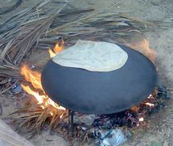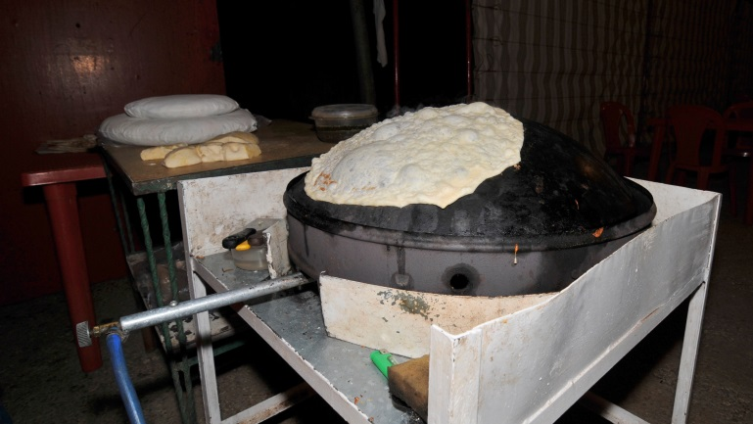
Recommendation: create a separate “sadj”-dedicated space due to differing preparation timing and needs for baking bread in this custom. It would avoid spatial overcrowding and efficiency of outputs (bread alongside other meal components).

Curved Concentrator Solar Cookers:
A mirrored surface with high specular reflectivity is used to concentrate light from the sun onto a small cooking area. Depending on the geometry of the surface, sunlight can be concentrated by several orders of magnitude producing temperatures high enough to melt salt and smelt metal. Solar cookers are typically designed to achieve temperatures of 150 °F / 65 °C (baking temperatures) to 400 °C / 750 °F (grilling/searing temperatures) on a sunny day. Solar cookers concentrate sunlight onto a receiver such as a cooking pan. The interaction between the light energy and the receiver material converts light to heat. This conversion is maximized by using materials that conduct and retain heat. Pots and pans used on solar cookers should be matte black in colour to maximize the absorption.

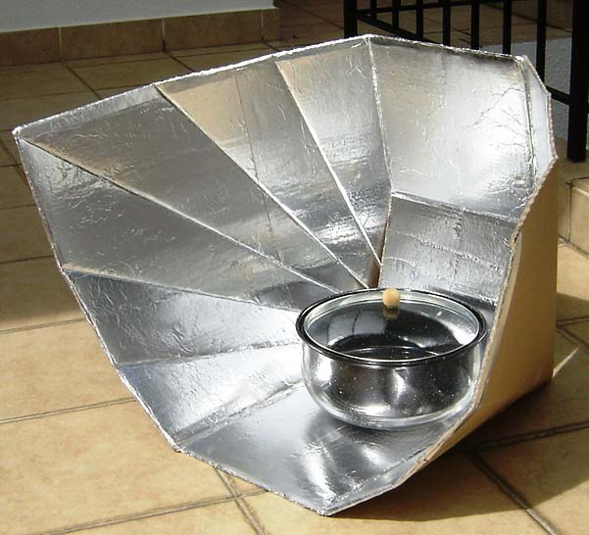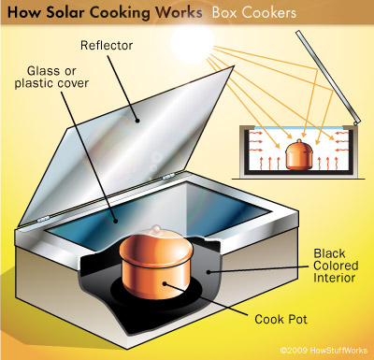

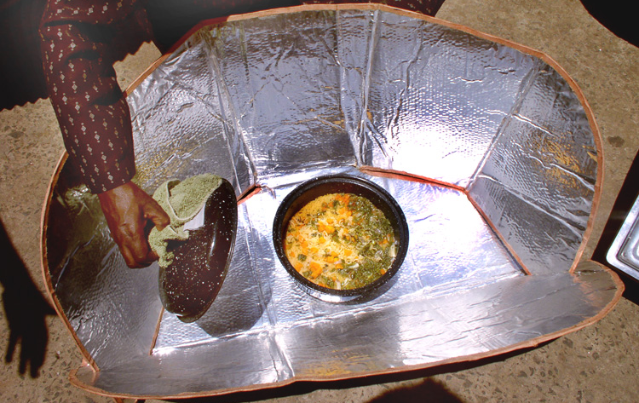

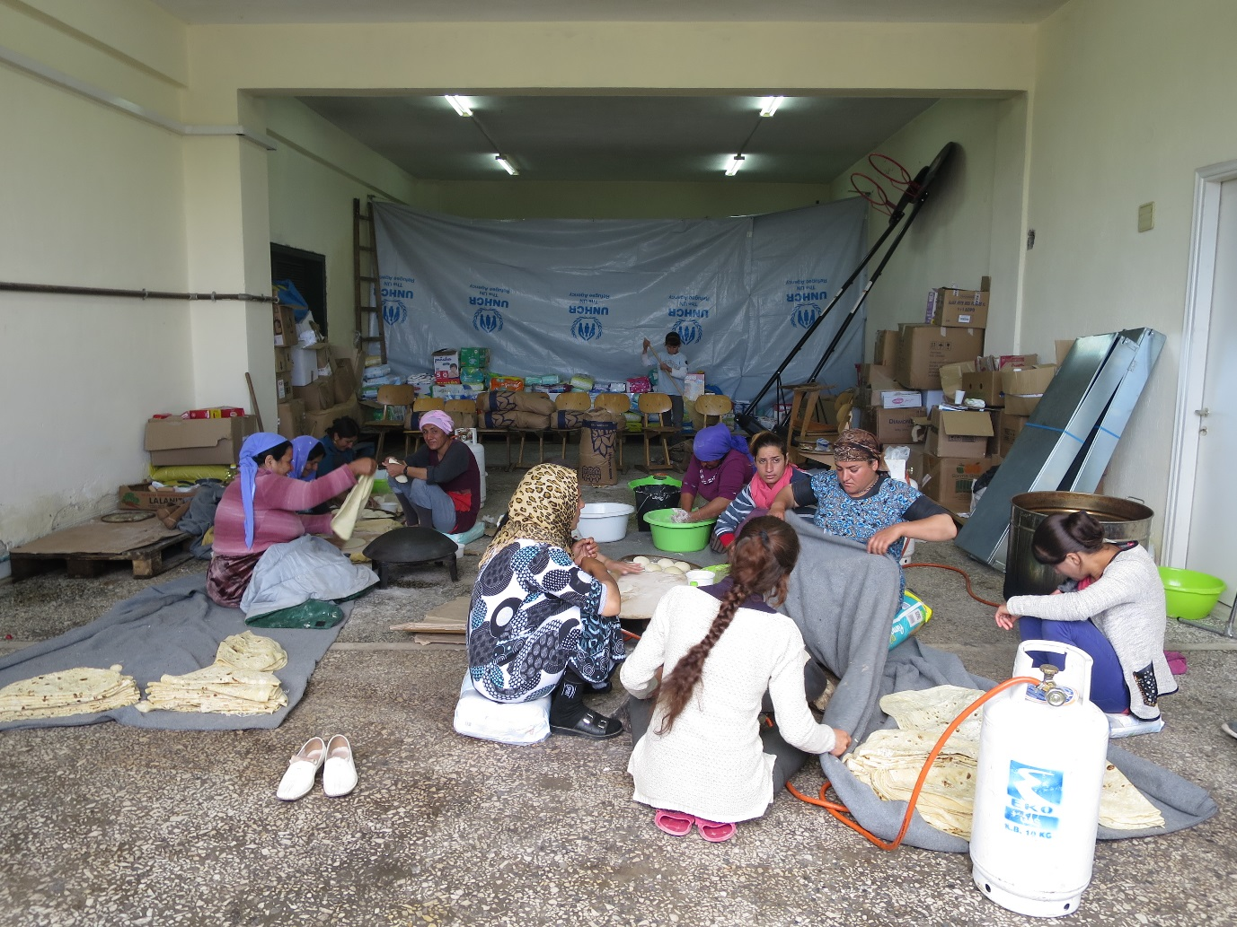IMAGE 001: Sadj bread-making at Petras Olympus site, Greece (17 May 2016, NRC).
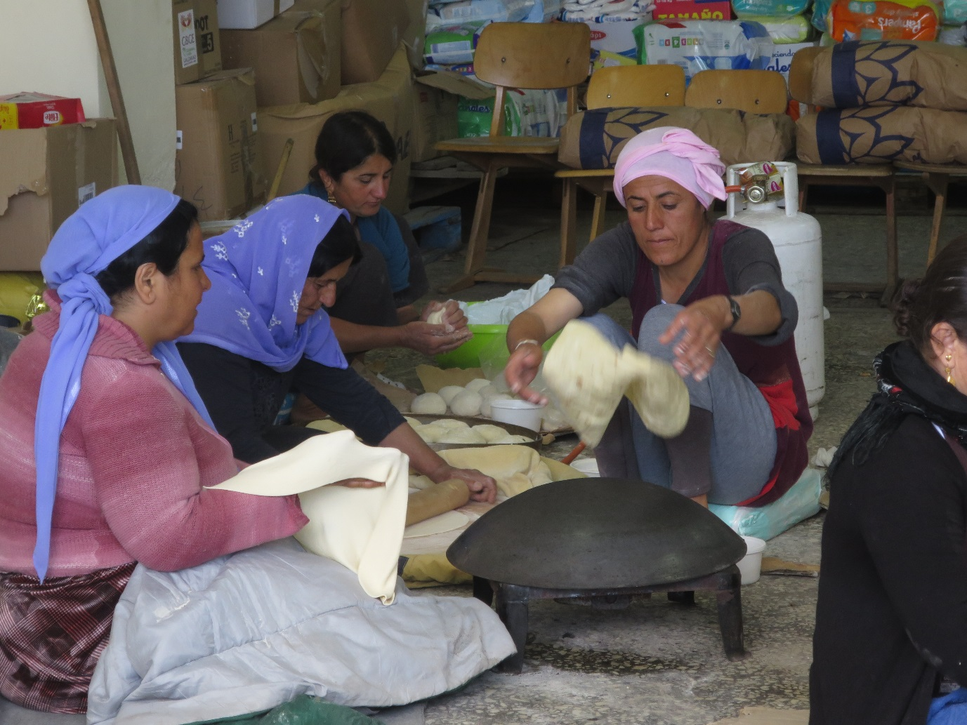
IMAGE 002: Sadj bread-making at Petras Olympus site, Greece (17 May 2016, NRC).

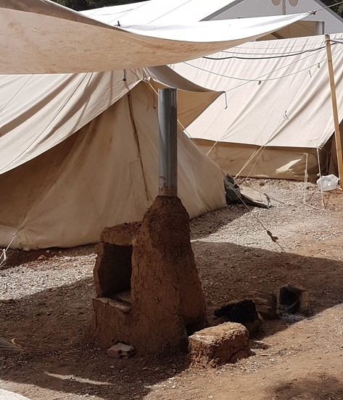
IMAGE 003: Brick insulated fire ovens at Ritsona site, Greece (15 May 2016, UNHCR).
Communal Kitchens in Pakistan:

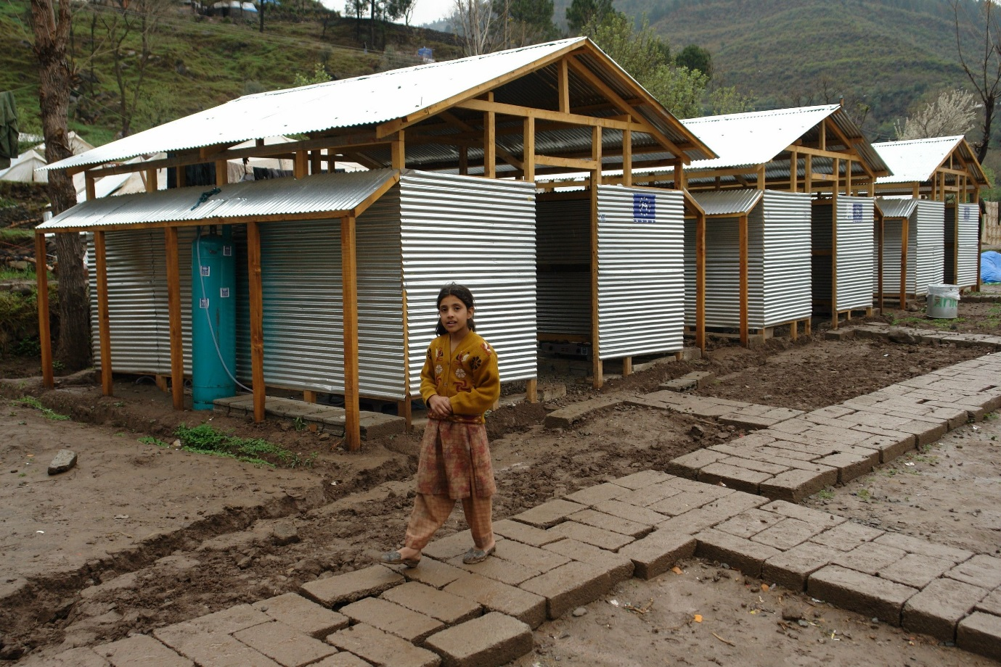

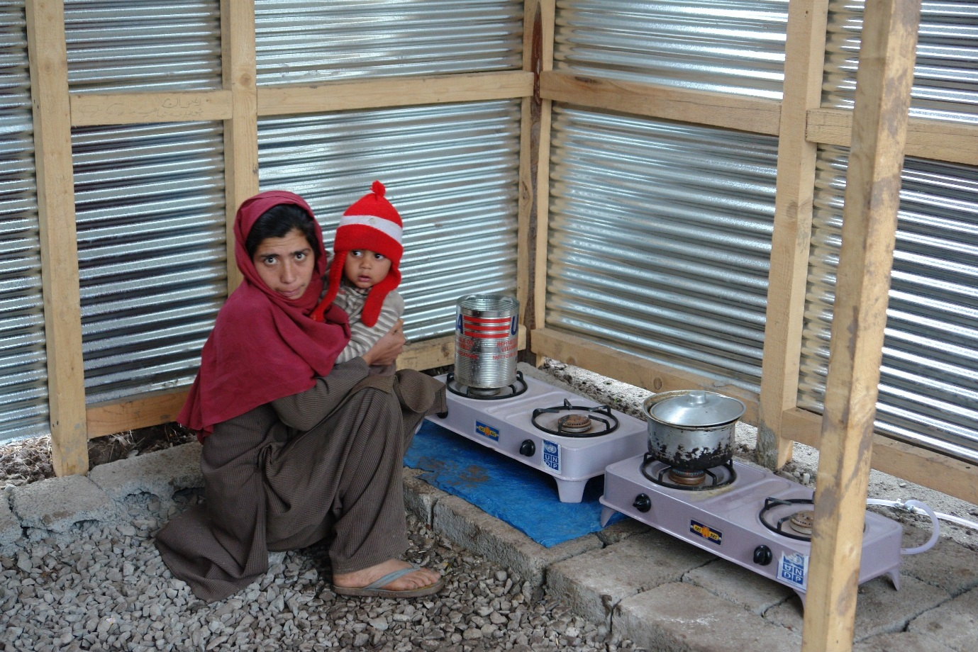

Cash Working Group, ‘Market-Based Response in Greece: Recommended Minimum Expenditure Basket’, version May 2016.

