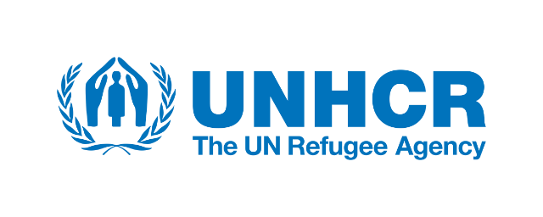

UNHCR commends Jordan’s continued solidarity with refugees on the occasion of World Refugee Day
Amman, 21 June 2018 – The UN Refugee Agency, UNHCR, marks World Refugee Day this year in honour of the resilience and courage of more than 68 million people who have been forced to flee war, persecution and violence. Under the heading “We stand together #WithRefugees”, we aim to mobilize global public support and all members of society to stand with refugees on World Refugee Day. When refugees and local communities work together, everyone benefits.
To mark World Refugee Day, UNHCR in Jordan is hosting its first ever #WithRefugees Summer Bazaar in Ras Al Ain Hangar in Amman. The Bazaar has more than 35 different stalls of refugee vendors, selling their handmade items of handicrafts, paintings, desserts, foods, clothes, accessories, home décor and many more. The sellers are refugees of different nationalities from in and outside the camps and organizations that work with refugees in all settings around the Kingdom. The revenue will go immediately to the vendors themselves. The 2-day Bazaar gives the refugees the opportunity to earn money, promote their work and mingle and communicate with different communities – refugee and host – in such an exciting setting.

The #WithRefugees Summer Bazaar is generously sponsored by the Embassy of Canada in Jordan, Cairo Amman Bank, IrisGuard, Landmark Amman Hotel & Conference Centre and Zain Jordan.

While Jordan is one of the countries most impacted by the consequences of forced displacement in the world, it remains a model in the region and beyond in its solidarity with refugees, which we also celebrate today. Latest UNHCR figures show that Jordan is a temporary home to the second largest number of refugees per capita in the world, with 1 in 11 people forcibly exiled. It is also the seventh largest refugee-hosting country in the world with over 750,000 refugees and asylum seekers registered for international protection with UNHCR across 56 different nationalities. The majority are Syrian but with sizeable communities from Iraq and increasing numbers from Yemen. Other refugees present in Jordan are from many of the world’s worst trouble spots including Sudan and Somalia.

Refugees unable to return to their countries want nothing more than protection and the opportunity to make a decent living away from home to benefit themselves, their families and their host communities. UNHCR worked together with the Government of Jordan towards making achievements in the right to work for Syrian refugees, which represents a good step forward for families’ resilience. However, the overall needs remain acute, with a staggering 86% of refugees living under the poverty line.

Stefano Severe, UNHCR Representative to Jordan, explains that “World Refugee Day is a time to highlight the resilience and bravery of those who have been forced to flee as they aim to rebuild their lives in safety. It is also a time to recognise the communities who have welcomed them in Jordan, their generosity and solidarity. By working together, we can all have an impact on improving lives.”

UNHCR, the UN Refugee Agency, was established on December 14, 1950, by the United Nations General Assembly. UNHCR safeguards the rights and well-being of refugees and stateless people. In more than six decades, the agency has helped tens of millions of people restart their lives. UNHCR is on the front lines of the world’s major humanitarian crises, including Syria, Iraq, Central African Republic, Afghanistan, South Sudan, Democratic Republic of Congo, Myanmar-Bangladesh and countless other emergencies.

END

For more information please contact:
[ENG/ARA] Nida Yassin, External Relations YASSINN@unhcr.org +962 79 715 2336

