Briefing document for technical Deployments in Uganda
PUBLIC HEALTH
aPRIL 2018
VERSION 1

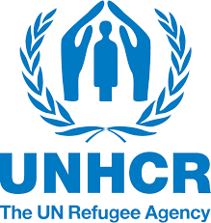

PUBLIC HEALTH SECTOR
Coordination and leadership
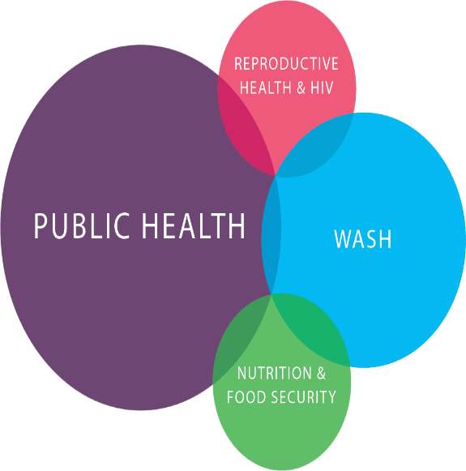
The UNHCR health sector is coordinated at Central level in Kampala and Field level by a team of skilled professionals that oversee refugee and immediate host population health service delivery. In each of the refugee hosting district, there is a Public health Officer that is responsible for the day to day health coordination with districts and partners to ensure integration; provision of technical support and guidance.
The UNHCR health sector works in collaboration with the Ministry of Health at both Central and field level through the respective District Health Offices where refugee settlements are located to ensure integration in to the national health care system. The Ministry of Health (through DHOs at field level) and UNHCR co-chair the monthly refugee health coordination meetings at Kampala and in the respective districts.
The refugee health and nutrition health response is guided by the Uganda National Integrated Health Response Plan for Refugees & Host Communities and UNHCR Public Health Strategic Plan 2018-2022. Health service delivery is in line with Uganda Health Policy and Health Sector Development Plan, guidelines, strategies and standard operating procedures. In addition, UNHCR in Uganda supported or is part of:
- UNHCR signatory of Compact between Ministry of Health and Partners for Implementation of the Health Sector Development Plan 2015/6-2019/20
- Uganda National Integrated Health Response Plan for Refugees & Host Communities
- MoU with Ministry of Health and MoU between UNHCR, MOH and Medical schools which are aimed at strengthening the Comprehensive Refugee Response Framework.
Currently UNHCR Partnerships:
- Ministry of health – Policy direction, oversight, coordination and technical support. UNHCR is a member of Health Policy Advisory Committee and MOH created a desk to UNHCR team at the ministry of Health.
- Health Donors Group –influencing of policy direction and funding for refugee and host population health services
- Bilateral agencies – funding of the CRRF for health through the NGOs or UN agencies
- UN agencies though UN Delivering As One initiatives for refugees hosting districts
- District Local Governments – decentralized health services implementation, support supervision and field level coordination. UNHCR is co-lead and health partners are members of the District Health Team
- International and National NGOs – implementation, coordination and resource mobilization for service delivery.

Health Care to Refugees and Host Community
In line with the NDP, ReHOPE and CRRF, Public health sector contributes to the integration of social services. In this, the integration of Public health is defined and pursued in the four prongs as follows:

- Accreditation & alignment of health facilities & Refugee health workers -recognized by MoH
- Building the capacity of the District Health Care systems
- Strengthening strategic coordination & leadership with MoH at central and districts
- Re-orientation of the roles of IPs more to support and less direct service delivery
UNHCR in Uganda works through implementing partners and District local governments to deliver health services. The refugees within the settlements share health and water facilities with the immediate host population. Each of the health facilities in the settlement is established in line with the Ministry of the health guidelines and reports to the Ministry of Health through the District. Health partners are part of the District Health Management Team (DHMT) and facilities are supervised by the DHO. Refugees benefit from the referral facilities which are located within or outside the district at no cost.
Current Status
In 2017, UNHCR supports 95 health facilities across 12 refugee hosting districts that provided a total of 2,129,027 medical consultations in 2017 out of which 22% were to host population. The Crude mortality rate was at 0.1 against a standard of 0.75 deaths for every 1000 population in a month and Under-five mortality rate stood at 0.2/1000/month against a standard of 1.5. The Food Security and Nutrition Assessment in 2017 reported weighted GAM 3.8% in South West and 10.8% in West Nile
There were 19,704 live births and approximately 94% of all deliveries were at the health facilities. There were 19 maternal death across all refugee settlements which were all investigated and documented. The coverage of PMTCT in 2017 was 100% and 93% of all newborns to HIV positive women were given ARVs within 72 hours after delivery. The total number of HIV positive patients on ARV treatment are 12,019.
The top causes of morbidity included malaria (37%), respiratory tract infections (24%), skin infections (5%), watery diarrhoea (5%), and intestinal worms (3%). Since February 2018, we have had an outbreak of Cholera in Kyangwali and Kyaka with a total of 2,106 cholera cases and 44 cholera related deaths reported.
Each of the settlements generate Analyzed weekly reports, surveillance reports of disease of outbreak potential and Monthly Health Information Reports. Gap analysis matrices and 3W matrices are updated on a monthly basis and disseminated.
Key challenges
Infrastructure - remains a critical challenge across the operation with 36 facilities temporary health facilities. We lack medicine stores in Arua, Moyo, Lamwo, Rwamwanja and Bidibidi. Staff accommodation is still a big gap where a number of health workers are sleeping in tents or sharing accommodation. These infrastructural gaps in the settlements compromise the quality of health care and are partly responsible for the high staff turnover.
Risk of outbreaks - The continued influx of refugees causes a high threat epidemic potential diseases like viral hemorrhagic fevers, cholera, measles and meningitis. The high influxes coupled with outbreaks strains the limited resources available especially human resource and medical supplies.
Community Health - The community health structure within all the settlements are inadequate due to low incentives of Village health teams (VHTs) which leads to increased disease morbidity that overwhelm the health facilities within the settlements.
Referral health care – there are challenges with the referral hospitals because of inadequate resources in terms of human resources, equipment, commodities and infrastructure.
Gap Analysis
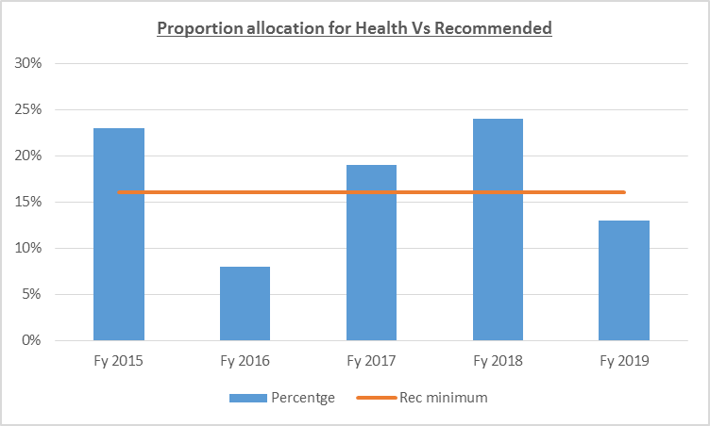
Inadequate budget for health – current per capita expenditure is $6.5 per refugee per year less than the 12 USD by government of Uganda. Hence conducting training for health workers as well as providing adequate support for community health interventions including incentives for Village health teams (VHTs) remains unfunded.
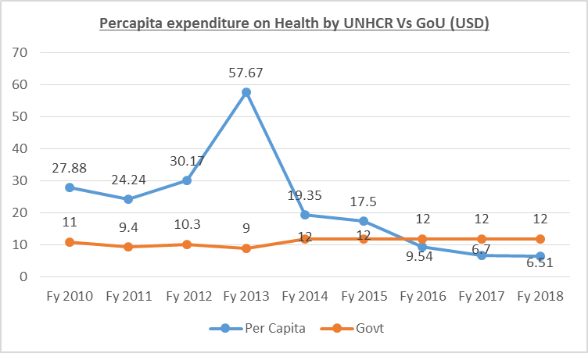
Infrastructure – 39% of the health facilities are temporary in nature therefore do not provide adequate privacy and quality of care. This includes the need for 197 staff accommodation units across the settlements, incinerators, placenta pits, isolation wards and diagnostic equipment.
Malnutrition – high prevalence of Aneamia and macrodeficiencies especially in West Nile refugee settlements (GAM > 10%). Mainly because of nutrition practices and food security.

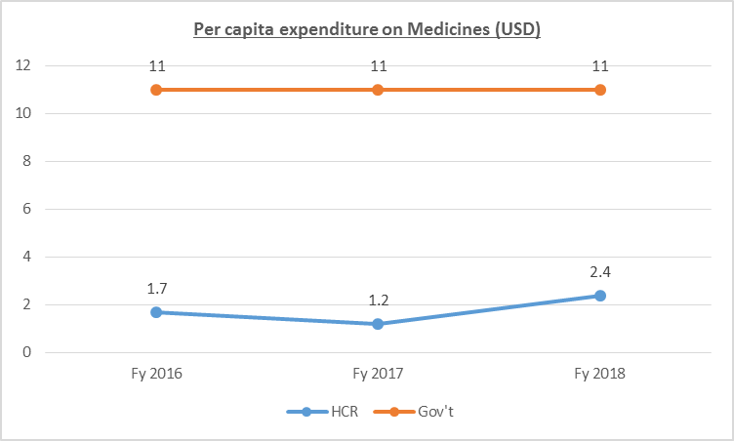
Medicines and medical supplies - While UNHCR provides $2.4 per refugee per year for medicines compared to $11 offered by the Gov’t of Uganda. This partly contributes to ruptures in the pipelines contributing to the loss of confidence and affects the health seeking behavior. This is further worsened by inadequately remunerated community health team.

Referral health care – inadequate capacities of regional and district referral hospital necessitate the need to support the HCIV near the settlement to provide the much needed referral services closer to the settlements.

UNHCR priority areas of interventions

The key priority areas of intervention as defined in the Strategy include improving access to comprehensive primary health care services, Preventative and community-based health care services, communicable and Non-communicable disease programming s, Tuberculosis control and prevention, rational medicines use in health facilities, Malaria and integrated vector management & control

Reproductive Health & HIV - Strengthening emergency response, comprehensive safe motherhood services, Care and treatment of PoCs living with HIV and AIDS, Clinical management of rape, Safe and rational blood transfusion and standard precautions practice,
Nutrition and food security - Promotion of IYCF Practices, Community Management of Acute Malnutrition programs, Control of Anaemia and Other Micronutrient Deficiencies, Capacity Development of health workers, Conduction Assessments and Analysis as well as implementing Nutritional Surveillance System

Cross cutting issues with other sectors
WASH
The availability of Water in the settlements is vital for the prevention and control of diarrhoeal diseases as well as personal hygiene. Each person should be able to attain water according to the UNHCR standard (20 liters/person/day). The latrine coverage is critical in the human waste management and hence contributes to prevalence of diarrheal diseases
Construction
The communal shelters built should have adequate aeration and less congestion to control the spread of air-bone and other communicable diseases. In addition it is critical to have isolated shelters for persons coughing so as to reduce spread of air-bone diseases.
The construction of roads leaves gutters where water collects and provides favorable breeding sites for mosquitoes which increases the burden of malaria in the settlement
Protection
Sexual and Gender Based Violence survivors need to be brought to the health facilities within 72 hours. At the same time, Protection teams needs to be part of the Multifunctional Teams for addressing sex work interventions in the refugee settlements by addressing the vulnerability of children, women, men and boys.
Resettlement
There are a number of sick cases that need durable solutions such as resettlement and should be identified and discussed by the health and resettlement sectors

Cash Based Initiatives (CBI)
Strengthening the community health structures within the operation will require use of voucher system for village health teams and this will need support and collaboration with the CBI sector

Project Control
The monitoring and auditing of the health partners should be a multifunctional team with the health sector, project control and core programme

Lessons Learnt (Dos and Don’ts)
Dos
- The UNHCR Public Health and WASH sectors should both attend the health and nutrition coordination meetings as well as the WASH coordination meetings at central and field level.
- It is important to conduct joint monitoring both the implementing and operational partners within the settlement at least once every quarter.
- Provision of room and facilitation for the District Health Offices and MOH to be actively involved and lead the health refugee response

Don’ts
- Sharing health related information without validating with the Public Health team – especially during outbreaks and emergencies

Names and functions

Name | Title | Email | Location
Julius Kasozi | Public Health Officer | kasozi@unhcr.org | Kampala
Ronald Nyakoojo | Assistant RH and HIV Officer | nyakoojo@unhcr.org | Kampala
Ibrahim Wadembere | Associate Public Health Officer | wadember@unhcr.org | Kampala
Emmanuel Omwony | Senior HIS Associate | omwonyi@unhcr.org | Kampala
 | Senior Pharmacy Associate | Recruitment ongoing | Kampala
 | Associate Nutrition and Food Security Officer | Recruitment ongoing | Kampala
Gerald Naluwairo | Assistant Public Health Officer | naluwairo@unhcr.org | Kyangwali & Kiryandongo
Agnes Naggayi | Senior Public Health Associate | naggayi@unhcr.org | Rwamwanja & Kyaka II
Alice Alaso | Senior Public Health Associate | Alaso@unchr.org | Nakivale & Oruchinga
Bosco Muhindo | Assistant Public Health Officer | muhindo@unhcr.org | Adjumani & Lamwo
Patrick Okello | Assistant Public Health Officer | Pokello@unhcr.org | Moyo
Emmanuel Kerukhado | Associate Public Health Officer | Kerukhad@unhcr.org | Ivempi & Rhino
 | Assistant Nutrition and Food security Officer | Recruitment ongoing | Arua
Harouna Iname | Public Health Officer | Iname@unhcr.org | Arua (West Nile)
Samuel Onyait | Assistant Public Health Officer | Onyait@unhcr.org | Yumbe
Emmanuel Tshibanda Tshisuyi | Associate Public Health Officer | Tshisuyi@unchr.org | Mbarara (South West)
Marcel Lumbala | Health and HIV Officer (ERT) | lumbala@unhcr.org | Kyangwali
Barbrah Nabutanda | Assistant Nutrition Officer | nabutand@unhcr.org | Adjumani

Public Health Unit
UNHCR Representation in Uganda

Annex: Understanding the medicines bottlenecks

