Terms of Reference - Basic Needs Working Group (BNWG)

With the influx of refugees and other vulnerable people coming from Ukraine and multiple humanitarian actors on the ground providing emergency assistance and longer-term solutions, in early 2022 a Basic Needs Working Group has been set up under the Refugee Coordination Model in Hungary. The group will support the local leadership and works to ensure the humanitarian response is linked with the government and local response.
- Governance and Leadership
The BNWG in Hungary is chaired by UNHCR and IOM with the proposal of having a rotational local partner co-chairing the meeting, to diversify the expertise of the chairs/co-chairs, promote inclusion and accountability, and build up on the capacity of local actors for a more sustainable coordinated response.
- Accountability
The BNWG is part of the Refugee Coordination Forum (RCF) structure and is accountable to the inter-agency coordination group.
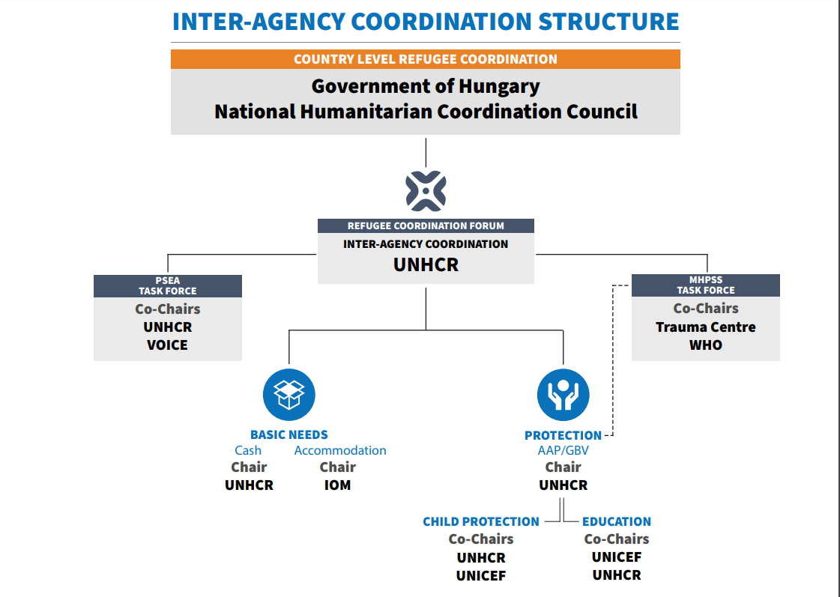
- Objectives of the Working Group

- To define needs-based standards to guide and support organizations active in the refugee response in-country;
- To identify and jointly address gaps in basic needs, accommodation and cash /voucher assistance.
- To mitigate against duplication and identify ways of continuously improving complementarity among sectors, sector partners, and governed-led response;
- To ensure the overall cash and voucher response is coherent, avoids duplication, and finds opportunities to increase effectiveness.
- To develop evidence-based tools that help inform appeal formulation, project design and prioritization to best assist the affected population;
- To promote effective information sharing, reporting and management on basic needs, accommodation, and the delivery of cash/voucher assistance across the response, and in close collaboration with RCF, and Information Management Officer (IMO)
- Promote the use of joint mechanisms (when possible), standards, and tools for harmonized, accountable programming:
• Coordinate discussions on setting transfer values and eligibility for cash-based assistance, that are aligned with the national social protection system
• Promote a coherent and secure approach to data management, data sharing, and digitalization
- To guide and facilitate annual planning for appeals and ensure timely reporting against operations (RRP and its monitoring framework) and contribute to interagency operational updates;
- To connect with and support government-led policy-making structures engaged in Response Plan;
- To mainstream protection, AGD approach and reinforce Protection from Sexual Exploitation and Abuse (PSEA) through core prevention and response measures, ensure CWG participation at the PSEA TaskForce;
- To facilitate preparedness in basic needs, cash/voucher assistance and accommodation for the contingency planning in case of new influx
- To provide technical guidance to other sectoral Working Groups.

- Outputs

- Develop and Implement Activity Plan for BNWG for 2023.

- Modalities

- Membership of the Basic Needs WG is open to operational actors aiming to coordinate humanitarian assistance on basic needs, accommodation and cash/voucher assistance in the country. Representatives of local and national authorities and other stakeholders, such as donors, are encouraged to participate.

- Meetings and Periodicity

- The group will meet monthly, or more frequently as required, notification of which will be sent by email to participants a minimum of seven calendar days beforehand.
- The meeting agenda will be shared beforehand and intercalated between thematic areas under BNWG
- Minutes of the meetings will be circulated for approval within ten days.
- Documents prepared by BNWG members for external audience will be uploaded in UNHCR data portal for wider dissemination, accessible here.

- Revision of the Terms of Reference
- The Terms of Reference guiding the structure and activities of BNWG will be reviewed after one year or based on immediate needs as agreed by the members.

