Syria crisis field diary (23 July 2012) (193 wds)
Feeling the pulse of UNICEF’s emergency response for Syrian refugee children
Ruba Mukbel
Field Monitor, UNICEF Jordan
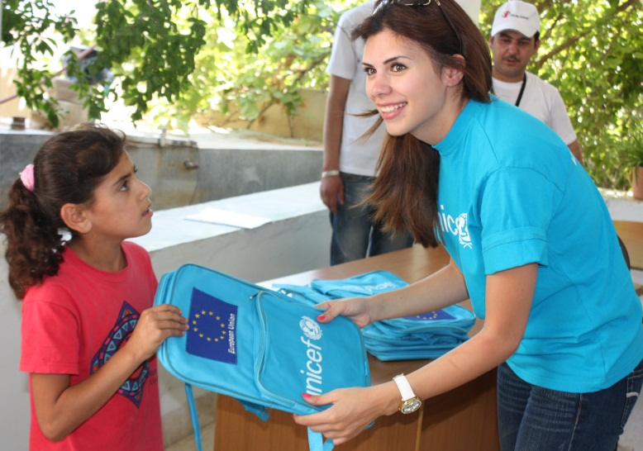
One of the best things about my job is that I get to see close up what UNICEF is doing to help Syrian refugee children and their families.
As a field monitor, I regularly visit UNICEF-supported programmes around Jordan. This includes the refugee transit sites near the Syrian border, where Syrian families go when they first arrive.
UNICEF supports Child Friendly Spaces, where children have a safe space for informal learning, recreation and psychosocial support. They are a great place for children to be with other children and recover their sense of play and fun.
UNICEF Jordan field monitor Ruba Mukbel distributes schoolbags to Syrian refugee children at a UNICEF-supported summer camp at Ramtha, northern Jordan. Photo courtesy of Save the Children/Elkhairy
UNICEF is also providing urgently needed water supplies and sanitation facilities, along with hygiene awareness training and materials. With growing numbers of people living in close proximity at the transit sites, support for hygiene awareness and water conservation in this water-poor area is vital.
I also monitor the summer camps and parenting sessions being held around Jordan. Every day is different and I enjoy interacting with a wide range of people such as children, parents, teachers, staff at partner agencies and government officials. I get a good sense of how our programmes are going and how Syrian children’s lives are being improved.

