Syria crisis field diary
Syrian refugee children & families face challenging conditions at Jordan camp
David Youngmeyer
Communication Specialist, UNICEF
It was about a month ago that I travelled to a tract of desert in northern Jordan to see the beginnings of this country’s first refugee camp. At that time graders were scraping and levelling the barren ground in readiness for tents and facilities for thousands of Syrian refugee children and families.
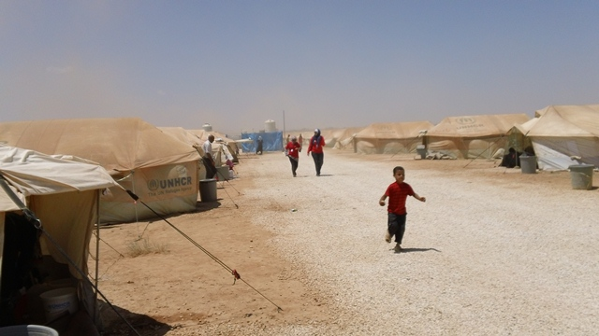
As the days turned into weeks, the flow of Syrian refugees crossing the border into Jordan became a torrent. Transit facilities at Ramtha became seriously overcrowded, with around 10,000 people being registered as refugees in July alone. There was a real race against time to get the new Za’atari camp up
Dust is a big issue for Syrian refugee children and families at Za’atari camp. © UNICEF/2012/Youngmeyer
and running.
Today what was an empty landscape is unrecognisable. It’s a bustling place full of tents and more than 6,000 people, half of them estimated to be children. UNICEF and partners provide essential services such as drinking water, toilets, showers, and Child Friendly Spaces.
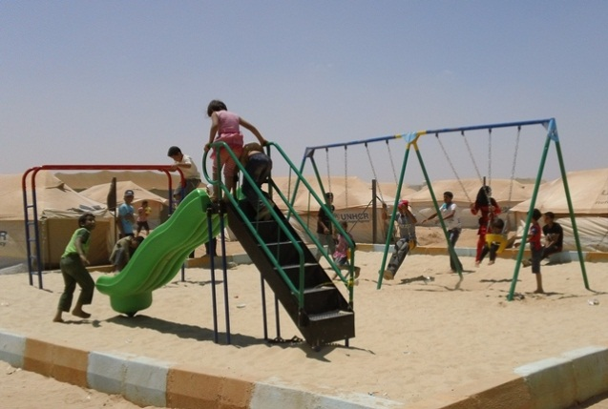
There is no doubt that the location is challenging, being both dusty and windswept, and with no natural shade. The heat has also created problems. Initially the drinking water in the 10,000 litre water bladders became very hot, making it difficult to drink, but tarpaulins have now been installed over the bladders to give shade.
Children enjoy the swings, slide and climbing frame at a UNICEF-supported playground at Za’atari camp. © UNICEF/2012/Youngmeyer
Traditional clay pots, which help to keep water cool, have been provided to families. A playground is now full of children, but the sun is unrelenting, so shading is to be installed soon.
The camp has come a long way in just a month and improvements continue to be made, but what is desperately needed is more funding. The numbers of new arrivals keep on rising every day.

