Winterization Standards 2015-2016
- Discussions from the First Winterization Standardization Meeting
In the first meeting of the Winterization TF (5 June 2015), the following elements were agreed:
- Standard package – this will remain the same as last year. The agreed contents of the standard package include:
Either 1 high thermal blanket per person or two medium thermal blankets per person + 1 heater + bottles + refills.
- Use of the winterization module – updates are to be made but the RAIS module will once again be used in order to avoid duplication.
- Referral between the Shelter WG and the Basic Needs WG – for better coordination between the two working groups, it was decided that whenever a Sealing Off Kit (SOK) is provided under shelter assistance, referral should be made to include a winterisation standard package. It was recognised that referral based on the opposite way round cannot be easily defined, but shall remain the responsibility of agencies to refer when they see fit.
- Distribution to vulnerable parts of the population – guidelines are to be drafted relating to those with special needs and the elderly.
- Inclusion of vulnerable Jordanians – this should be tackled proactively, by coordinating with local partners such as JHCO, Tkiyet Um Ali, and the Zakat Fund.
- Targeting criteria – this is to be discussed in August.
The following elements were discussed but required further follow up:
- Two-tiered system – there were discussions on whether NFIs that can last more than one year should be redistributed or not. A tiered system was in place during the last cycle, which allowed for partial winterization packages. However, concerns were raised, as refugees are known to liquidate NFIs received as part of winterization assistance in the warmer summer months. It was agreed that a rapid assessment of heaters should be conducted to better understand to what degree these assets are liquidated (see section II).
- Preference for per capita calculation of assistance (even if pro-rated) – it was agreed that a household approach to distributing assistance creates difficulties, as more than one family often live in the same household. Instead, a per capita approach would be more effective, particularly when distributing cash assistance. However, the TF encountered some difficulties when discussing how a per capita approach could be applied to NFI distribution. It was agreed that some market research should be conducted to determine the cost in JOD of the NFI items included in the standard package (see section III for results).

- Rapid Assessment of Heaters
Since the first meeting, five partners (DRC, IRC, PU-AMI, UNHCR, UNICEF) conducted a rapid assessment to better understand to what degree heaters are liquidated. Partners used one of two options:
- When there has been prior confirmation that a heater was provided/purchased for previous winter seasons, beneficiaries should be asked if they still have the item.
- When there is no prior knowledge on whether Winterization assistance was provided, beneficiaries should be asked if they received winterization assistance and whether it included a heater or cash for a heater. If a heater was acquired, they should then be asked if they still have it.

IRC
Methodology: A small sample (around 20%) of beneficiaries had reported buying winter household items, from which a random sample of 87 cases was selected. They were asked questions related to scenario 1: did you buy a heater last winter? Do you still have it?
Results: 80.46% reported buying a heater from IRC Winterization cash assistance, of which 91.43% reported that they had kept it until now.

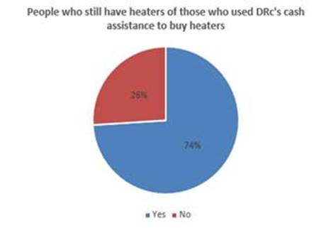DRC
Methodology: A follow-up phone survey was done with HH randomly sampled form the originally contacted for feedback in March 2015. The sample includes 70 households (interviews with HoH or spouse).
Results: 27% of the beneficiaries reported using the cash assistance provided by DRC in December-January to buy heaters. These had an average cost of 66 JOD. Of those who used at least a portion of the cash to buy a heater, 74% of still have heaters at their homes. Only three interviewed households indicated that they had sold their heaters. Overall (not only those who used cash assistance for heaters), 64% of the participated beneficiaries (average family size = 5) reported that they still have heaters for the coming winter season.

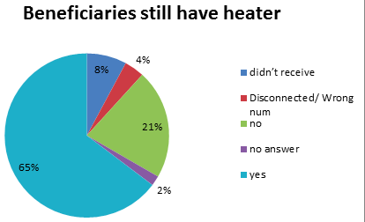
PU-AMI
Methodology: 51 households were selected, all of which had received either full NFI assistance or a heater in the 2013-2014 Winterization cycle. They were asked one question related to scenario 1: do you still have the heater?
Results: 33 out of 51 households (64.71%) reported that they still have the heater received in the 2013-2014 Winterization cycle. 11 out of 51 households (21.57%) reported that they no longer have the heater; 1 did not give an answer and 2 were either disconnected or a wrong number. Note: 4 households answered that they did not receive a heater, despite their case numbers being present on the list. This could be due either to a small percentage of error on the list, or the beneficiaries not giving the correct answer.

UNICEF
Methodology: Telephone interviews were conducted with a sample of 100 random families from a total of 500 families receiving UNICEF child cash grants.
Results: 63 families out of the 100 asked acknowledged receiving Winterization assistance. Out of this 63, 39 families stated that the type of assistance received was cash, whilst 24 said they had received heaters. Out of these 24 families who received heaters, 12 families stated that they still have the heaters.

UNHCR
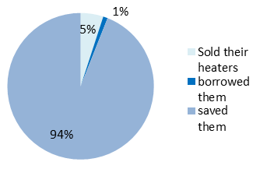
Methodology: A sample size of 270 families who had declared they had bought either heaters or gas refills for their heaters in the PDM for the 4th quarter of the year 2014 was selected. These families were called and asked questions based on scenario 1.
Results: 94% of cases answered that they did not sell their heaters. 5% of cases said they had sold their heaters, which they did after the winter season and for varying reasons. The most prevailing reason was to pay the accommodation rent, whereas others sold their heaters to buy NFIs or to pay for health services. 4 cases answered that the heaters they used during winter had been borrowed from their neighbours and returned after the winter season had finished (Note: these are all families
who had reported buying refills in the PDM).

- Discussions from the Second Winterization Meeting

In the second meeting of the Winterization TF (30 June 2015), the following elements were agreed:

- Two-tiered system - The findings from the rapid assessment of heaters received in previous Winterization cycles generally show that most often, beneficiaries actually kept their heaters. The retention rates observed suggests that beneficiaries are not planning on returning to Syria anytime soon, and that the heaters are clearly an effective and valued item to have. It was therefore agreed by the TF that this is sufficient evidence to act in favour of keeping a two-tiered system, as in the previous cycle.
- Distinction between settlement types in urban areas – the issue of those living in makeshift shelters was raised, as the winter season is particularly tough in these living conditions. It was agreed that when there is a case living in a makeshift shelter, the beneficiaries should automatically qualify to receive the full winterization package. However, agencies offering assistance to beneficiaries living in makeshift shelters should be as discrete as possible and should monitor the actions and discussions of the ITS Task Force. It is important to be aware that when giving assistance to beneficiaries living in ITS, the needs of the host communities should also be addressed.
- Preference for per capita calculation of assistance – a draft table outlining the costs of the standard winterization package per family size was presented to the TF. This was based on the results from the market research conducted by four organisations (ICMC, NRC, PU-AMI, UNHCR) to determine the cost in JOD of the items that make up the winterization standard package (see table below). For the NFI items that are not per capita, namely the heater, the calculations were made under the assumption that the suitable family size to use one standard heater would be up to 5. Discussions on this assumption took place, as UNICEF’s recent findings show that families most often have between 3 and 5 children, therefore challenging the basic assumption that the definition of the family unit as 5 people. In order to address this, the model used is a pro-rating one. Concerns were also raised that family sizes of 1 or 2 would not receive enough money to buy a heater and a bottle under this model. However, it was acknowledged that smaller families often share accommodation with other families. Partners are reminded that every organisation should see it within the remit to add extra assistance when they feel a case has extra vulnerability.

Market Research - Item Cost (in JOD)
 | MTB | HTB | Heater (local) | Heater (imported) | Gas bottle | Gas refill
NRC | N/A | N/A | 80 | 43 | 43 | 8
ICMC | N/A | 14 | 80 | N/A | 45 | 8-10
PU-AMI | 12-15 | 20-25 | 75-110 | N/A | 35 | 8
UNHCR | 8 | 12-15 | 70-80 | N/A | 46 | 10

- Winterization Standard

Summary of standards

- The standard package includes: Either 1 high thermal blanket per person or two medium thermal blankets per person + 1 heater + 1 bottle + refills.
- A two-tier system will be applied, as adopted last year. Cases living in makeshift shelters will automatically quality for the full standard package.
- The standards are based on a per capita approach. Based on findings from the market research (see table in section III) and using the MEB approach, the table below gives an estimate of the cost of a standard Winterization package, depending on the case size.
Note: for the costs of the “pro-rated heater + gas”, it was agreed that the suitable family size to use one standard heater is up to 5. Therefore, the figures have been calculated by taking the total price of the heater + gas + bottle package (285 JOD) and dividing it by the family size of 5.
Cost of Winterization (in JOD)
 | Unit Cost | Entitlement | Family Size
 |  |  | 1 | 2 | 3 | 4 | 5 | 6 | 7
MTB | 8 | 16 | 8 | 16 | 24 | 32 | 40 | 48 | 56
HTB | 16 | 16 | 8 | 16 | 24 | 32 | 40 | 48 | 56
Heater | 80 | 80
Bottle | 45 | 45
Refill | 10 | 160
Pro-rated heater + gas + refill |  | 57 | 57 | 114 | 171 | 228 | 285 | 342 | 399
Pro-rated refill |  | 32 | 32 | 64 | 96 | 128 | 160 | 192 | 224

Final Standard:
Per capita cost (Tier 1 – “Full”): 16 + 57 JOD = 73 JOD
Per capita cost (Tier 2 – “Partial”): 16 + 32 JOD = 48 JOD

Please Note: the criteria outlined above are intended describe the MINIMUM STANDARD of what assistance should be delivered. Every organisation should see it within the remit to add extra assistance when they feel a case has extra vulnerability. This also applies to distributing different kinds of assistance, aside from the contents of the standard package outlined.

