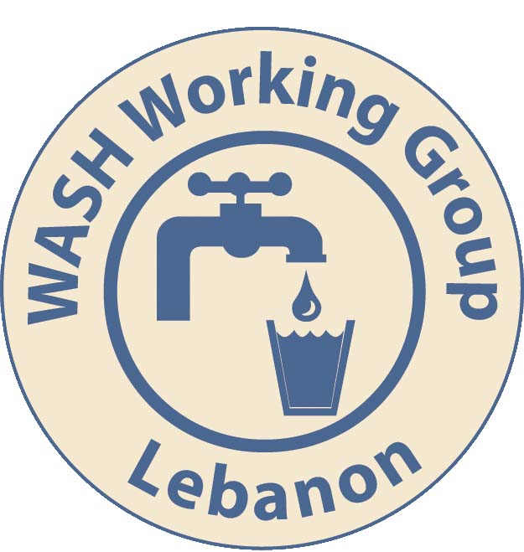

Minutes of WASH Sector Coordination Meeting - Bekaa
Date | 2015-04-08 | Time | 14h00
Meeting location | UNHCR SO Zahle | Duration | 90 mins
Chair | UNHCR Prachuap Yangsa-Ngobsuk | Co-Chair | Absent.

*Pre-meeting: WASH overlapped with the Shelter Working Group meeting, where joint issues were discussed. These are reflected in Section 7 below.

1 | Introductions and minutes from previous meetings
1.1 | In February a joint WASH and Shelter meeting was held. Since it has been determined that separating the meetings is most appropriate forum for both sectors.
2 | Updates on intervention in Informal Settlements – water/ sanitation
2.1 | Activity info:  Presentation of the updated information the database showing partners. Deadline for reporting monthly is usually the end of the first week of every month. For March uploads: Deadline is April 9th.  - Some new indicators have been included, in particular 2.4 Desludging.  - *A list of updated indicators will be shared with partners.  - All sector leads are requested to follow up with their data entry team to review the data and ensure it is accurate. This is the information needed for donor reporting.  - Training is conducted regularly at Beirut level, please contact: Remo Fambri: fambri@unhcr.org  - Training can be requested at Bekaa level if a quorum is formed. Please indciate your interest with sector coordinator or with Remo.  - Planned activities also have indicators for planned activities. Hence why you will see some planned activities in May. You can extract the achievement to isolate out the planned activity, break it down by indicator, and date trends. Etc.  - An overview of all activities by sector, area etc. for all partners can be requested from sector coordinators. (WASH: UNICEF, UNHCR).
2.2 | IAMP WASH:  - IAMP provides a monthly overview of the reporting on IAMP related to site coverage. The database is prepared by Medair. The most recent version is IAMP12, released March 28 2015.  - Some updates are delayed in reporting due to access, Medair will communicate these gaps directly with partners.  - Objective for WASH sector: One agency is responsible for all beneficiaries in an agreed area. i.e. the agency works comprehensively over the whole area. This is mainly to avoid many actors working in an area to reduce tensions and protection issue, as well as increase efficiency of service delivery and simplify the referrals process.  - An analysis of the mapping by geography over cadastrals illustrates that there is a gap in terms of WASH coverage. i.e. There are agencies that are geographically responsible, but currently many settlements in the area are not receiving assistance. This could be due to bad reporting.  - In contrast, there are partners who have capacity to expand their coverage and can cover these gaps.  - Informal Settlements with less than 4 tents: There is no specific target or restriction on providing assistance to these sites. If you have capacity you respond to everyone within the geographic area.  NOTE: apply good programming to have maximum impact with efficient use of resources.  ACTION: Partners requested to:  - All partners review the reporting by their agency to make sure there are no errors in reporting.  - All partners review their coverage to assess their issues (capacity, funding etc.), if there is a need to consolidate their coverage or if they have capacity to expand.  - The IAMP also has a column for reporting Funding Deadline. Partners are requested to use the Note section for intentions and planning and highlighting potential gap so that a handover can be arranged.  - The sector as a whole will cooperate to address these gaps. UNHCR with Medair will review the gaps as reported in IAMP and approach relevant agencies.
3 | Updates on response to evicted refugees in Rayak and other informal settlements
3.1 | Update provided by UNHCR Protection Unit  - 19 sites evicted in the last 3 months, requiring direct assistance from WASH and Shelter sector. In many of the ‘new settlements, Municipalities / Landlord are not permitting humanitarian assistance to be given.  - In some cases, Refugees are bringing with them their infrastructure from previous sites.  - There is a monthly list prepared by UNHCR on the eviction sites planned and actual and the assistance needed / given.  - Monthly committee is convened, all partners welcome.  - DEFCO5 Reyak water supply project with a borehole for Lebanese and refugees. This area is also due for evictions.  - A Google docs referral sheet is being used as a tracking mechanism for referrals. Please contact Sander Van Niekerk (NIEKERK@unhcr.org).
3.2 | Updates on contingency stocks  Contingency stock information in the system is not accurate.  ACTION: Partners are requested to update this information in the system.
4 | Partners report/ challenges/ gaps
4.1 | - Challenge in getting the relevant information to report, and the proceedures of reporting.  - Funding for each donor is under different phases and timing in the year. This is a challenge for agencies implementing under different donors.  - Donor targetting and vulnerability prioritisation may lead to gaps. The discussion is ongoing, but often in these forums it is not the right decision makers from the agencies in the room.  - Medair are looking for beneficiaries to meet their targets. Challenge is that the areas with refugees in need are either in very small settlements dispersed in a large geographic area, or larger settlements in a geographic area that is covered by another agency.
5 | Updates from National Level
 | Meeting with MOSA to review NGO operations.
6 | AOB
6.1 | The Ministry of Public Health will be meeting to determine which municipalities to target related to municipal level WASH planning. There is a workshop for planned to improve lobbying. Ross/Renata will update.
6.2 | Lice (and scabies)  There have been recent Public Health referral from schools related to Lice. Steps for action:  - PH sector will undertake assessment in the area.  - WASH & PH partners to assist the families with shampoo and guidance on the treatment  - Follow up with comprehensive Hygiene promotion.  - Post distribution monitoring  Few partners have lice stock, therefore there is a need for combined response.  There is a referral system but PH reporting is not robust. This is a PH issue, but can use the assistance from WASH to raise it.  Action: Health and WASH to collaborate to act.
6.3 | Solid waste collection and management.  - Refugees are disposing of the waste locally (ditches, burning). There is a pending concern raised with the summer heat and vector borne disease spreading.  - Under the umbrella of MOSA, UNDP launched last year the MRR process where municipalities in need were identified under criteria put forward by MOSA. Organizations are encouraged to ask to see action plans/MRRs when visiting municipalities to avoid duplication. These activities include the collection and disposal of waste.  - Partners are requested to coordinate with municipality to ensure solid waste collection is being done, and report where donated equipment is not being used.  - Distribution of bins to municipality and responsibility of municipality to use the trucks. WVI has an MOU to collect waste in 8 municipalities, as well as a flood mitigation program and cleaning of rivers.  ACTION: WVI to provide written update.
 | Agenda item for next meeting: Decommissioning of latrines. Particularly with evictions. Agency inputs.

Pre-meeting during Shelter Working Group. Cross-cutting issues discussed.

7 | Update on Google Docs referral mechanism. WASH Meeting joined.
There is a Google doc used for coordinating all sector referrals, both WASH and Shelter. This appears to be not widely used or known. This referral system is used to track movements and populations.
ACTION: UNHCR to share the link. Please use it.

8 | Information required for new Informal Settlements
As mentioned in the evictions sections, all sites under verified evictions are given a written notice.
New sites created will need a pcode. The SOP for this is to use the interagency form, which is shared with the minutes.

9 | Sealing off Kits
Large amounts of sealing of kits (SOK) were procured, and distributed as needed. There is a general impression that the content of this kit need to be reviewed based on the actual needs on the ground and the current context. Breaking up the kits and reporting on the changes is challenging.
Specific points to review include the classification of light, medium and heavy, and the content of the tool kits. Also modality through vouchers might resolve this issue.

ACTION: Refer item to Beirut with the specific caveat that Bekaa winter needs were different, which should be reflected in any TTC. Interested parties to ensure their participation.
Update from SWG Beirut 15-04-14: Temporary Technical Committee will convene on this subject. Please engage directly with your agency counterpart in Beirut to make sure your comments are conveyed, or directly represented.

10 | AOB
10.1 | Query: ECHO funding – interagency questionnaire. Anyone know what this is.  ACTION: UNHCR, Medair to follow up.  Update from SWG Beirut 15-04-14: Interagency HH vulnerability assessment form.This is used to guide unconditional cash assistance. It is multi-secotral. This item is almost completed.
10.2 | Query: DFID and ECHO request that partners feed into RAIS and collect information from RAIS.  ACTION: Shelter sector will soon be expected to input the houehold level data into RAIS. Partners are requested to talk to their Information management focal points to determine their input their agency has into RAIS, access to data.
10.3 | Mass Scanning facilities at UNHCR through high-speed machine.

Documents Shared: | Key links shared:
WASH Strategy | Google referrals
Shelter Strategy | Data.unhcr.org
Updated indicators list | Activity Info
New pcode form.
Evictions list

