Highlights
25  Voluntary repatriation: seven (07) Ivorian families of twenty-five (25) individuals were entered on the departure list. Arrangements are underway to facilitate the departure of these families in safety and dignity during the first fortnight of August. | 30  From May to 31 July 2017, thirty (30) new births were regularized and recorded in the database. |  | 20  Candidates did the BEPC exam of which 07 girls and all have passed, a success rate of 100%. | 35  Ivoirians were resettled in Canada, including 10 from Conakry and 25 from Nzérékoré. In total, from January to July 2017, 61 people left for Canada, including one Liberian and 60 Ivorians.
Population of concern |  | Funding
A total of 5,105 people of concern  By country of origin  Country Total PoC  Cote d’Ivoire 4,521  Liberia 289  Sierra Leone 185  Others nationalities 110  Total 5,105 |  | USD 4,471,017 requested

UNHCR Presence
Staff:  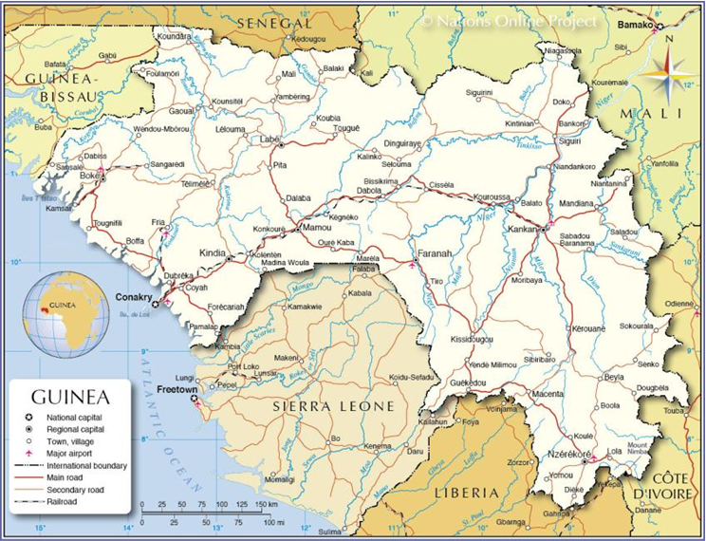  28 national staff; 01 international staff; 01 UNV; 01 National UNV  MAPPING OF REFUGEE POPULATION IN GUINEA  TOTAL REFUGEES: 5,105  TOTAL DEMANDEURS D’ASILE: 319  LAST STATISTICAL UPDATE : 30 Août 2014  Conakry: 935  Zone Forestiere 4170 | Offices:  02 offices located in: Conakry and Nzerekore

Working with partners
UNHCR works with the Government of the Republic of Guinea, along with one NGO (ODIC), other operational partners such as UN sister Agencies (FAO, UNFPA, IOM UNICEF, WFP, WHO, UNAIDS, HCDH, and UNV). Two partners (including the Governmental counterpart CNISR) implement projects in partnership with UNHCR in several areas including protection, community services, health, livelihoods, education, WASH, camp management, security as well as warehouse management. The activities are implemented by two (02) national NGOs: ODIC and the governmental partner CNISR with its regional office in Nzérékoré, BRISR (Regional Integration and Refugee Monitoring Office), and a microfinance institution: YETEMALI.
The two (02) operational partners are implementing activities in various sectors. UNAIDS, UNFPA, WHO and UNICEF support us in the areas of health, HIV / AIDS, Child Protection and Education; FAO in the field of agriculture, and UNDSS in the field of security. UNHCR works closely with non-governmental organizations (NGOs), non-profit humanitarian organizations that do not represent any government to ensure the protection of refugees and others of concern. A number of other United Nations agencies and international organizations, including the Office of the United Nations High Commissioner for Human Rights (OHCHR), the United Nations Children's Fund (UNICEF), the World Food Program (WFP), The United Nations Volunteer Program (UNV), the International Organization for Migration (IOM),

Main activities

Protection
- Ivorian refugees and Urban-based refugees: Promote voluntary repatriation and ensure the return of candidates in dignity and security. The objective of UNHCR was to bring the Ministry of Territorial Administration and Decentralization through the CNISR to support its efforts for the adoption of the Law on Asylum and Refugee Protection by the National Assembly and its promulgation by the President of the Republic. At the same time, in collaboration with the Ministry of Foreign Affairs, to encourage Guinea's accession to the Kampala Convention on Internal Displacement. In the context of statelessness, the postponement of the adoption of the Civil Code by Parliament in April will make it possible to revise the provisions on nationality before the October session. This will contribute to strengthening the national protection environment for persons under UNHCR mandate. Identify vulnerable cases that meet the resettlement criteria and refer them for resettlement consideration; ensure fair protection process and documentation; reduce risk of SGBV and improve the quality of response, including for HIV patients; guarantee efficient child protection through family tracing/reunification for UAMs and SCs; provide basic needs and services; support optimal access to education; improve the level of self-reliance and livelihoods. Facilitate the local integration in the Beyla area.

- Refugee Status Determination: In the case of DSR, out of a total of 174, the ‘’Comité Permanent d’Eligibilite’’ has sat on 40 cases. It recognized the refugee status of 33 asylum seekers, including 12 Ivorian, 18 Sierra Leonean, 2 Liberian and 1 Malian. On the other hand, the files of 7 individuals were rejected including 3 Ivorian, 2 Senegalese and 2 Sierra Leonean. The files of 34 persons were closed following the decisions of rejection of the ‘’Comité de Recours’’, but also those who abandoned the procedure. All 33 recognized asylum seekers were registered in proGres. Actually, 100 asylum seekers are awaiting their decisions.

- Documentation: Following the recommendations contained in the SOPs, the Protection Unit makes refugee documentation a priority. Concerning the registration of new births, this activity is implemented on an ongoing basis. The protection negotiated and obtained the organizer of the communities of Macenta, five records of birth certificate that it manages to its level to avoid falling into the cycle of the rupture which is frequent in the Sub - Prefecture of Kouankan. This strategy enabled the parents of all refugee children born in the camp to obtain the birth certificates of their children within the legal time limit. From May to 31 July 2017, thirty (30) new births were regularized and recorded in the database.

- Statelessness: With regard to the eradication of statelessness in Guinea, in July, the recruitment of a consultant to carry out an in-depth diagnostic study of statelessness throughout the country was launched. The main objective of this study is to collect a critical mass of qualitative and quantitative information on statelessness and to make a critical situational analysis of the phenomenon in the Republic of Guinea. The consultant recruited will start the study from 1 September 2017. In addition, several awareness-raising activities to be implemented in the second half of the year have been identified by the ‘’Comité de Suivi’’. These activities include the official launch of the National Action Plan, the organization of a radio and television panel and three (3) conferences on statelessness in universities, the dissemination of films on statelessness, the distribution of visibility kits in schools, hospitals, town halls and to the various actors involved in the struggle.
- With the postponement of the adoption of the new ‘’Code Civil’’ by the National Assembly, a meeting was held in July between the UNHCR Representative and the Director of Legislation and the Executive Director of Justice Reform both (2) officials at the Ministry of Justice. In the discussions, the representative of UNHCR invited his hosts to take into account the UNHCR comments on the provisions on nationality before the next session of the National Assembly. At the end of the meeting, the hosts made a commitment to revise the provisions in question before the adoption of the ‘’Code Civil’’ in October 2017.

- Internal Displaced Persons: In the framework of the protection of internally displaced persons, the UNHCR Representation in Guinea began negotiations with the Ministry of Foreign Affairs for the ratification of the Kampala Convention. After a meeting with the representatives of this department, documents were shared with them so that Guinea accedes to the Convention before the end of 2017.
- Celebration of World Refugee Day: Like other UNHCR Offices around the world, UNHCR Guinea celebrated World Refugee Day (June 20) at the Kouankan II camp. The celebration of this day took place in the presence of the administrative authorities of the region of Nzérékoré and the UNHCR Representative in Guinea who traveled with some colleagues from Conakry to celebrate with the rural refugees. All the arrangements were made for the success of the event: the trip of Conakry colleagues to Nzérékoré, media coverage, writing and reading of the speeches by the guests, the presentation of sketches and poems by the refugees, including football matches (girls and boys), etc ... Note that t-shirts and caps were distributed to the refugees on this occasion.

Health
Awareness sessions continued through educational talks with focus groups around the theme: "How HIV / AIDS is Transmitted". A total of 80 young adolescents took part in these talks, including 40 girls. On the other hand, 06 religious leaders of which 02 Christians were sensitized and invited to become involved in the awareness of the faithful in relation to the scourge of the HIV / AIDS. Two new people were screened positive and sensitized to submit to ARV treatment. This has led to the number of people living with HIV/AIDS at sixteen. These individuals were followed up and received their ARV endowment during the period indicated.

Camp Coordination and Camp Management
SGBV: On July 9, 2017, a case of gang rape on a lady aged thirty years was recorded between the 2 camps of Kouankan 1 and 2. The victim received medical and social care. The perpetrators of the rape remain unidentified until then, and a written complaint against X was introduced at the level of the Gendarmerie de Kouankan. Case tracking continues for documentation.

Education
The results of all national examinations have been proclaimed. For the refugee candidates, the following results were obtained: CEP, out of 56 candidates, 43 have passed including 18 girls, a success rate of 77%. BEPC: 20 candidates did the exam of which 07 girls and all have passed, a success rate of 100%. BAC: out of 20 candidates, only 8 have passed, including one girl, a success rate of 40%.

Persons with specific needs
Concerning the follow-up of persons with specific needs, home visits continued. A total of 72 PBS’s were visited by the Social / GBV / UNHCR team, including 32 chronic patients, 20 single women with children, 04 ENA’s, 01 rape survivor, and 15 elderly persons. In addition, 06 monthly food distributions were made to 451 PBS’s, including 430 Ivorian, 20 Liberian and 01 Sierra Leonean.
In Conakry, 41 persons with specific needs were visited and advised at home by the ODIC partner, including 12 women and 29 men. Among these refugees, 26 individuals, including 14 women and 12 men with specific needs (food, rent, transport ...) were assisted through the granting of financial allocations.

Durable Solutions
- Repatriation: There were no convoys of voluntary repatriation in Côte d'Ivoire during the period under review. However, the Protection Unit in Conakry and in the field has focused most of its activities on information, awareness and continuous registration of Volrep candidates. Despite the efforts made in this direction, the observation is that the refugees are not in favor of this lasting solution. In terms of statistics, only seven (07) families of twenty-five (25) individuals were entered on the departure list. Arrangements are underway to facilitate the departure of these families in safety and dignity during the first fortnight of August.
The pace and timetable for awareness-raising is maintained, ie twice a week (Tuesdays and Thursdays).

- Resettlement: During the period under review, 35 Ivoirians were resettled in Canada, including 10 from Conakry and 25 from Nzérékoré. In total, from January to July 2017, 61 people left for Canada, including one Liberian and 60 Ivorians.

- Self-reliance activities: Pursuant to Recommendation 3 of the 2016 audit report referenced OIOS audit of UNHCR operations in Guinea (AR2016 / 110/03), in accordance with AUD-17/05474 of 1 March 2017, a baseline survey was carried out in July 2017 in Kouankan, Beyla and peripheries. The individual interviews conducted with 211 beneficiaries of the self-reliance program (refugees and members of the host population) covered the following two outputs:
- Improved agricultural production
- Easy access to self-employment (02)
This process involves the collection of baseline data and also end-of-term data (the latter is scheduled for November 2017) to systematically analyze the impact of our livelihood interventions while helping to close the recommendation of the aforementioned audit report on the collection of baseline data.

UNHCR is grateful for the generous contributions of donors who have given unearmarked funding to UNHCR worldwide as well as donors who have contributed directly to UNHCR’s programmes in West Africa in 2014: Canada| Denmark | European Union | France | Japan | Liechtenstein | Nigeria | Republic of Korea| Spain | United Kingdom | United States of America
Contacts:
Firmin COKER, Protection Associate, cokerf@unhcr.org, Cell: +224 622 816 131
Tchakoly Ali TCHANILE, Representative, tchanile@unhcr.org, Cell: +224 624 401 786

