RESPONSE MONITORING TASK FORCE – MEETING 2
Minutes | November 8, 2018 | 15:00-16:00 | UNHCR BOARDROOM

Meeting called by | BO HURKMANS – IM TEAM LEADER
Type of meeting | COORDINATION
Facilitator | BO HURKMANS
Note taker | HILLARY MUMBERE
Attendees | BO HURKMANS (UNHCR), CHARLES MATOVU (UNHCR), HILLARY MUMBERE (UNHCR), DENNIS TUMUSIIME (WFP), SARAH COLLMAN (REACH), JOHN PAUL MUZEI (REACH), BYARUBAHANGA GODFREY  (OPM), MBABAZI JOHN BOSCO (FAO), KUTEESA MOSES ANGEL (SAMARITAN’S PURSE)

Agenda topics, Opening remarks, Agreement on response monitoring outputs, Agreement on reporting procedure, Agreement on reporting platforms, AOB

discussion
- Comments from Last Meeting Minutes
  - WFP asked if they could add their partners to the Task Force, this was welcomed.
  - There is need to have sector leads capacity in the Task Force, only Education has expressed interest so far but other sector leads will be approached again.

- Review of indicators and standardising activities
  - There is a need to define the activities that feed into the RRP indicators (and how they are combined if there are multiple ones) together with the sector leads. An example from Environment and Energy was shown which will be used to help other sectors do the same. The aim is to present this back to the inter-sector meeting at 20 November.
  - For each indicator the source of information, disaggregation (by location, population group, sex/age etc.), frequency of data collection, unit of measurement and calculation method will be defined. In addition, whether the indicator appears in the Regional RRP, UNHCR results framework and/or sectoral systems will be tracked in order to ensure comprehensive coverage while avoiding duplication.
  - The indicators should be ranked in terms of priority of tracking so as to identify the main indicators to track, the focus will be on RRP indicators.

- Agreement on the outputs from the response monitoring
  - It was agreed that 3-page factsheets with analysis of key RRP indicators, operational presence maps and narrative around achievements and challenges would be produced per sector on a quarterly basis at national level.
  - REACH mentioned that from their experience with the gap analysis factsheets additional pages would be needed for multi-sectoral factsheets at settlement level in order to be able to represent all relevant indicators per sector.

- Agreement on the standard procedure for reporting
  - It was agreed that reporting should be done by partners at field level with validation at national level by the sector leads and IM Unit.
  - However, in addition to this, a two-tier system was proposed whereby activity tracking forms the first level and verification or monitoring visits would form the second. A joint monitoring team from the Task Force would then carry out regular multi-sectoral monitoring missions together with the sector leads (minimum once per year, maximum once per quarter). This would help to show accountability to the public and inform programming in the long run.
  - It was suggested that all activities (whether implemented by UNHCR partners or operational partners) should be verified by the sector leads.
  - Sectors should carryout assessments to create baseline data which will help with selecting locations for the monitoring visits, this can be done through existing exercises like the MSNA.
  - The revised timeline for reporting includes 1 week for resubmission of reports in case any inconsistencies were discovered during the validation. The timeline currently looks as follows, with the first reporting to start on Monday 1 April 2019 with products expected to be available by the end of April:

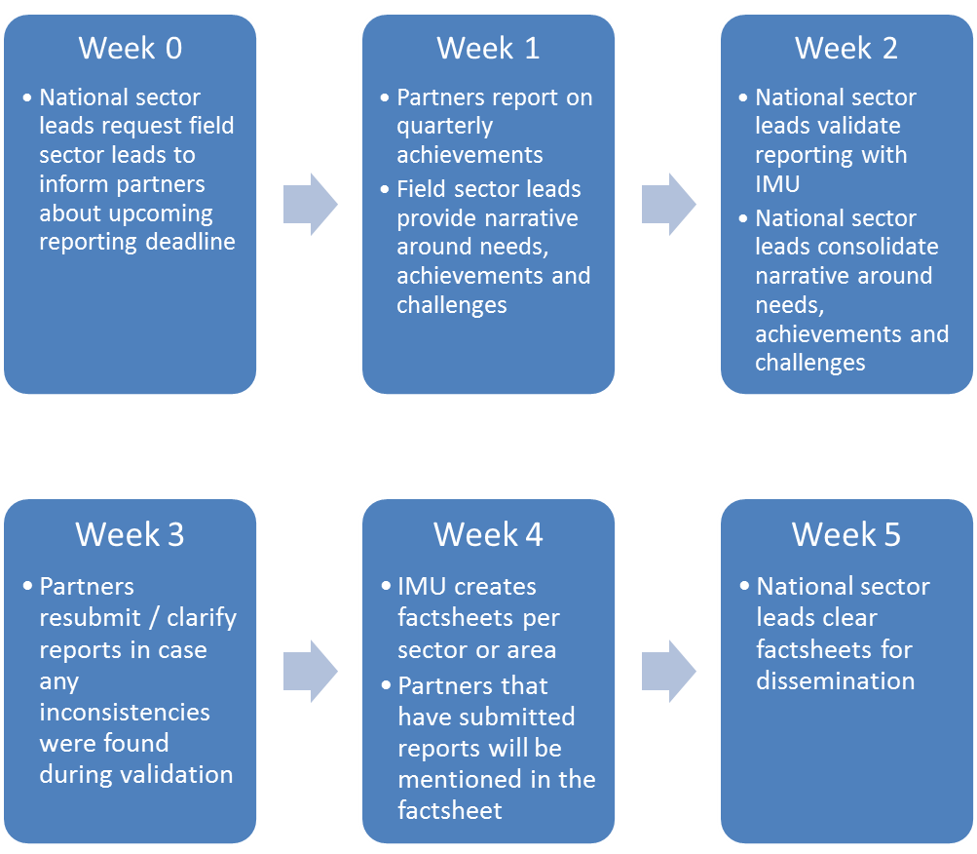

  - Although it was previously agreed that the reporting should be quarterly, sector leads seem to prefer monthly reporting for the activity level indicators in order for them to be operationally relevant, however, RRP level indicators can be generated quarterly from these monthly reports or reported on separately.

  - The minimum granularity of information needed is:
    - Location: settlement level (or zone level for large settlements).
    - Beneficiaries: nationality, sex/age and specific needs.
  - Products will be produced even if not all partners are reporting their activities, it was suggested to leverage donors and government counterparts to persuade those partners that are not reporting to do so.

- Agreement on the reporting platforms
  - UNICEF eTools is no longer being considered due to lack of hosting options during the pilot phase.
  - The Refugee Response Planning and Monitoring (RRPM) platform from Ethiopia will be considered instead.
  - Only currently existing systems are being considered, no development will take place in-house.
  - In terms of requirements, the following elements are considered:
    - Offline / low bandwidth functionality
    - Bulk import functionality
    - Advanced user management
    - Automated reminders for reporting
    - Embedding content from the platform on other websites
    - Auto-populating items distributed based on pre-defined kit contents
    - Data security (auto-logout functionality, anonymous browsing of data etc.)
    - Aggregation and filtering of data at various levels (user generated reports)
    - Compatibility with different browsers
    - Ability to handle multiple logins at the same time (if this forms a bottleneck it was suggested that partners could also report to sector leads and sector leads could then upload the data to the platform, however, this is not the preferred workflow)

- Next meeting will be on 15th Nov (3 – 4pm)

Action items |  | Person responsible | Deadline
Reach out to colleagues in UBOS, NPA and UNDP  Discuss REACH support to the Task Force |  | BO | Immediate

