UNHCR SERBIA UPDATE

As at the end of May, 5,186 refugees and migrants are in the territory of Serbia, of whom 4,724 are accommodated in 13 operational governmental centres across the country. 135 refugees and asylum seekers live in private accommodation. Twenty unaccompanied and separated children (UASC) are accommodated in specialised institutions, and 47 in asylum/reception centres.
14,151 newcomers to governmental centres were registered in April and May 2022 (6,132 in April and 8,019 in May).

April and May saw 1,025 pushbacks from the neighbouring countries to Serbia (66% from Hungary, 29% from Romania and 5% from Croatia). Nationals of Syria make up 50% of all the pushbacks, Afghans make up 14%, and Pakistani come third with 12% of all pushbacks.

The Asylum Office (AO) of the Ministry of Interior (MoI) of Serbia granted subsidiary protection to a national of Niger and a refugee status to a national of Libya. 916 persons expressed intention to seek asylum in Serbia (387 in April and 529 in May). 816 persons submitted formal applications (287 in April and 529 in May).

UNHCR and partners counselled 2,531 persons on asylum and integration in April (821) and May (1,710), 228 beneficiaries received language lessons, 50 educational support and 297 were supported through cultural mediation. UNHCR continued to monitor the progress of four refugee awardees of DAFI scholarship and provided additional support to them for the annual exams.
More than 40 UASC are receiving various forms of UNHCR support as is the guardianship care system of the Ministry of Labour, Employment, Veteran and Social Affairs (MOLESVA).

In early April, partner Belgrade Centre for Human Rights (BCHR) submitted a request for an interim measure to ECtHR for an asylum-seeker from Tunisia facing deportation. As a result, ECtHR ordered Serbia to refrain from deportation until the closure of the case.

UNHCR partners Crisis Response and Policy Centre (CRPC) and Humanitarian Centre for Integration and Tolerance (HCIT) organised a conference called “Let’s meet – refugees our neighbours” on 14 April to present four publications: “Between Closed Borders 2020-2021”, “Life of Serbia”, “Standards of Cultural Mediation in Protection” and “Game People”. These were produced in collaboration with the Serbian Commissariat for Refugees and Migration (SCRM) and MOLESVA.
Partner IDEAS conducted four focus groups with field staff and guardians to analyse the UASC alternative care system. As a result, the factors influencing the decisions to place children and the challenges faced by field staff and guardians were identified.

In the asylum centre Krnjača, partner Danish Refugee Council (DRC) and SCRM organised interactive workshops for 47 participants on prevention of human trafficking and smuggling, reproductive health/family planning, COVID-19 preventive measures and psychosocial support, as well as workshops to support the mothers of school-age children.

Employment
Intensifying the efforts to include refugees and asylum-seekers into the Serbian labour market and taking advantage of the established cooperation UNHCR-SCRM-National Employment Service (NES), NES presented their services to privately accommodated asylum-seekers and refugees. The presentation was also attended by SCRM, MOLESVA and BCHR.

Within the framework of Refugees for Refugees project, partner BCHR organised two sessions for refugees and asylum-seekers: one on entrepreneurial experiences of refugees and the other on practical issues such as opening of bank accounts, work permits issuance procedure and replacement of foreign driver’s licences.

Eight refugees and asylum-seekers from Iran, Bangladesh, Congo, Iraq, Nigeria, and Burundi started a three-month internship in IKEA Serbia as part of the second round of The Skills for Employment programme. Several asylum seekers and refugees have also started to work at the IKEA, Mona Plaza hotel and in the Mercator retail company.

Action on SEA & SH prevention/response, AGD initiatives: DRC provided information, counselling and referrals to the relevant state agencies and service providers.

UNHCR participated in five trainings for the institutions involved in mixed migration management aimed at changing the narrative on refugees and migrations and combating anti-refugee/migrant narrative. In all, some 150 representatives of the ministries of interior and education, centres for social work and SCRM discussed on the ways to make the narrative on migration more fact-based and balanced.

UNHCR, SCRM, and partners organised an integration workshop in the asylum centre Krnjača attended by 26 asylum-seekers. As part of a series of discussions about the key challenges to integration and finding solutions thereto, UNHCR and SCRM organised a focus group discussion with privately accommodated refugees and asylum-seekers from Afghanistan, Iran and Russia.

Responding to the needs expressed by UNHCR, Microsoft Serbia approved the donation of 18 computers to the selected asylum centres and institutions accommodating young refugees and unaccompanied minors.

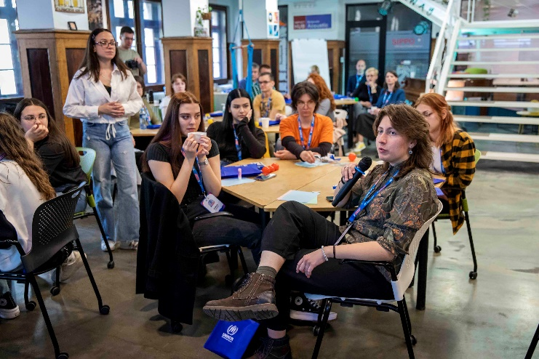
Building on the success of the project “Welcome to My Country”, UNHCR Serbia started a tailored awareness-raising project “In their sneakers” for secondary school pupils. The participants included refugee/asylum-seeker youth, the pupils and the teachers from 13 secondary schools across Serbia. The project will continue during the year, with new initiatives being created by the students themselves. In addition to providing participants with input on UNHCR’s work and igniting their interest in refugee-related topics, the workshops prepare the students to develop small scale projects on refugee protection within their local communities.

The film directed by Branka Katić, UNHCR Serbia High Profile Supporter "What They Took with Them” was shown at the closing ceremony of the Belgrade Documentary and Short Film Festival. The interview in which Branka Katić talked about the stolen lives of the forcibly displaced persons was aired on 28 April.

The Acting Representative gave an interview for the Diplomacy & Commerce Magazine on 13 April. In a feature “We are All United in This Unprecedented Crisis”, Stefanie Krause talked about the about the global displacement situation thus far in 2022, the population displacement inside and outside Ukraine, and UNHCR’s work on the ground.

On 27 April, the public service broadcaster RTS carried an interview about the persons at risk of statelessness/stateless globally and in Serbia.

Refugees from Ukraine in Serbia
In support of the Government of Serbia’s Decision on Granting Temporary Protection in the Republic of Serbia for Displaced Persons Arriving from Ukraine and the Response Plan, UNHCR established the UN Inter-Agency Group and provided information and support to Ukrainian refugees.

Early on UNHCR and the partners established presence in the Centre Vranje, designated for accommodation of Ukrainian refugees. As at 31 May, 68 Ukrainian refugees (8 men and 60 women with children) were accommodated in the Centre Vranje run by the Serbian Commissariat for Refugees and Migration. 27 Ukrainian children attend primary Serbian mainstream schools (data of the Ministry of Education). Transportation is ensured by SCRM. Most of the children also attend online classes held by the Ukrainian education system. Partner INDIGO is organizing educational and recreational activities for refugee children and assisting them with homework and catch-up of regular curriculum. Serbian language classes are organised by partner Sigma Plus since 23 May. UNHCR-supported interpreter for Ukrainian language is present in the Centre 24/7 to assist SCRM with interpretation and issuance of documents. A doctor and a UNHCR partner-supported psychologist maintain regular presence at the Centre. As a part of the UNHCR/IKEA partnership two donations including beds, tables, chairs, curtain rods and supporting equipment to the Centre in Vranje were delivered in early April.

In all, 550 persons were registered for temporary protection in the period 25 February - 31 May. In the same period, 200 persons were issued Decisions on Temporary Protection, that the authorities started issuing formally only on 05 May.

In mid- April, UNHCR Serbia uploaded new information onto its Help Page with dedicated information for refugees from Ukraine. The Help Page was uploaded onto the OPEN Belgrade website and mobile application. Info booklet for Ukrainian refugees including the most important information on asylum procedures, rights and legal counselling (in Ukrainian and Russian) was shared with the City authorities for distribution at the Info Centre downtown Belgrade. Legal partner BCHR produced a Guide to Asylum in Serbia video, subtitled in Ukrainian and Russian languages.

UNHCR Serbia is grateful for the support of all the donors who contribute to UNHCR activities,
with special thanks to:
Austria | Belgium | Denmark | European Union | Germany | Ireland | Netherlands | Norway | Serbia | Sweden | Switzerland
With the support of the following organisations and private sector partners:
IKEA SEE | Microsoft Serbia

