Multi-channel Communication with Communities Network Mapping Template
Use the table below to populate with as much information as possible about the different communication channels that are applicable to your context.

Channel Types | Channel Description | Channel Audience | Channel Language | Channel Contact Information | Channel Accessibility Information | Channel owners | Open or Restricted Channel
Digital Channels
WhatsApp Chat | i.e Dedicated WhatsApp chat available 24/7 in locations A and B. | i.e Refugees, Internally Displaced people (IDPs). | i.e operators can respond in Arabic, French, English. | i.e  For location A  +000 000 00001  For location B  +000 000 00002 | i.e use of text, voice and recordings. | UNHCR Field Office location A. | i.e Open Channel.
SMS Messages
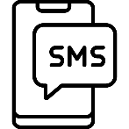
Email
Online Chat
WhatsApp Communication Trees
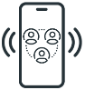
Hotline/Helpline/ Call Centre
Video Calling
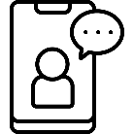
Facebook Groups
YouTube or Video Channel
Other Social Media Channels
Traditional Channels
Face-to-face communications
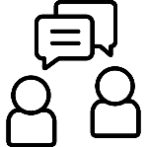
Community Outreach Volunteers
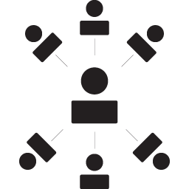
Complaint Boxes
Radio Broadcasts
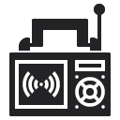
Community Gathering or Community Reference Groups
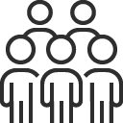
Community Centres
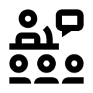
Helpdesk
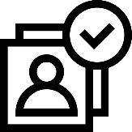
Counseling Centre
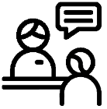
Reception Centres
