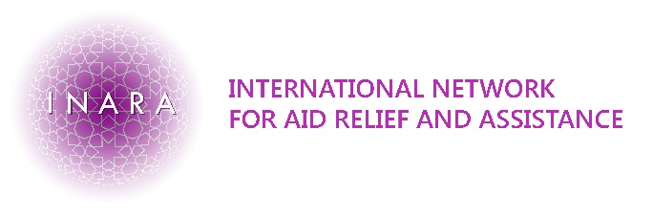

INARA’S REFERRAL FORM

Beneficiary information
Name:_______________________________________________  Address:_____________________________________________  Name of Guardian:__________________________________  Relationship to the child:___________________________  Contact details:______________________________________ | DOB:________  Sex: _________ | ID No.: _________________________  UNHCR No.: ___________________  AUBMC No.: ___________________  Nationality: ___________________  Language: _____________________

Referred To (INARA personnel): | Referred By:
Name: ________________________________________  Phone:____________________________________________  Email:______________________________________________ | Agency/Clinic:______________________________  Region:______________________________________  Name: _______________________________________  Phone:_______________________________________  Email: _______________________________________
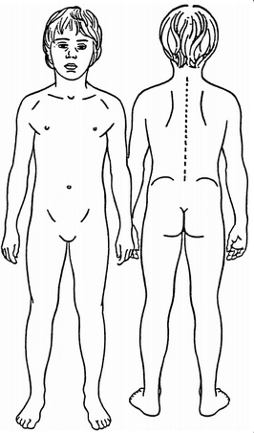
Reason for referral:

1. Suspected/ known injury which falls under INARA’s coverage criteria (see ‘INARA’s Coverage Criteria’)
Please tick all that apply:

- Orthopedic surgery (including orthopedic implants):

- External injury requiring reconstructive and plastic surgery, including bone and soft tissue injuries:

- Burn scars causing reversible physical disability and which require surgical treatment:

Cause of injury and background information, including: Please circle the affected area/s:
- Date and location of injury
- Did the beneficiary get any previous treatment or surgery for the injury?
(date, name and address of doctor)

Continue on next page…

2. Other injury or illness which falls outside INARA’s coverage criteria (see ‘INARA’s Coverage Criteria’)
Cause of injury or type of Illness and background information (please be as detailed as possible):

*Please note that whilst we will endeavor to refer these beneficiaries to a suitable humanitarian organisation, we cannot guarantee this is always possible.

3. Severity of injury or illness
Is the injury or illness, if left untreated/ currently is:

Life threatening (death)

A severe irreversible physical disability

A severe reversible physical disability

Does the beneficiary have existing medical files or do they need medical testing (if the diagnosis is suspected to fit within INARA’s coverage criteria)
Medical files relating to the cause for referral (please attach):

The beneficiary requires medical testing:

*Please note that INARA will only pay for medical testing when the possible diagnosis falls within the realm of our services.

Other
Are you aware of other funds that could be contributed to the cost of treatment?

Have you referred the beneficiary to other humanitarian organisations/ medical providers (relating to the reason for referral to INARA)? If yes, please provide details of where and outcome.

Send this referral form to: sofia@inara.org or for more information, call +961 789 17173

Referral Received by:

Date:

