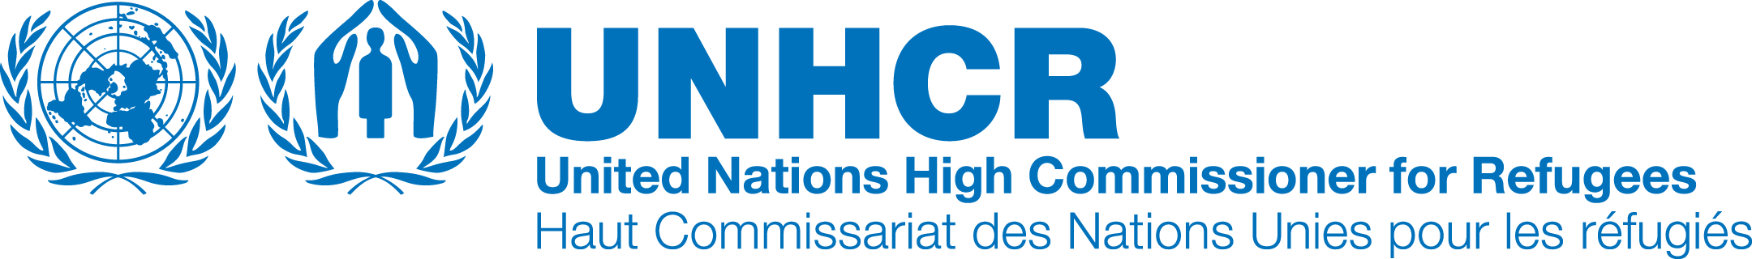
Press Release
Baccalaureate 2017 in Hadjer-Hadid: UNHCR welcomes strong symbol of mixing between refugees and Chadians

July 16 2017

Hadjer-Hadid - From July 17 to 22, 2017, 1,338 young refugees, 58% of whom are girls (770) in Chad, will take part alongside their Chadian counterparts in the written exams of the Baccalaureate session of July 2017. For the first time ever, Sub-prefecture of Hadjer Hadid, in eastern Chad, has two baccalaureate examination centers.

These centers will welcome 788 secondary school students, including 682 Sudanese refugees and 106 Chadians from the town of Adré, the capital of the department that covers Hadjer Hadid.

This is a successful outcome of a joint initiative between the Ministry of Higher Education and Scientific Research through the National Office for Examinations and Competitions (ONECS) and the United Nations refugee agency's Representation in Chad. It aims to facilitate the conduct of this national examination for the children of this department who had previously to go to Abéché, located 171 km from the town of Adré and 120 km from that of Farchana, to pass it.

Thanks to this initiative, which strengthens the mix between refugees and their Chadian hosts, through this key sector of education, children can now move closer to their families and take the exams with less anxiety - Hadjer-Hadid is located at 85 km from Gaga camp, the most remote with fewer candidates (84) and 500m from Treguine camp, nearest with more candidates (229) and 65km from Adré.

It is a logistical and administrative operation that UNHCR and its partners have organized in collaboration with several departments of the Chadian administration. Activities range from transporting pupils to their accommodation for those coming from the camps of Gaga and Farchana and the city of Adré, and their restoration as well as their medical care, preparation and accompaniment in the classrooms.

UNHCR welcomes this joint initiative, which reflects the hospitality and solidarity of the people and the Government of Chad towards refugees, said the Agency's Acting Representative in Chad, Edward O'Dwyer, who stressed the importance of consolidating these achievements.

"We have, through education where there has been a lot of progress over the last three years, a genuine opportunity to strengthen the mix between this generous Chadian population and the refugees," said Edward O'Dwyer. He will launch the baccalaureate on Monday, July 17, 2017 in Hadjer-Hadid, together with the Prefect of the department of Assoungha and the representative of BPRM, the American Bureau for Population, Refugees and Migration. On Sunday, he and his delegation spent time with high school students, refugees and Chadians, encouraging and motivating them to approach this stage of their young life with serenity and confidence and to assure them of their support.

According to the UNHCR Representative, "the time has come to help Chad to promote the socio-economic inclusion of refugees in Chadian society while continuing efforts to protect them and the search for durable solutions such as voluntary repatriation in their countries of origin when conditions permit ".

As they are the clear majority of refugee candidates taking part in the baccalaureate [over 90 per cent], Sudanese students participate for the third consecutive time in this national examination since the integration of the Chadian curriculum by schools in the refugee camps in the east of the country since 2014-2015 school year.

Since then, their numbers have grown from 609 registered candidates in 2015 to 1,211 in 2017, with increasing success rates - 19.12% in 2015 and 28.79% in 2016.

In the country, there was a success rate of 19.05% and 30.64% among refugees in 2015 and 2016, respectively.
It is an incentive for UNHCR and its partners to place special emphasis on the education of refugee children / youth, supported by financial partners such as BPRM.

With much improved figures, UNHCR and its partners are aware that more efforts are needed to provide access to tertiary education (universities, colleges, professional schools ...) to more refugee students. To this end, the Agency welcomes initiatives such as the DAFI (German government) scholarships, which enable more than 90 young refugees to study in Chadian universities or agreements that allow them to study under the same conditions as the young Chadians.

According to the mid-term report for the school year 2016/2017, a total of 86,961 refugee children were enrolled in schools.

Contacts médias:
Ibrahima Diane, dianei@unhcr.org, 0023565274775

