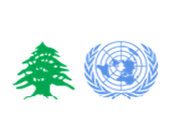
South Lebanon Livelihoods & Social Stability Sectors Working Group Meeting - Minutes

MEETING

Name | Social Stability & Livelihood WG / Coordination Meeting | Meeting date | July 26 2017
Meeting location | UNDP South | Meeting time | 11:30 a.m.
Chair person | Yousra Taleb / UNDP | Meeting duration | 1.00 hrs
Minutes prepared by | UNDP
Participants | ANERA, UNDP, UNIFIL, UNHCR, ACTED
Meeting Agenda | - Welcome & Introduction;  - Presentations:  - UNHCR – PSEA  - UNDP-Tension mapping updates July 2017  - Central Level Update  - Social stability and livelihoods sectors’ contingency plans  - Sectors’ M&E new log-frames  - Activity Info reporting  - AOB  - Youth initiatives lessons learnt workshop proposed date (Friday August 11th 2017)  - Info briefing for the Governorate of Nabatieh

Summary of Discussion Points

A. | Deviations from original agenda  - The Protection presentation by UNHCR will be held next working group meeting.  - Added a point for partners’ updates
1. | Welcome & Introduction
- The chair welcomed the participants on behalf of the co-leads
- The agenda was briefly presented and validated by partners.
2. | Presentations
- UNDP-Tension mapping updates July 2017
The tension mapping task force met in early July and went through the list of villages in the South and Nabatieh where tensions were identified and assessed using the 8 sources of tension (competition over jobs, pressure on resources, perception of international assistance among others). As a result, most of the identified villages from the previous mapping remained in the list and some new villages were added. The following are the key findings of the tension mapping exercise:
  - Bint Jbeil district 8 village were identified with tensions, 3 of which scored high tension (Rmeich, Ain Ebel and Bent Jbeil)
  - Hasbaya district 6 villages were identified with tensions, 2 of which scored high tension (Chebaa and Kfar Chouba)
  - Marjeyoun district 7 village were identified with tensions, 3 of which scored high tension (Khiam, Dardara and Wata Khiam)
  - Nabatieh district 4 villages were identified with tensions, 1 of which scored high tension (Nabatieh Fawqa)
  - Saida district 7 villages were identified with tensions, 2 of which scored high tension (Bisarieh and A’aqbieh)
  - Tyre district 9 villages were identified with tensions, 3 of which scored high tension (Dhaira, Jal AlBaher and Qlaile)
  - Jezzine district 2 villages were identified with tensions, but none of high tension
Most of the incidents reported in the areas are fights between host communities and refugees in addition to competition for jobs and pressure on resources, however, it is important to highlight that cases of sexual exploitation have been identified in A’aqbieh/Bisarieh areas. Though this is mainly a concern for the child protection working group, which already have the area on their radar, it is important for the social stability/tension mapping task force to keep a close eye on the situation as it might cause further tensions between host communities and refugees who might have reactions against the exploitation of ‘their’ young girls. Furthermore, in some areas, municipalities do not accept any organization entering the area unless the municipal police accompany them.

In addition, a tension mapping whatsapp group has been activated on June 20th 2017 with more than 22 partners in addition to UNDP. Among these, 3 partners are most active: SHEILD, IRC and DPNA. Other partners are encouraged to have more participation in the group. The news that was mostly shared during the past week was related to the demonstrations and anti-demonstrations allegedly called for by Syrians and Lebanese on social media. However, now that the wave has passed, no major issues have been reported.

- Q: Has there been a comparison of trends between the current and the previous mappings?
A: No, but this is something we are planning to do more systematically. However, we can see through the changes in tension scoring every three months whether tensions in particular place are rising or decreasing.

The sector created a map of curfews in the South (comparing areas that implemented curfews with those which announced them but without enforcing them). The map will be shared with the minutes.
3. | Central level updates (presentation annexed)
- Social stability and livelihoods sectors’ contingency plans
- Background: Risk analysis workshop held on 23 May 2017
Objective: Evaluate the risk for the next 12 months of 3 contingency scenarios validated by the HCT.

(1) Inter-community clashes leading to mass evictions and severe restrictions on refugees
(2) Armed clashes in the Palestinian camps leading to injuries/casualties, discontinuation of all services by UNRWA and NGOs and mov. of population out of the camps.
(3) Renewed conflict with Israel leading to mass displacement out of Southern Lebanon, potentially causing spillover of intercommunity conflicts.

- In the first four to six weeks of the crisis, the social stability sector will conduct the following three activities: 1) supporting key public institutions (governor’s office, municipalities and qaemaqan’s office) in responding to and coordinating the crisis through staff support, 2) implementing community recovery activities (infrastructure repair and access) by providing key institutions with relevant equipment, 3) conflict analysis and sensitivity by activating dialogue committees at the community level.
- The main objective of the livelihood sector will be to initiate emergency livelihoods interventions to provide affected municipalities and communities with the means to quickly recover. Therefore, the sector will start implementing community recovery activities as soon as the security situation allows it (foreseeably within the first few weeks following the incidents) and will primarily support repair, cleaning, and infrastructure rehabilitation work. This will be done through labour intensive interventions which will fulfill the dual objective of supporting rehabilitation and debris removal while providing affected communities with short-term livelihoods opportunities. These rapid employment programs will benefit both host & refugee communities in the municipalities affected by the clashes as well as in neighboring municipalities.
- The contingency plan will be shared with partners for their information and feedback. The HCT will validate the plan on 10 August.
- M&E Review 2017: Proposed Revised Logframe for the Social Stability Sector
Following the consolidation of the M&E Inter-Sector Framework, sector frameworks have been revised to better feed into the strategic objectives of the LCRP.

The social stability sector log frame was restructured as follows:

Outcome 1 - Municipalities, national and local institutions ability to alleviate resource pressure strengthened. This will result from three outputs: service delivery through participatory processes; provision of integrated solid waste management services and capacity development support for local crisis response.

Outcome 2 - Municipal and local community capacity to address sources of tensions and conflict strengthened. This will be achieved through two outputs: capacity development support provided to municipalities and local actors for dialogue and conflict resolution and youth empowered to engage in their communities.

Outcome 3 - Social Stability is mainstreamed in the LCRP. This will be achieved through one output: LCRP partners trained and provided with information to mainstream conflict sensitivity across LCRP programmes.

The Indicators won’t change but instead of all sector outputs being under one outcome; they are under three different outcomes.

The new logframe looks as follows:

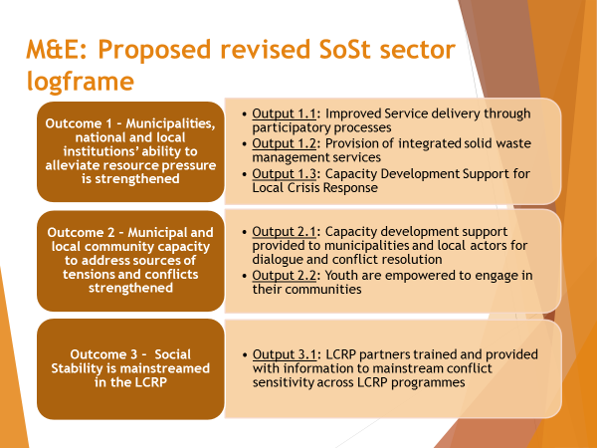

The livelihoods sector log frame has been restructured as follows:

The number of outcomes has been increased to three. The three outcomes will focus on:
Outcome 1 - Creation of employment and income generating opportunities: will include outputs related to: SME creation, financial and technical support services to MSMEs, value chains and labor-intensive infrastructure/assets.

Outcome 2 - Enhancing employability: will include all supply side outputs such as skills training, job matching, and internships/apprenticeships.

Outcome 3 - Institutional support: include outputs related to labor regulations to ensure decent work, and policies and strategies to support employment and Lebanese businesses.

The new logframe looks as follows

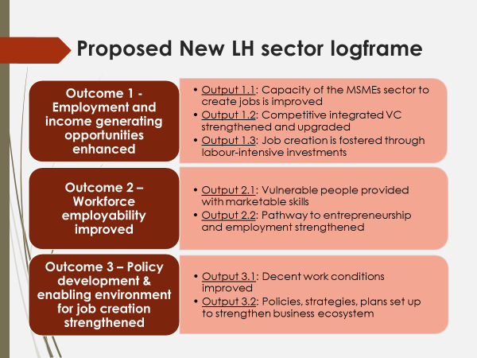

- Activity Info reporting
- New Deadline for Dashboard: Monday 7 August
- 32 active partners in the sector in the first two quarters
Sector Trends mid-year:
- Support to municipalities: 61 CSP projects implemented since the beginning of the year (20 projects implemented in the South & Nabatieh)
- Dialogue committees: 26 new committees set up (0 committees set up in the South & Nabatieh this year)
- Youth empowerment: 158 youth initiatives set up (23 initiatives in the South & Nabatieh)
- The national 3W map is now online for partners to have details on all type of interventions.
4. | Partners’ updates
- Acted: Implementing the Leaders Project in municipalities in Nabatieh and Sour together with Sheild, Lebanon Support and Akkarouna (it’s a nation-wide project). The project aims at strengthening the role of civil society in both policy development (health, education and environment) and local development processes addressing the basic needs of marginalized groups.
- UNDP Peacebuilding: currently work in 10 villages in South Lebanon to test the water with the municipality together with MOSA on peacebuilding initiatives. In the second phase of the intervention will conduct focus group discussions on how people cope with tensions. The Mechanism for Social Stability (MSS) – a conflict resolution mechanism customized to each village – will then be launched in cooperation with the mayor in these villages. MSS participants will receive training in conflict resolution.
- ANERA is working within and outside of the Palestinian camps on the ‘back to school campaign’. They will conduct trainings and household visits next week for start of school in September. They also conduct trainings on basic literacy and numeracy, as well as vocational training.
- UNHCR will be implementing ‘hp’-learning studios in Saida and Tyre (negotiations with municipalities are ongoing). There will also be a graduation ceremony soon for participants of the ‘Microsoft imagine academy’ in Tyre.
- UNIFIL has not decided on projects yet.
5. | AOB
Youth initiatives lessons learnt workshop
- The aim of the workshop is twofold 1) to foster an exchange of lessons learnt and best practices between partners working on youth initiatives, 2) to inform and be informed by current discussions on the youth action plan currently developed by the government together with UNFPA. After consulting with UNFPA, the social stability working group will organize a core group meeting at central level to devise a sector strategy on youth engagement in light of the youth action plan. This discussion will then help us to create a conceptual framework for the workshops at field level. UNDP South will also consult with UNICEF as well as with the field coordinators of the other regions on how to frame the workshop and what themes to discuss. The date for the workshop still needs to be confirmed but will likely be in the second half of August or beginning of September.
Info briefing for the Governorate of Nabatieh
- The Sector leads will be presenting all the information from sector activities to the Governorate to show to municipalities and the governor the type of projects and interventions implemented in the different areas to improve transparency and coordination with local governance institutions.
NEXT SSLH working group meeting will be on August 30th 2017 at UNDP office
Presentations will include PSEA by UNHCR and T’acir project by ACTED

