Report on the SGBV SWG’s 16 Days Campaign Activities, 2018

The SGBV Sub-Working Group (SGBV SWG) conducted this year’s 16 Days campaign of activism against Gender Based Violence under the framework of the Jordanian National Commission for Women (JNCW). The thematic focus of the national campaign was sexual harassment which was based on the launch of a comprehensive JNCW study on the topic. The hashtags, #SpeakUpJo (#لازم_نحكي) #16DaysJo and were developed on the national level and used by different stakeholders throughout the campaign.

The SGBV SWG joint activities detailed below included the following:
- Development of common messages
- Arrangement of a “SpeakUpJo fair”
- Joint calendar collecting all activities at field locations

Development of Common Messages

The SGBV SWG, with the help of Syrian refugees, developed key messages under eleven topics related to sexual harassment. The work was led by a taskforce consisting of a selection of the organizations that make up the SGBV SWG. The messages included e.g. “You have control over your own bodies and have the right to say NO! Wherever you are, in public space, at home or online”, “No excuses - sexual harassment is never ok, whatever she is wearing” and “Speak up, You are not alone! Together we can stop sexual harassment. Together we can make Jordan safer for all.”

The #SpeakUpJo Fair

On 29 November, the SGBV SWG organized a fair event in the Ras Al Ain Hangar to celebrate the collective efforts to prevent and respond to gender-based violence in Jordan and to highlight the 16 Days of Activism. The fair was a joint event featuring the work of 22 national and international organizations, including United Nations agencies, NGOs and local women’s organizations. It was the first initiative of its kind in Jordan and it aimed at shedding light on protection services provided to survivors of GBV.

Based on the theme of the national campaign, the fair’s slogan was “Speak up: Join your voice with mine to stop sexual harassment”. In addition to the UN Resident and Humanitarian Coordinator, Mr. Anders Pedersen, the opening ceremony included remarks by Dr. Salma Nims, Secretary General of JNCW, who presented some of the findings of their recent study, and Dr. Ibrahim Aqel, Director of Institute for Family Health.

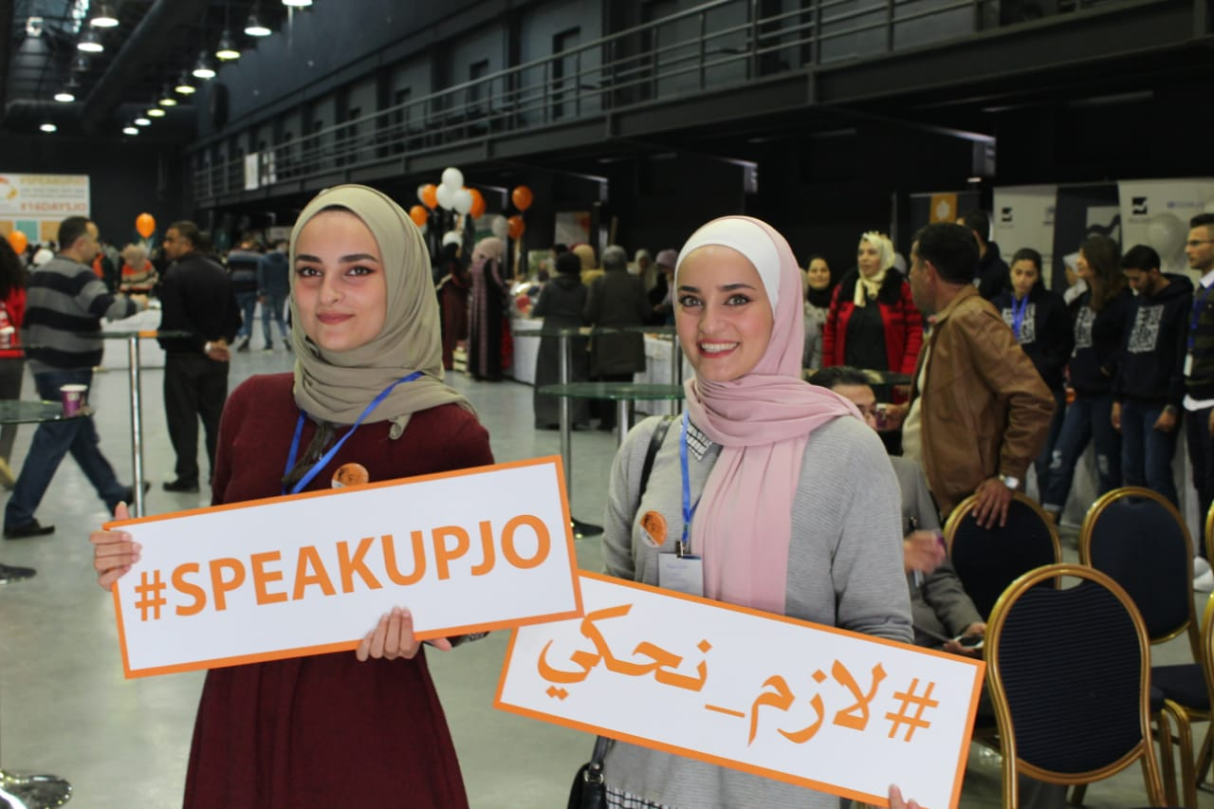
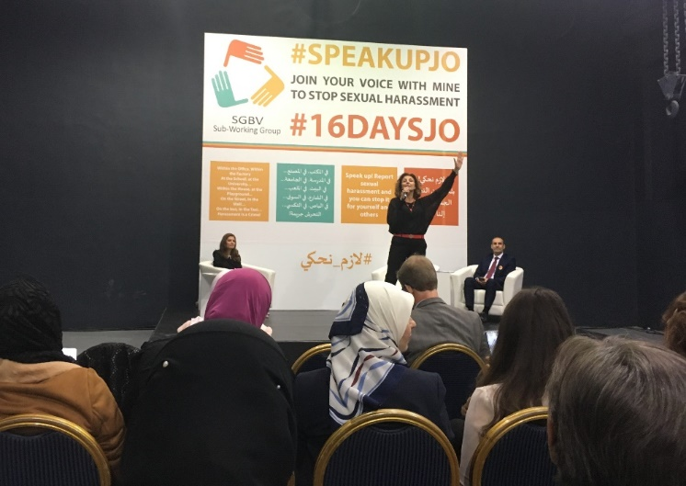
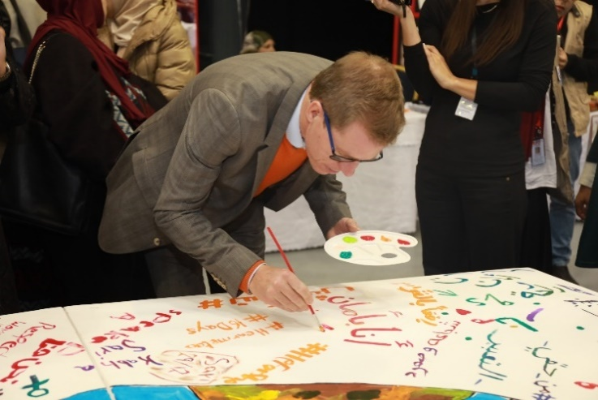
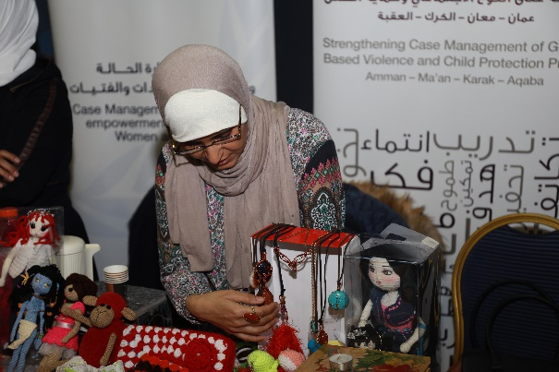
UNFPA and UNHCR, as co-chairs of the SGBV SWG, emphasized the importance of individuals’ actions in creating change through joint awareness-raising efforts and by educating others on the existence of sexual harassment. The event advocated for the rights of survivors of violence, including amplifying their voices, mobilizing the general public against gender-based violence, holding perpetrators accountable, as well as ensuring access to specialized services and reporting mechanisms. Moreover, a young Syrian student and a Syrian volunteer also gave opening remarks.
The #SpeakUpJo Fair, Ras Al Ain Hangar, Amman, 29 November 2018 (Photo Credit: UNFPA, IRD and JRF).

The fair included booths showcasing participating organizations’ work on gender-based violence, art activities, self-defense classes, theater plays, a video screening and a bazaar featuring food items and handicrafts made by local women’s organizations. In addition to the general public, guests included government stakeholders, donor agencies humanitarian and development actors, beneficiaries of the programs and refugee volunteers.

The fair was attended by over 300 participants and received some attention in local media. In addition to being mentioned in Ammon News and the Al Ghad Newspaper, both the Associated Press and Al Jazeera Arabic recorded and broadcasted video material from the event.

Activities at Field Level

Several of the organizations that make up the SGBV SWG reported having conducted individual 16 Days activities throughout the campaign period. 17 organizations reported activities and events including e.g. social media campaigns, workshops, awareness sessions and trainings on sexual harassment-related topics, book launches, film screenings on early marriage and sexual harassment, art competitions, interactive theatre plays and silent sketches, painting activities, art and photo exhibitions, community dialogs, flash mobs, marathons, youth caravans, sport activities, women self-defense classes and bazaars. These activities were carried out in ten governorates across the country (Amman, Ajloun, Balqa, Irbid, Jerash, Karak, Ma’an, Madaba, Mafraq and Zarqa) and in four camps (Zaatari, Azraq, EJC and KAP).

Zaatari Camp
Under the National Theme # Speak Up Jo and the global theme # Hear Me Too, a huge number of activities were conducted in Zaatri. Nine organizations (UNHCR, UNICEF, UNFPA-IP’s, IFH, QS, IRD, RI, SCJ ,NRC and IMC) conducted 57 activities such as awareness lectures by a number of female students about the importance of providing an environment free from harassment of girls in society, awareness sessions with parents on sexual harassment, awareness sessions by juvenile police, origami sessions with early marriage cases, videos against sexual harassment, play theaters, an art gallery, sessions on risks of social media for adolescent girls (including online harassment), how men and boys could be involved in stopping other men from harassment acts at Makani centers, a wall for children’s words, painting on caravans , tailoring on t-shirts, a human body map exercise, a selfie frame, a silent sketch on sexual harassment (including follow-up discussions), a joint walking activity in the camp holding cards and props on sexual harassment, awareness sessions for child labors on sexual harassment/exploitation at workplaces and awareness sessions by ARDD on different protection issues.

The mentioned activities were conducted in different sites and locations covering different districts. The activities were provided for women, men, boys and girls to ensure the coverage of both sexes and different age categories.

The SGBV Working Group (SGBVWG) in Zaatari worked on having coordinated and arranged activities in the camp, including the coordination of a joint opening event which was held on 25th of November. UNHCR, UNFPA, SRAD, IFH, IRD, UNWOMEN and SCJ attended the opening event with 100 beneficiaries from the Zaatari community in addition to a group of volunteers from different organizations. The opening ceremony included a remark by UNHCR camp manager and SRAD camp manager. The messages related to sexual harassment that were developed by the national 16 days taskforce were brought up in these remarks and were disseminated in both Arabic and English to the beneficiaries and participants. A group of female and male volunteers presented a silent sketch on sexual harassment followed by discussions with the audience on the sketch. At the end of the event, all beneficiaries were invited to a gallery walk. The gallery included products (soaps, accessories and handy crafts) made by female volunteers from different organizations, including IFH and UN Women. Finally, pins with the national hashtag (#SpeakUpJo) and the SGBVWG logo were distributed to the participants of the event.
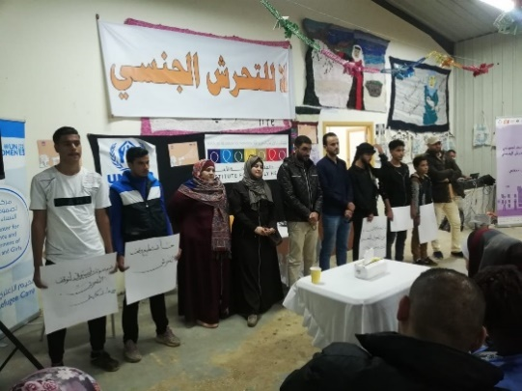
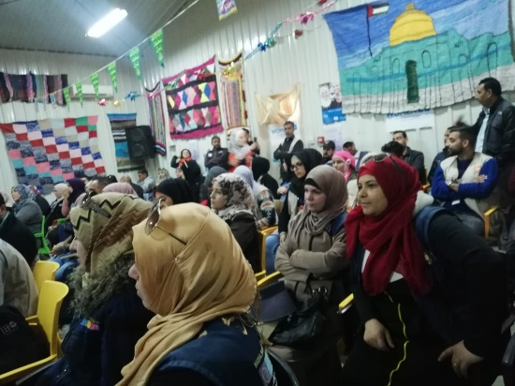
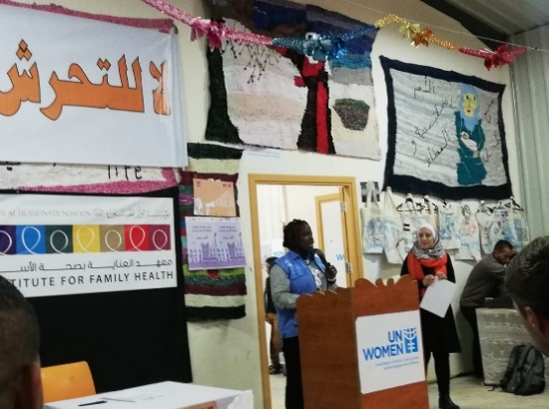
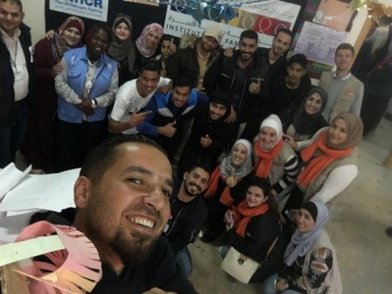

Opening Ceremony in Zaatari Camp, 25 November 2018.

Mafraq
In Mafraq, SGBV SWG members initiated a Bazar in addition to other activities throughout the 16 days of activism. The activities included awareness sessions, plays, presentations of success stories of women’s empowerment and drawing activities.

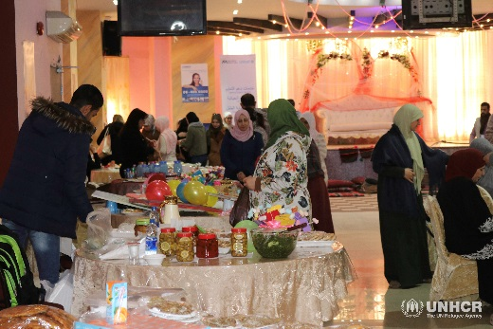
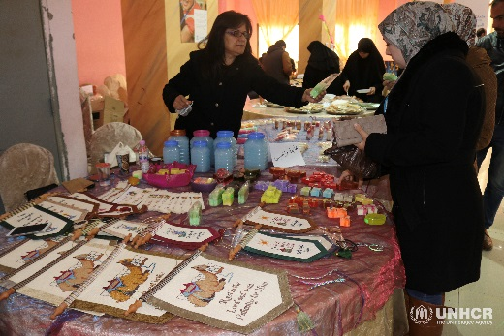
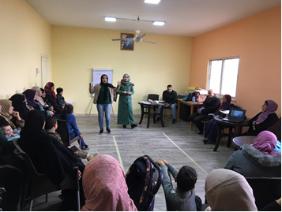
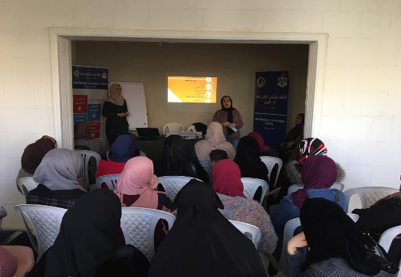

16 Days Activities in Mafraq.

Main Lessons Learnt

- A national theme aligned with JNCW ensured that more people were reached across the development and humanitarian setting, with the same message, which amplified the impact.
- Common messages developed to be used throughout the year and not only limited to 16 days.
- Public participation need to be better defined for improved outreach.
- Donor engagement strategy needs to be redefined.
- The creation of a taskforce with short weekly meetings was conducive for responsibility sharing.
- Creation of more IEC materials is needed.
- Earlier involvement with JNCW is needed, including timeline alignment for the development of common materials.

Main Lessons Learnt from Zaatari Camp
- Conducting coordination meetings to arrange for the 16 days activities made all the planned activities arranged and coordinated.
- Developing common messages at the national level helped the planning of activities and enabled a wider dissemination.
- Creation of more IEC materials like posters and banners is needed.

Main Lessons Learnt from Mafraq
- Community mobilization to reach more people from both the refugee and local community needs to be improved.
- Women with crafts and businesses need to be better linked with donors, business owners and the community, e.g. through creation of a social media page.

The taskforce was chaired by UNFPA and UNHCR and included the following organizations: ActionAid, Institute for Family Health, International Relief and Development, Jordan River Foundation, Mercy Corps, Première Urgence International and UN Women.
For the full list of topics and messages, please see Annex 1.
For UNFPA Jordan’s Social Media Campaign “#SpeakUpJo: 16 Voices on Sexual Harassment”, please see UNFPA Jordan’s Faceebok page: https://www.facebook.com/UNFPA.Jordan/

